L48 – 2.1 Angles in Standard Position
Key Ideas
The reference angle is the positive acute angle that can represent an angle of any measure. The reference angle is always the smallest angle that you can make from the terminal side of an angle (ie wher eteh angle ends) with the x-axis.
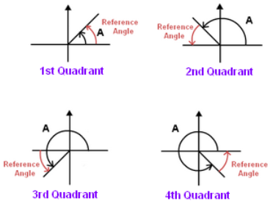
There are two special triangles in trigonometry. One is the 30⁰-60⁰-90⁰ triangle, and the other is an isosoles 45⁰-45⁰-90⁰ triangle. They are special because, with simple geometry, we can know the ratios of their sides.
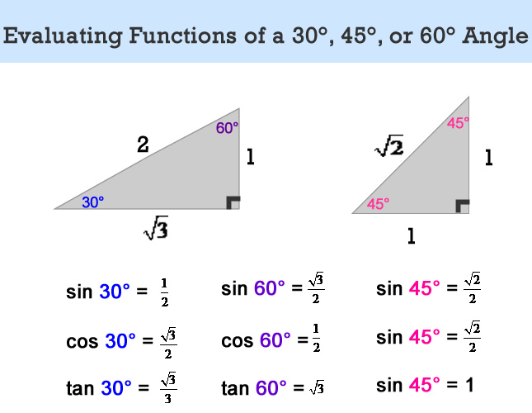

Part 1 – Polar Coordinates and Quadrants
Q1: Draw an angle of 60⁰. Which quadrant? Q2: Draw an angle of 20⁰. Which quadrant?
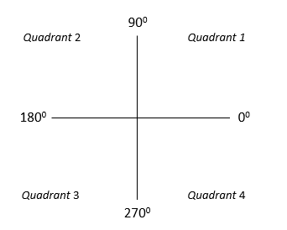
Q3: Draw an angle of 120⁰. Which quadrant? Q4: Draw an angle of 200⁰. Which quadrant?
Q5: Draw an angle of 170⁰. Which quadrant? Q6: Draw an angle of 330⁰. Which quadrant?
Part 2 – Reference Angles
Q7: Draw the angle 140⁰ in Standard Position, Q8: Draw the angle 225⁰ in Standard Position,
determine the Reference Angle, and state determine the Reference Angle, and state
which Quadrant it is found in. which Quadrant it is found in.
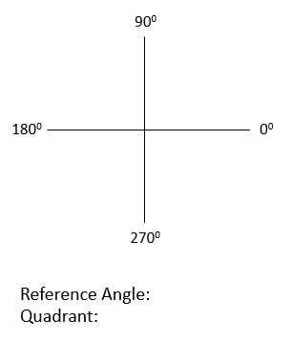
Q9: Draw the angle 325⁰ in Standard Position, Q10: Draw the angle 200⁰ in Standard Position,
determine the Reference Angle, and state determine the Reference Angle, and state
which Quadrant it is found in. which Quadrant it is found in.
Part 3 – Special Triangles
Q11: Use Pythagoras Theorem to determine the missing side for each triangle. Next, label the missing angles on each triangle.
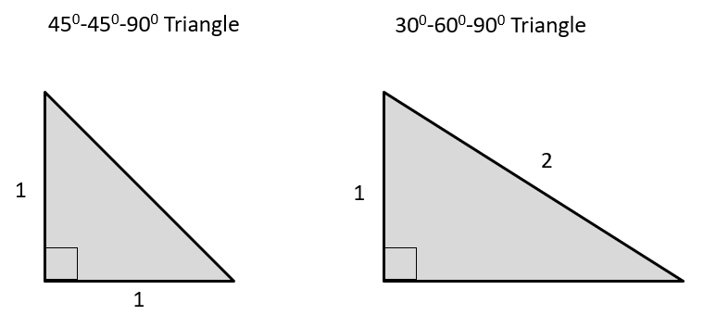

Q12: For each triangle, determine the exact values of the Trigonometric Ratios.

Use the following information to answer Q13-14:
Q13: Given the triangles below, determine the exact value of x.
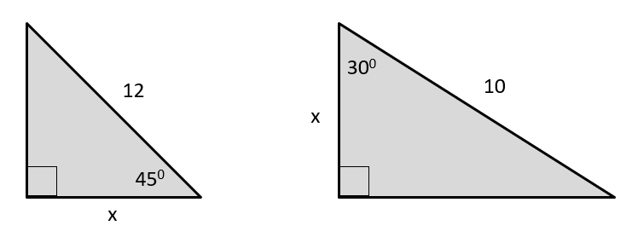

Q14: Given the triangles below, determine the exact value of x.
