L48 - Substitution
Part 1 – Method
Substitution is an algebraic method of solving systems of equations.
Process:
- Solve one equation for one variable.
- Substitute that expression into the other equation.
- Solve for the other variable.
Part 1 – Algebraic and Graphical Questions
Q1: Find the solution to the system of equations both algebraically and graphically.
$y=x+1$ $y=-2x-7$

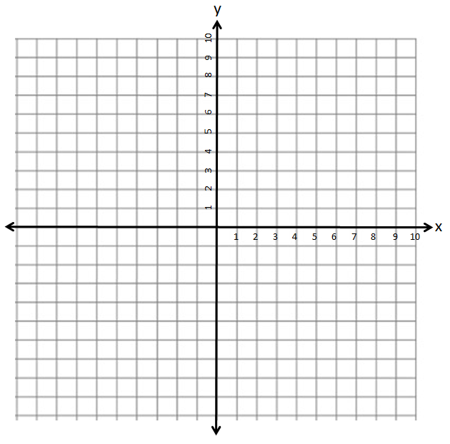
Q2: Find the solution to the system of equations.
$y=\frac{1}{2}x+7$ $y=2x+2$

Part 2 – Easy Algebraic Questions
Q3: Find the solution to the system of equations.
$y=-4x+22$ $y=-2x+12$

Part 3 – Medium Algebraic Questions
Q4: Find the solution to the system of equations.
$y=-5x+21$ $x-2y-2=0$
Part 1: Solving $y=-5x+21$ for y.

Part 2: Solving $y=-5x+21$ for x.

Part 3: Solving $x-2y-2=0$ for y.

Part 4: Solving $x-2y-2=0$ for x.

Q5: Find the solution to the system of equations.
$y=4x+16$ $2x-3y+8=0$

Q6: Find the solution to the system of equations.
$y=4x+16$ $5x+2y+13=0$

Part 3 – Harder Algebraic Questions
Q7: Find the solution to the system of equations.
$x+4y+18=0$ $2x-3y-8=0$

Q8: Find the solution to the system of equations.
$3x+4y+10=0$ $2x-3y-7=0$

Q9: Find the solution to the system of equations.
$y=\frac{1}{3}x+7$ $4x-7y-16=0$

Part 5 – Textbook Practice
Pg. 427 #6,7,8,10

