L48 – Worksheet – 2.1 Angles in Standard Position
Part 1 – Unit Circle and Special Right Triangles
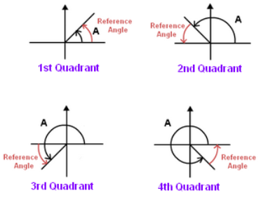

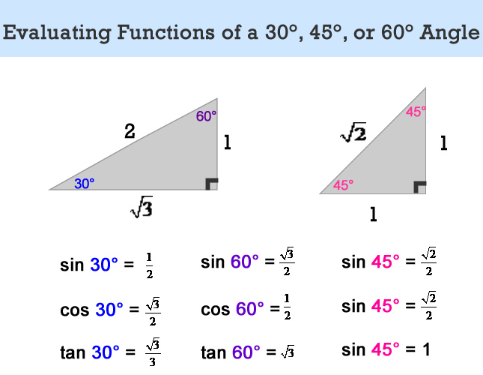

Part 2 – Textbook Questions
Pg 83 #1: Is each angle, θ, in standard position? Explain.
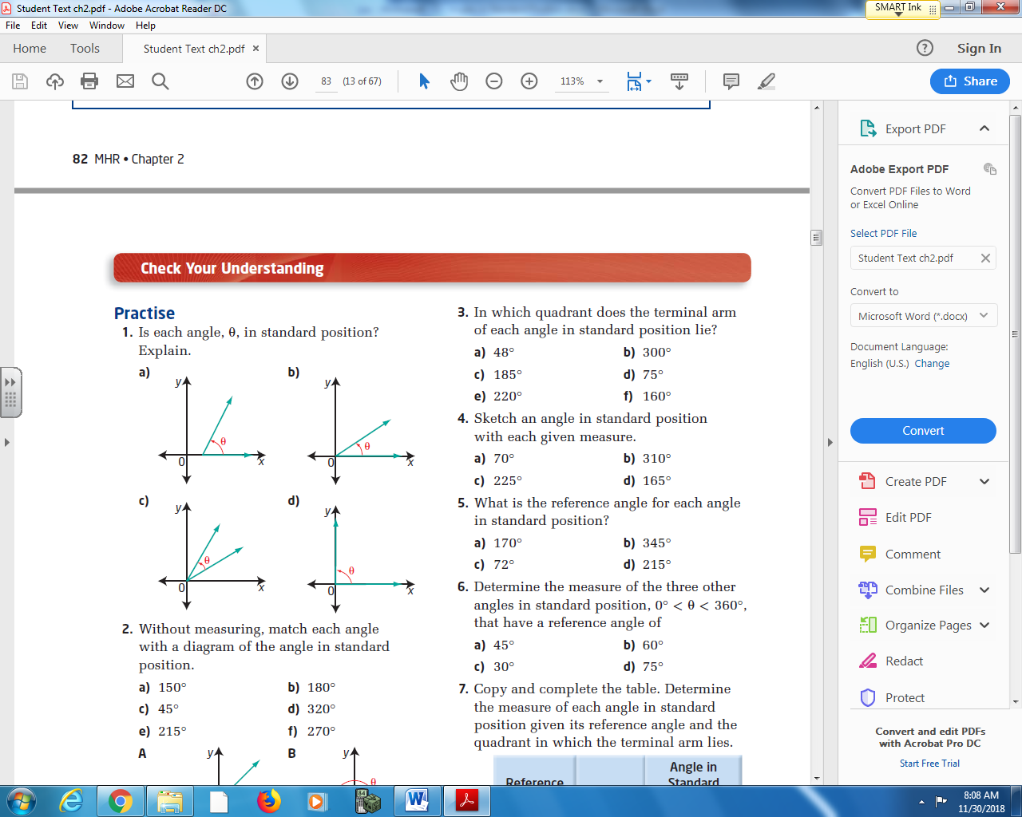

Pg 83 #2: Without measuring, match each angle with a diagram of the angle in standard position.
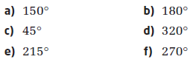
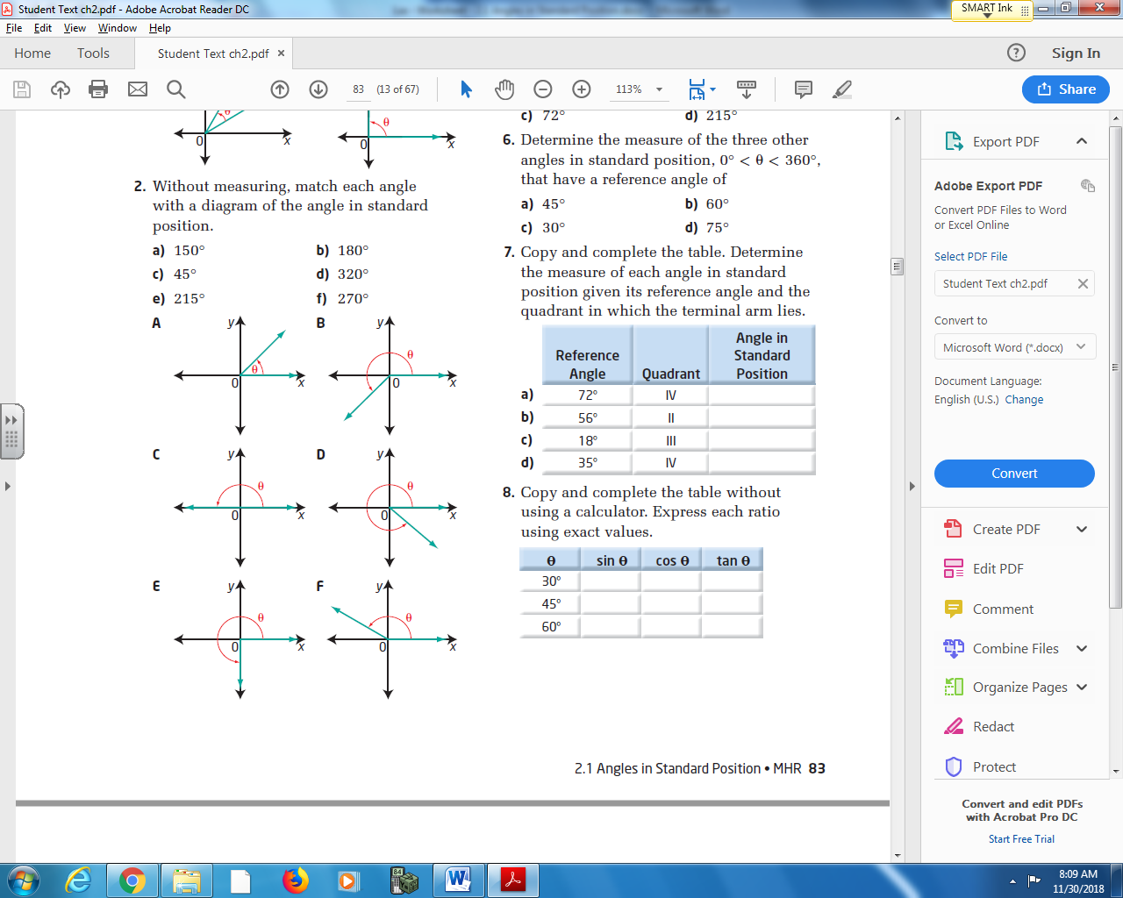

Pg 83 #3: In which quadrant does the terminal arm of each angle in standard position lie?
- 48⁰ b. 300⁰

- 185⁰ d. 75⁰

- 220⁰ f. 160⁰

Pg 83 #4: Sketch an angle in standard position with each given measure.
- 70⁰ b. 310⁰ c. 225⁰ d. 165⁰
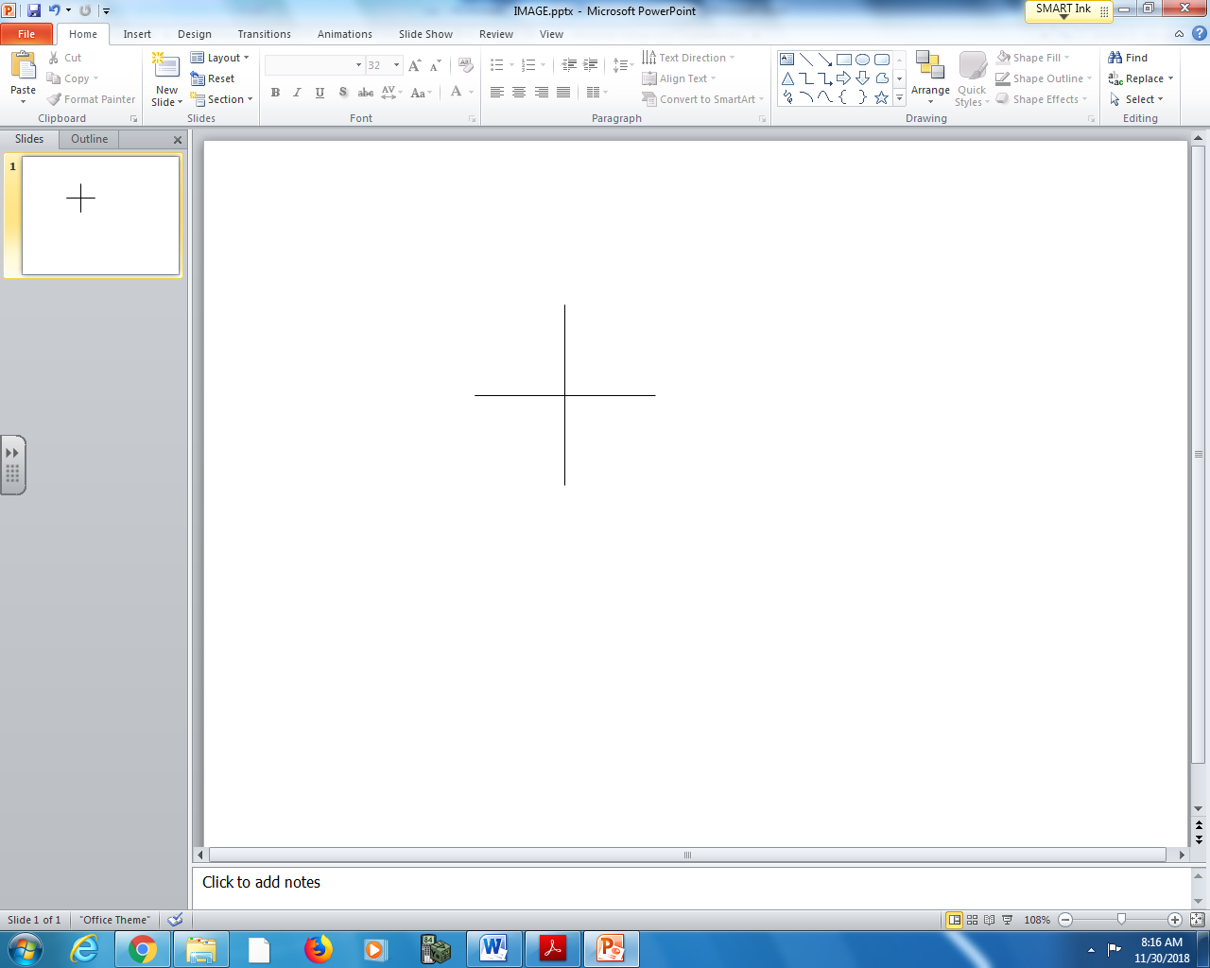

Pg 83 #5: What is the reference angle for each angle in standard position?
- 170⁰ b. 345⁰ c. 72⁰ d. 215⁰

Pg 83 #6: Determine the measure of the three other angles in standard position, 0⁰ < θ < 360⁰, that have a reference angle of
- 45⁰ b. 60⁰ c. 30⁰ d. 75⁰

Pg 83 #7: Determine the measure of each angle in standard position given its reference angle and the quadrant in which the terminal arm lies.
Reference Angle | 72⁰ | 56⁰ | 18⁰ | 35⁰
Quadrant | IV | II | III | IV
Diagram
Angle in Standard Position

Pg 83 #8: Complete the table without using a calculator. Express each ratio using exact values.
θ | Sin θ | Cos θ | Tan θ
30⁰
45⁰
60⁰

Pg 83 #11: A windshield wiper has a length of 50 cm. The wiper rotates from its resting position at 30⁰, in standard position, to 150⁰. Determine the exact horizontal distance that the tip of the wiper travels in one swipe.
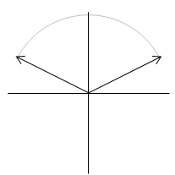

Pg 83 #13: A 10-m boom lifts material onto a roof in need of repair. Determine the exact vertical displacement of the end of the boom when the operator lowers it from 60⁰ to 30⁰.
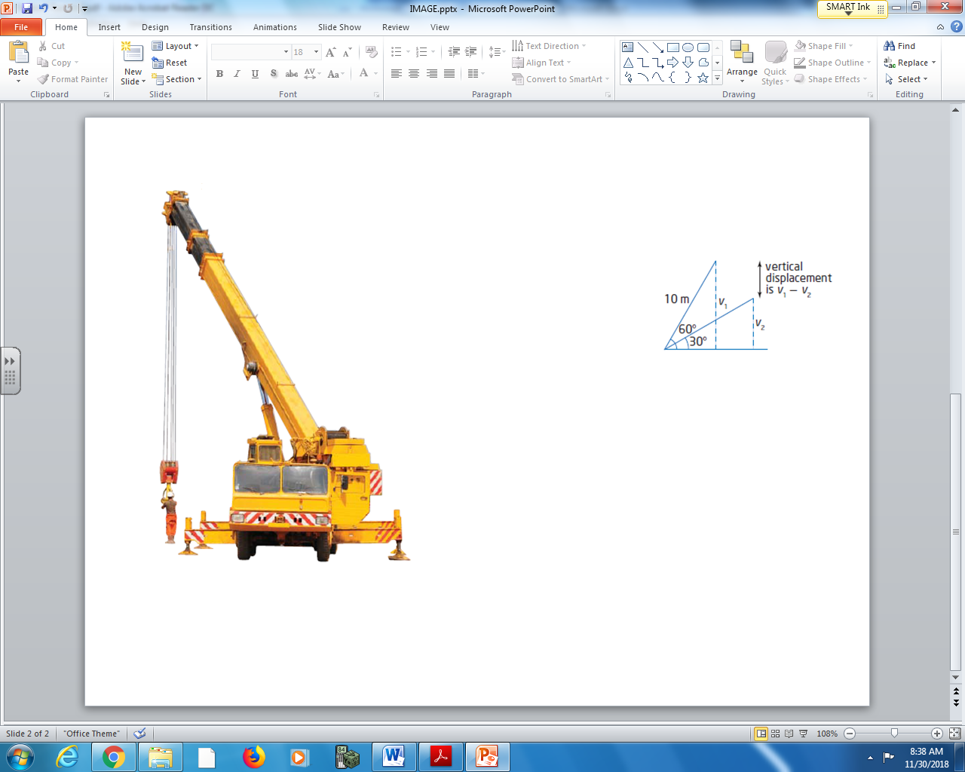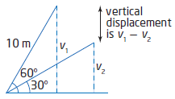

Pg 83 #20: Carl and a friend are on the Antique Ferris Wheel Ride at Callaway Park in Calgary. The ride stops to unload the riders. Carl’s seat forms an angle of 72⁰ with a horizontal axis running through the center of the Ferris wheel.
- If the radius of the Ferris wheel is 9 m and the center of the wheel is 11 m above the ground, determine the height of Carl’s seat above the ground.
- Suppose the Ferris wheel travels at four revolutions per minute and the operator stops the ride in 5 s.
  - Determine the angle in standard position of the seat that Carl is on at this second stop. Consider the horizontal central axis to be the x-axis.
  - Determine the height of Carl’s seat at the second stop.
