L49 – FQ – 2.1 Angles in Standard Position
Q1: (a) Draw an angle of 220⁰. (1 mark)
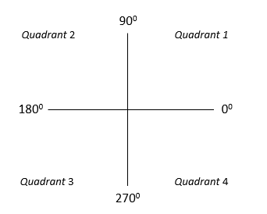
(b) Which quadrant is the terminal arm located in? (1 mark)
(c) What is the reference angle? (1 mark)

Use the following information to answer Q2:
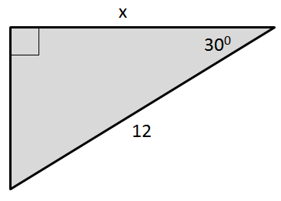

Q2: Determine the exact value of x. (3 marks)

MARKING:
Beginning 0.0 – 2.5
Progressing 3.0 – 4.0
Competent 4.5 – 5.5
Exemplary 6.0

