L49 – 2.2 Trigonometric Ratios of Any Angle
Key Ideas
The 30⁰-60⁰-90⁰ and 45⁰-45⁰-90⁰ special triangles will be used again in this lesson.
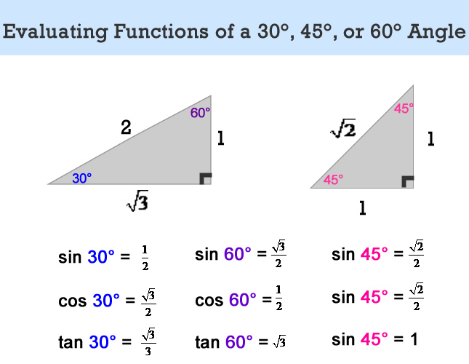
This time, however, the orientation of the triangle matters.
- Terminal arms to the right of the origin will have positive x-values (i.e. “adjacent sides”)
- Terminal arms to the left of the origin will have negative x-values (i.e. “adjacent sides”)
- Terminal arms above the origin will have positive y-values (i.e. “opposite sides”)
- Terminal arms below the origin will have negative y-values (i.e. “opposite sides”)
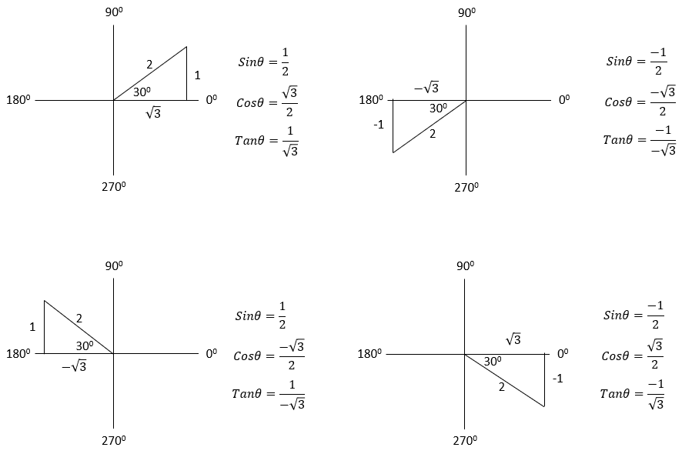
Part 1 – Determine Exact Value of Trig Ratios (Quadrant 1 Only)
Q1: Determine the trigonometric ratios for each triangle.
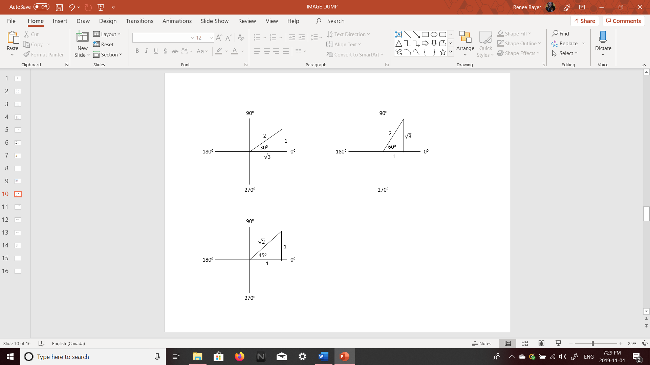

Part 2 – Determine Exact Value of Trig Ratios (All Quadrants)
Q2: Determine the trigonometric ratios for each triangle.
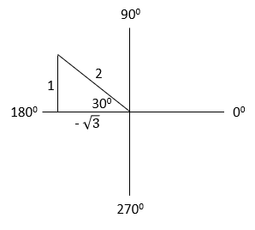

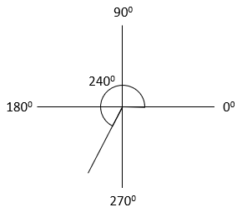

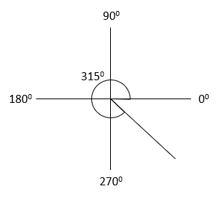

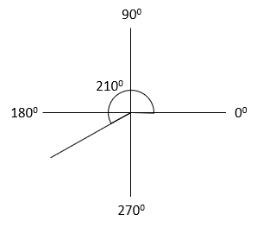

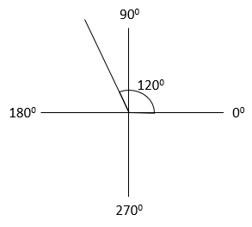

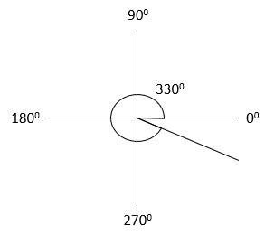

Part 3 – Determine Exact Value of Trig Ratios (non-Special Triangles)
Q3: Determine the exact values of Sin θ, Cos θ, and Tan θ if the terminal arm of an angle in standard position passes through the given point.
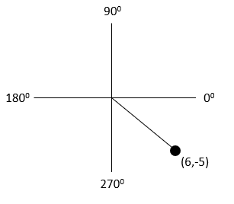

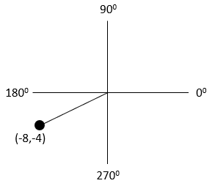

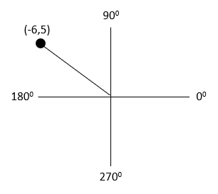

Part 4 – Solving a Trig Ratio
Q4: Solve each equation, for $0≤θ<360 deg$ , using a diagram involving a special right triangle.
 | Sketch of Angle in Standard Position | Sketch of Special Right Triangle | Solution to Equation
$$Tanθ=\frac{1}{\sqrt{3}}$$ | 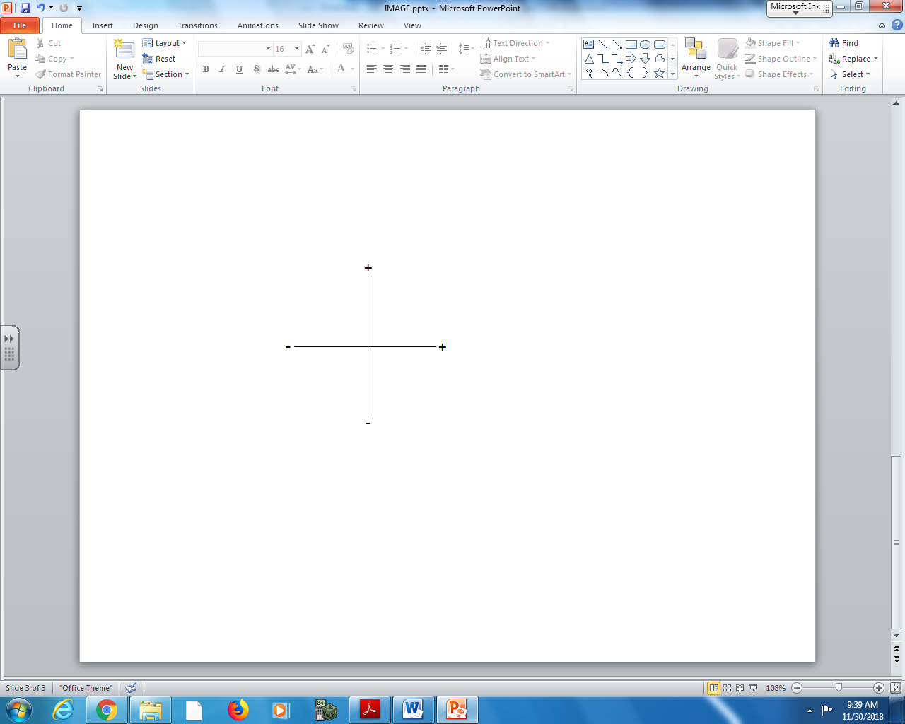
$$Cosθ=-\frac{1}{2}$$
$$Sinθ=\frac{1}{2}$$
$$Cosθ=-\frac{1}{\sqrt{2}}$$
$$Tanθ=-1$$

