L49 – Worksheet – 2.2 Trigonometric Ratios of Any Angle
Part 1 – Quick Review of Concepts
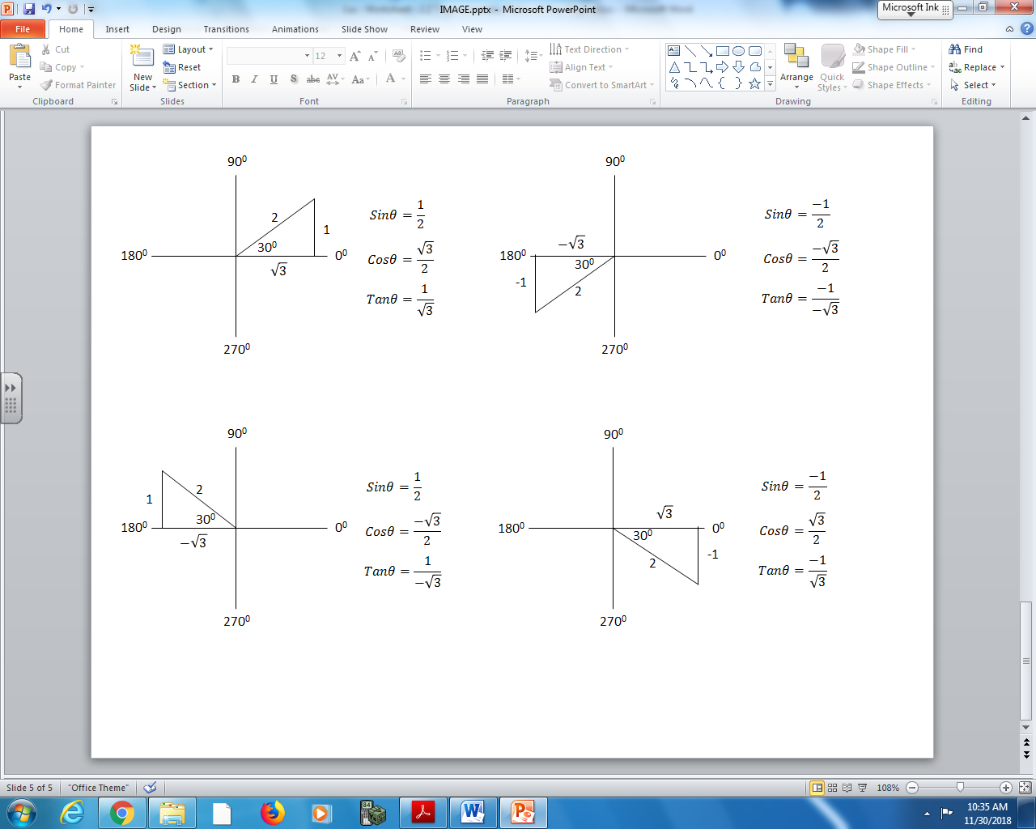

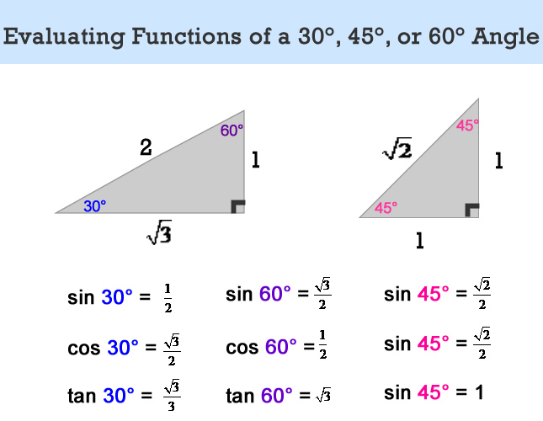
Part 2 – Textbook Questions
Pg 96 #2: Determine the exact values of the sine, cosine, and tangent ratios for each angle.
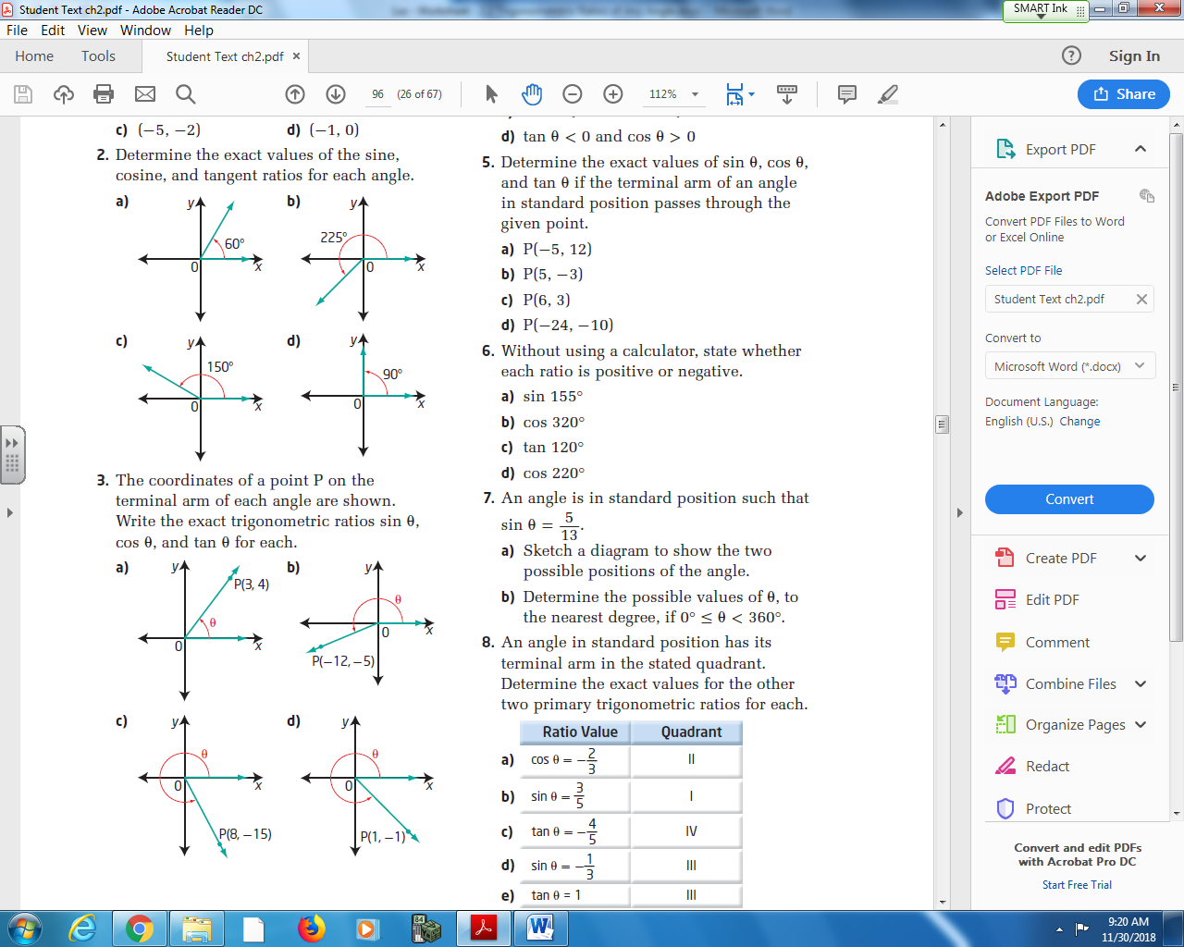

Pg 96 #3: The coordinate of a point P on the terminal arm of each angle are shown. Write the exact trigonometric ratios of sin θ, cos θ and tan θ for each.
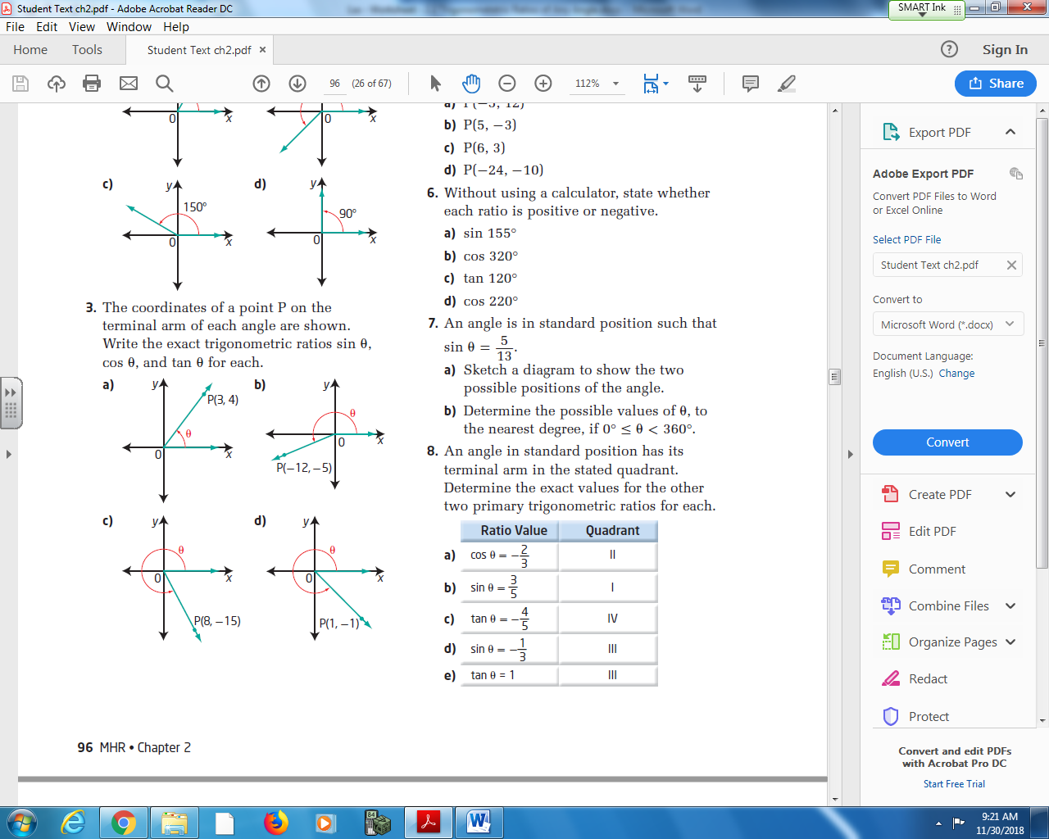

Pg 96 #4ab: For each description, in which quadrant does the terminal arm of the angle θ lie?
Cos θ < 0 and Sin θ > 0 Cos θ > 0 and Tan θ > 0

Pg 96 #4cd: For each description, in which quadrant does the terminal arm of the angle θ lie?
Sin θ < 0 and Cos θ < 0 Tan θ < 0 and Cos θ > 0

Pg 96 #5ab: Determine the exact values of Sin θ, Cos θ, and Tan θ if the terminal arm of an angle in standard position passes through the given point.
P (-5,12) P (5,-3)

Pg 96 #5cd: Determine the exact values of Sin θ, Cos θ, and Tan θ if the terminal arm of an angle in standard position passes through the given point.
P (6,3) P (-24,-10)

Pg 96 #7: An angle is in standard position such that $Sin θ=\frac{5}{13}$
- Sketch a diagram to show the two possible positions of the angle.
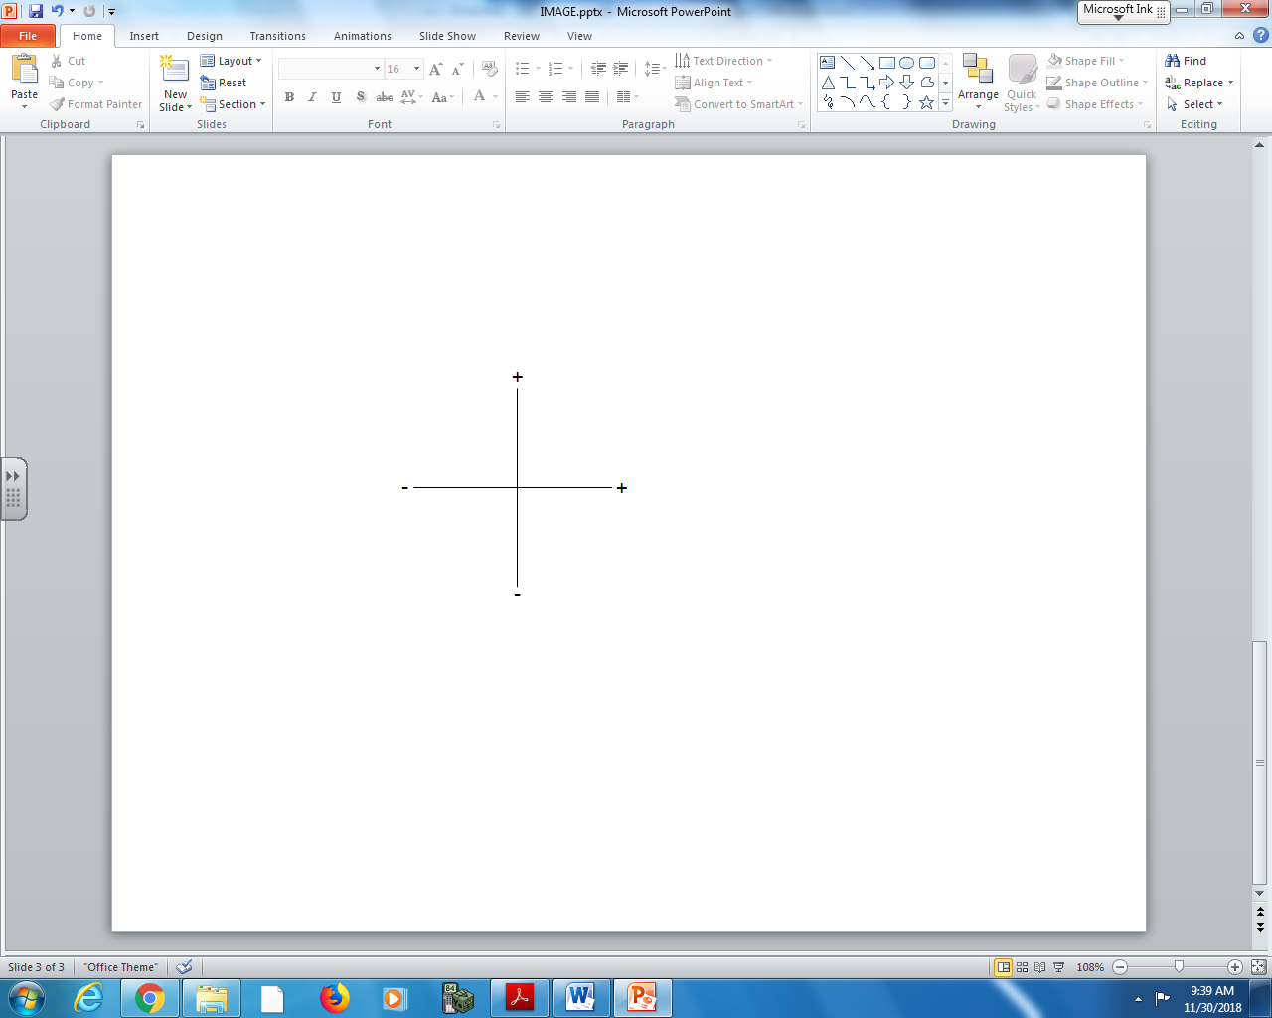
- Determine the possible values of θ, to the nearest degree, if $0≤θ<360 deg.$

Pg 96 #9abcde: Solve each equation, for $0≤θ<360 deg$ , using a diagram involving a special right triangle.
 | Sketch of Angle in Standard Position | Sketch of Special Right Triangle | Solution to Equation
$$Cosθ=\frac{1}{2}$$
$$Cosθ=-\frac{1}{\sqrt{2}}$$
$$Tanθ=-\frac{1}{\sqrt{3}}$$
$$Sinθ=-\frac{\sqrt{3}}{2}$$
$$Tanθ=\sqrt{3}$$

Pg 96 #11: Determine the values of x, y, r, sin θ, cos θ, and tan θ in each.
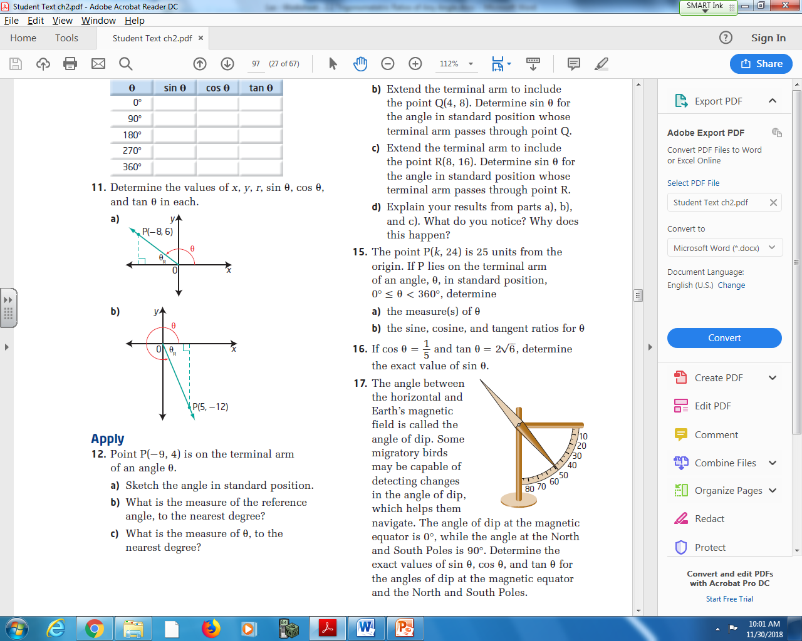

Pg 96 #16: If $\cos{θ=\frac{1}{5}}$ and $tanθ=2\sqrt{6}$, determine the exact value of sin θ.

Pg 96 #18ab: Without using technology, determine whether each statement is true or false. Justify your answer.
Sin 151⁰ = Sin 29⁰ Cos 135⁰ = Sin 225⁰

Pg 96 #18cd: Without using technology, determine whether each statement is true or false. Justify your answer.
Tan 135⁰ = Tan 225⁰ Sin 60⁰ = Cos 330⁰

