L50 – FQ – 2.2 Trigonometric Ratios of Any Angle
Q1: Label all angles and sides on the 45-45-90⁰ and 30-60-90⁰ special triangles. (2 marks)
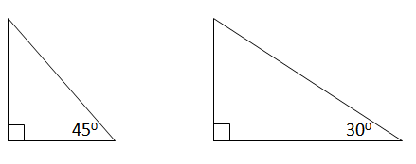

Q2: Determine the exact value for the Sin 120⁰ ratio. (1 mark)
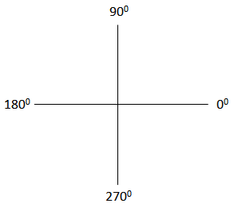

Q3: Solve $Cosθ=\frac{1}{2}$ equation, for $0≤θ<360 deg$ , using a diagram involving a special right triangle.
(2 marks)
MARKING:
Beginning 0.0 – 2.0
Progressing 2.5 – 3.5
Competent 4.0 – 4.5
Exemplary 5.0

