First Name:______________________________ Last Name:______________________________
L50 – FQ – 9.2 Elimination
Use the following information to answer Q1-Q3:
$$2x-3y+19=0$$
$$y=-x-2$$

Q1: Solve the system of equations using elimination: (3 marks)

Q2: Solve the system of equations using substitution: (3 marks)

Use the following information to answer Q1-Q3:
$$2x-3y+19=0$$
$$y=-x-2$$

Q3: Solve the system of equations using graphing: (3 marks)
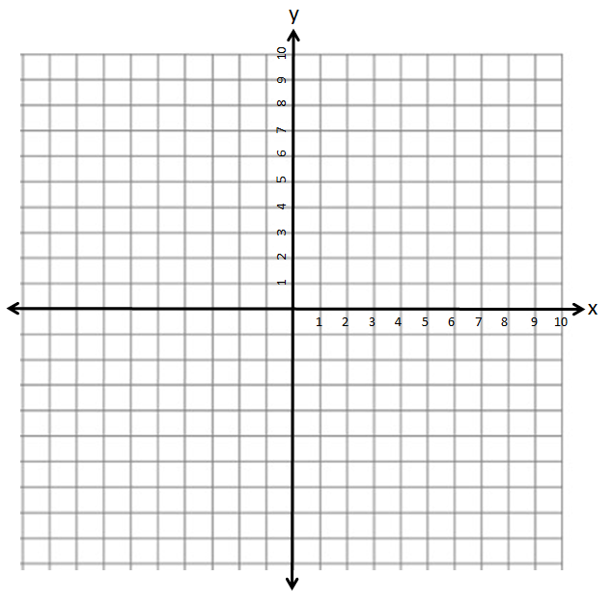

MARKING:
Beginning 0.0 – 4.0
Progressing 4.5 – 6.5
Competent 7.0 – 8.5
Exemplary 9.0

