L50 – 2.3 Sine Law
Key Ideas
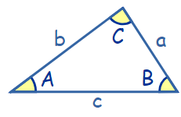
Sine Law:
$\frac{SinA}{a}=\frac{Sin B}{b}=\frac{Sin C}{c}$ or $\frac{a}{Sin A}=\frac{b}{Sin B}=\frac{c}{Sin C}$

“AmbiguouS caSe” – This only happens in the “Angle-Side-Side” case, where we know two sides and an angle not between them. For example, in the diagram below, if we know ∠A , b, and a, this is a case of “Angle-Side-Side” resulting in an AmbiguouS caSe with two possible solutions.
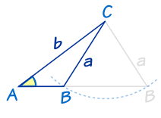
The solutions to the AmbiguouS caSe for ∠C will be:
Don’t do the “180-θ” thing for the angle between the two known sides.
- ∠C₁ = θ (the value you solved for)
- ∠C₂ = 180⁰ – θ

Part 1 – Solving for a Side
Q1: Find the length of x. Q2: Find the length of a. Q3: Find the length of AC
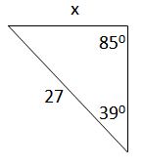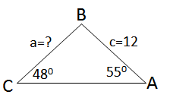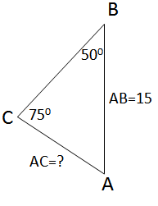

Part 2 – Solving for an Angle (Easy)
Q4: Solve for θ. Q5: Solve for ∠B. Q6: Solve for ∠ABC.
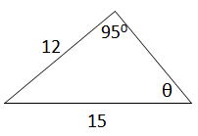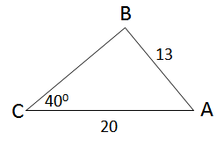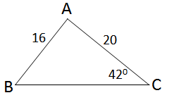

Part 3 – Solving for an Angle (Harder – 180deg in a Triangle)
Q7: Solve for x. Q8: Solve for ∠A.
.
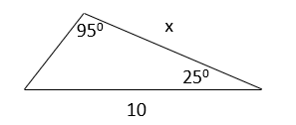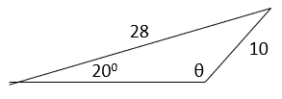

Part 4 – Solving for an Angle (Hardest – AmbiguouS caSe, Angle-Side-Side)
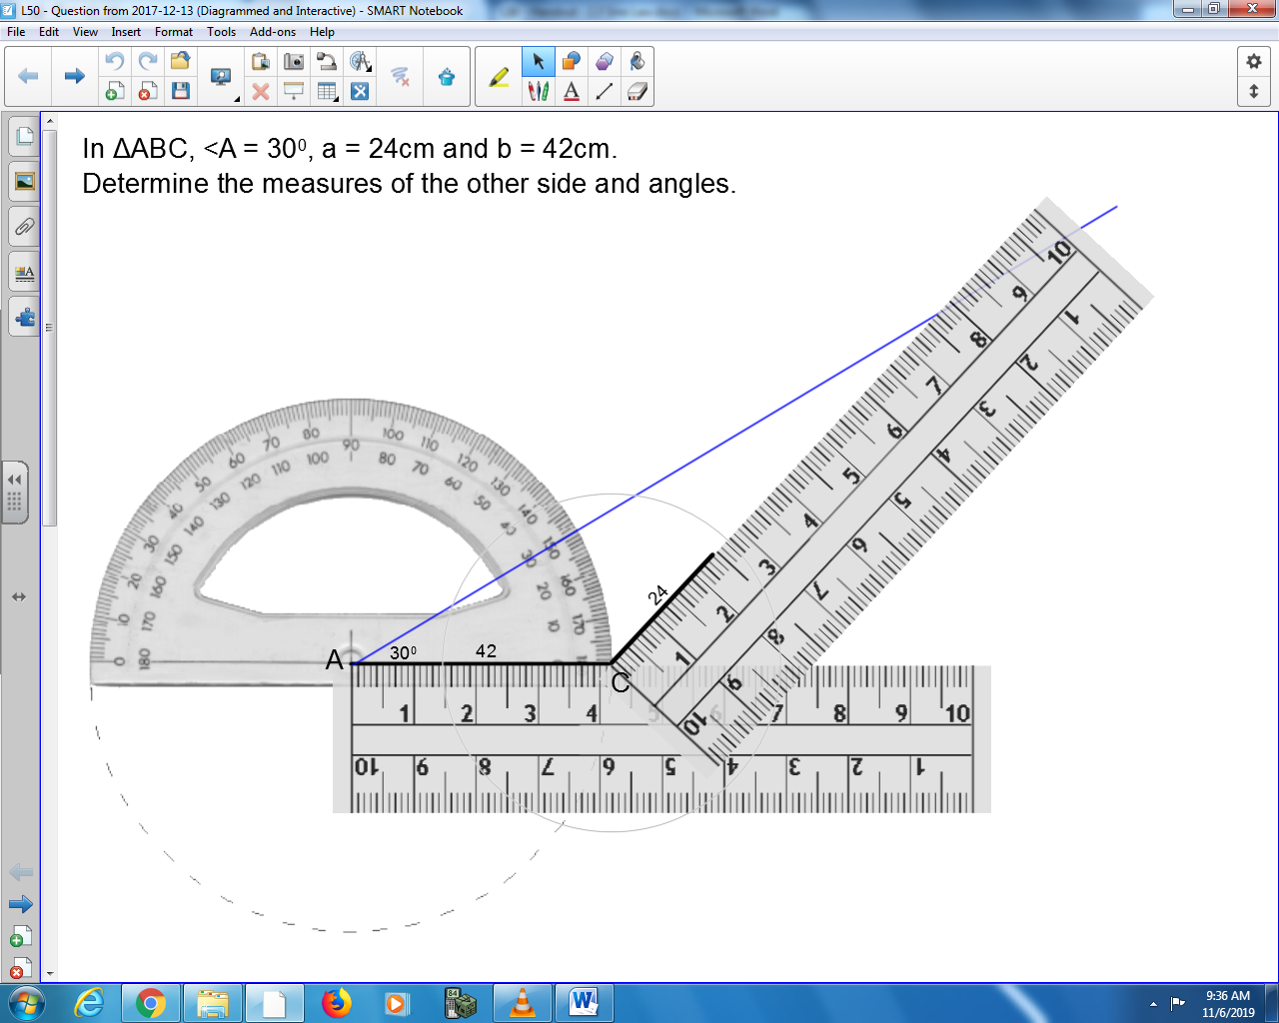
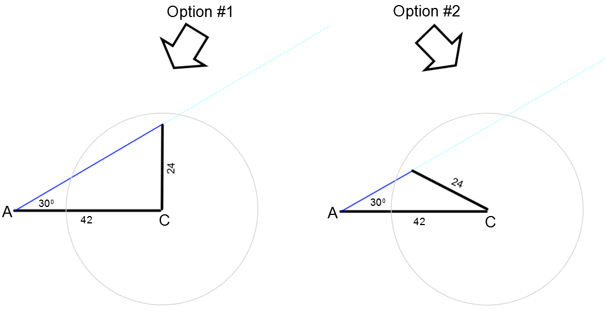
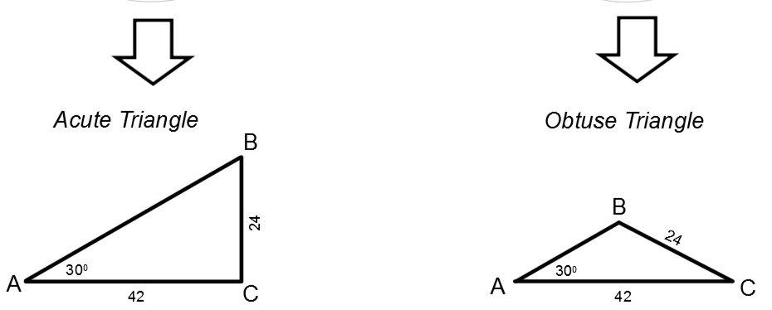
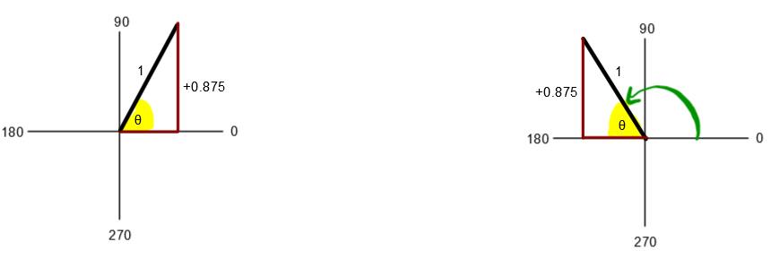
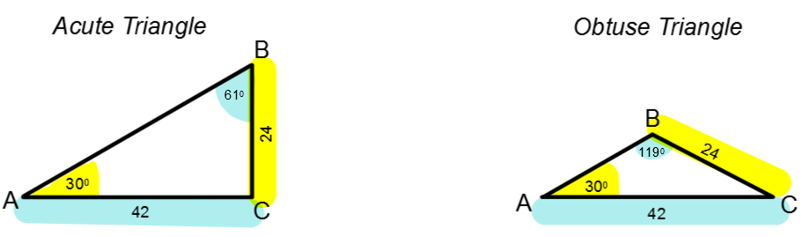

Use the following information to answer Q9:
In triangle ΔABC, side AB=12, side AC=15, and ∠C=40⁰.

Q9: Determine the value(s) of ∠B.

Part 5 – Derivation of Sine Law
Q10: Derive the Sine Law.
