L50 – Worksheet – 2.3 The Sine Law
Part 1 – Sine Law Overview
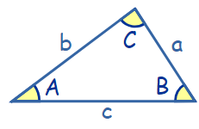
Sine Law:
$\frac{SinA}{a}=\frac{Sin B}{b}=\frac{Sin C}{c}$ or $\frac{a}{Sin A}=\frac{b}{Sin B}=\frac{c}{Sin C}$

“AmbiguouS caSe” – This only happens in the “Angle-Side-Side” case, where we know two sides and an angle not between them. For example, in the diagram below, if we know ∠A , b, and a, this is a case of “Angle-Side-Side” resulting in an AmbiguouS caSe with two possible solutions.
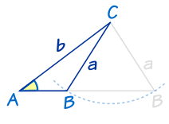
The solutions to the AmbiguouS caSe for ∠C will be:
Don’t do the “180-θ” thing for the angle between the two known sides.
- ∠C₁ = θ (the value you solved for)
- ∠C₂ = 180⁰ – θ
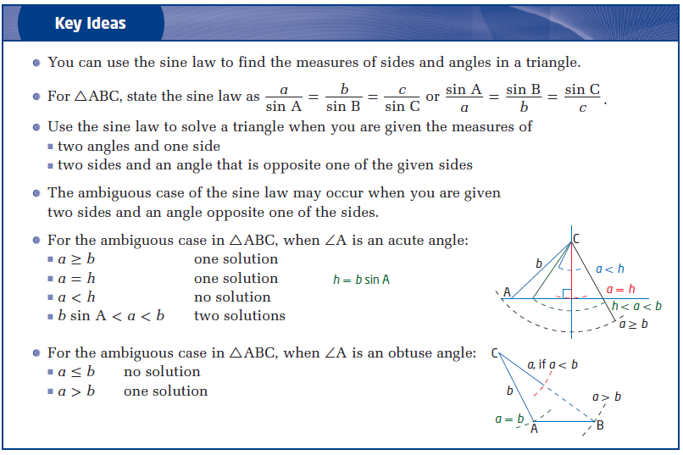
Part 2 – Textbook Questions
Pg 108 #2: Determine the length of AB in each.
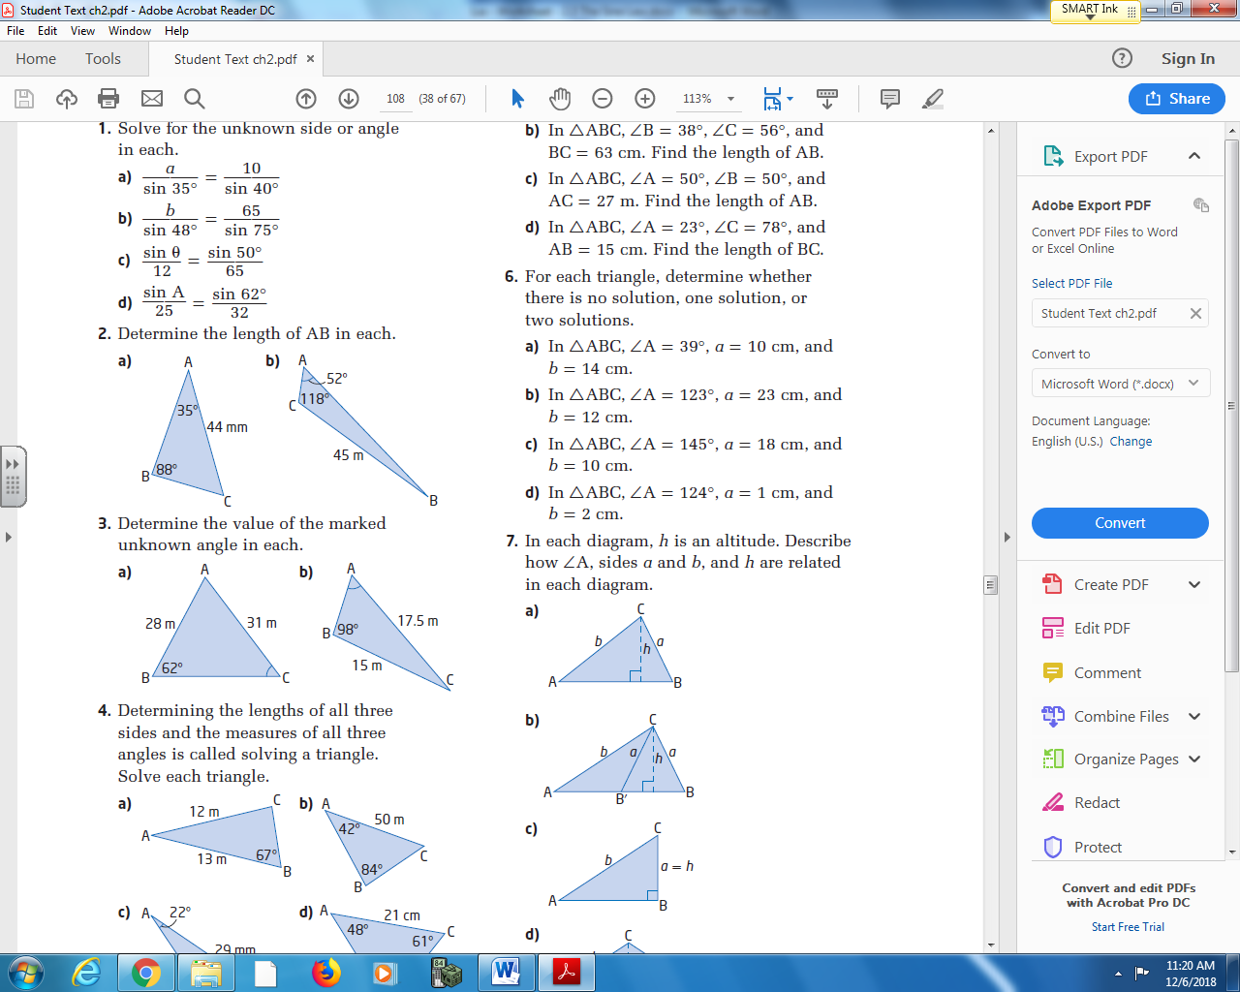

Pg 108 #4a: Determining the lengths of all three sides and the measure of all three angles is called solving a triangle. Solve each triangle.
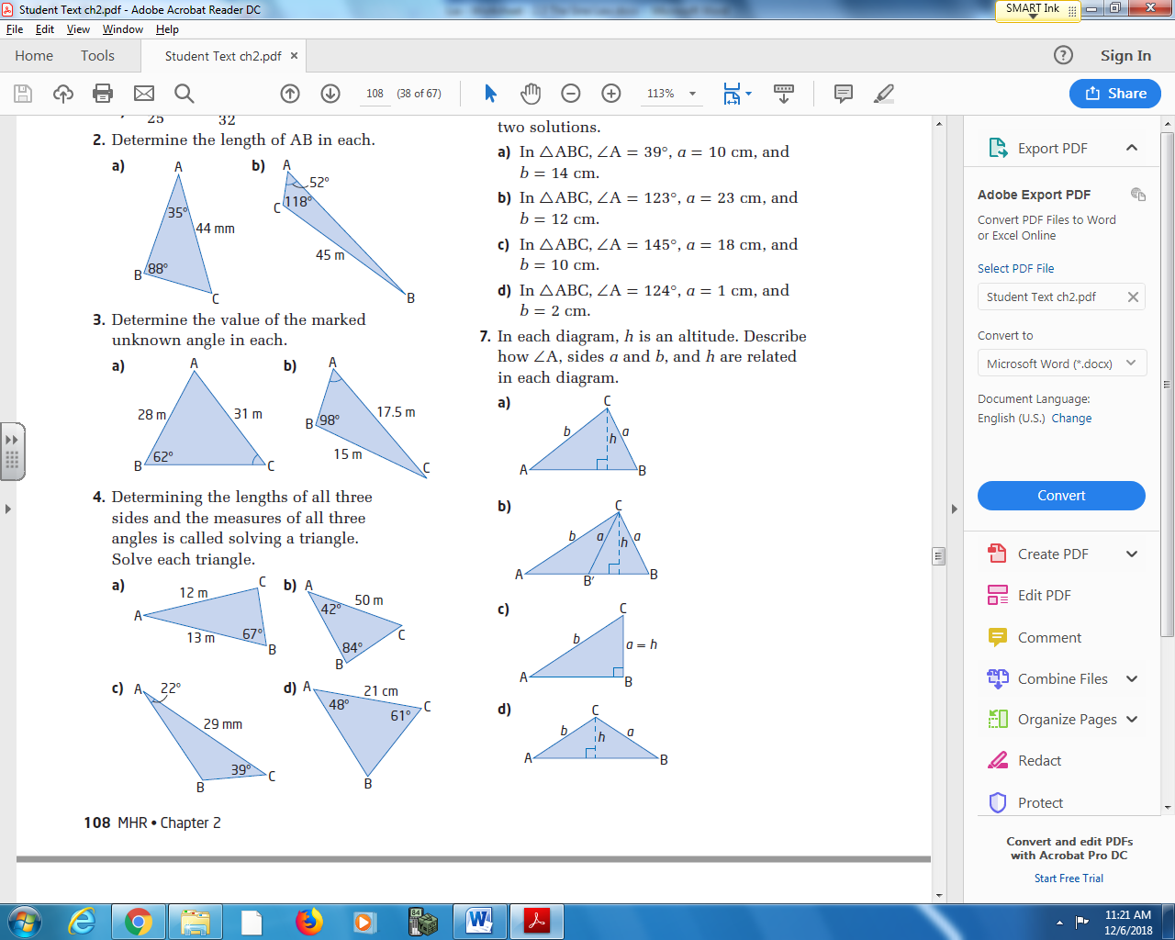

Pg 108 #4cd: Determining the lengths of all three sides and the measure of all three angles is called solving a triangle. Solve each triangle.

Pg 108 #5ab: Sketch each triangle. Determine the measure of the indicated side.
In ΔABC, ∠A = 57⁰, ∠B = 73⁰, and AB = 24cm. In ΔABC, ∠B = 38⁰, ∠C = 56⁰, and BC = 63cm.
Find the length of AC. Find the length of AB.

Pg 108 #5cd: Sketch each triangle. Determine the measure of the indicated side.
In ΔABC, ∠A = 50⁰, ∠B = 50⁰, and AC = 27cm. In ΔABC, ∠A = 23⁰, ∠C = 78⁰, and AB = 15cm.
Find the length of AB. Find the length of BC.

Pg 108 #6ab: For each triangle, determine whether there is no solution, one solution, or two solutions.
In ΔABC, ∠A = 39⁰, a = 10cm, and b = 14cm. In ΔABC, ∠A = 123⁰, a = 23cm, and b = 12cm.

Pg 108 #6cd: For each triangle, determine whether there is no solution, one solution, or two solutions.
In ΔABC, ∠A = 145⁰, a = 18cm, and b = 10cm. In ΔABC, ∠A = 124⁰, a = 1cm, and b = 2cm.

Pg 108 #8ab: Determine the unknown side and angles in each triangle. If two solutions are possible, give both.
In ΔABC, ∠C = 31⁰, a = 5.6cm, and c = 3.9cm. In ΔPQR, ∠Q = 43⁰, p = 20cm, and q = 15cm.

Pg 108 #8c: Determine the unknown side and angles in each triangle. If two solutions are possible, give both.
In ΔXYZ, ∠X = 53⁰, x = 8.5cm, and z = 12.3cm.

Pg 108 #11: The Canadian Coast Guard Pacific Region is responsible for more than 27,000 km of coastline. The rotating spotlight from the Coast Guard ship can illuminate up to a distance of 250 m. An observer on the shore is 500 m from the ship. His line of sight to the ship makes an angle of 20⁰ with the shoreline. What length of shoreline is illuminated by the spotlight?
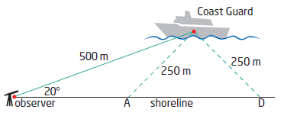

Pg 108 #14: From the window of his hotel in Saskatoon (well above the statue), Max can see statues of Chief Whitecap of the Whitecap First nation and John Lake, leader of the Temperance Colonists, who founded Saskatoon. The angle formed by Max’s lines of sight to the top and to the foot of the statue of Chief Whitecap is 3⁰. The angle of depression of Max’s line of sight to the top of the statue is 21⁰. The horizontal distance between Max and the front of the statue is 66m.
- Sketch a diagram to represent this problem.

- Determine the height of the statue of Chief Whitecap.

- Determine the line-of-sight distance from where Max is standing at the window to the foot of the statue.

Pg 108 #22: For each of the following, include a diagram in your solution.
- Determine the range of values side a can have so that ΔABC has two solutions if ∠A = 40⁰ and b = 50.0 cm.

- Determine the range of values side a can have so that ΔABC has no solutions if ∠A = 56⁰ and b = 125.7 cm.

- ΔABC has exactly one solution. If ∠A = 57⁰ and b = 73.7 cm, what are the values of side a for which this is possible?

