L51 – 2.4 Cosine Law
Key Ideas
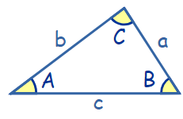
Sine Law:
$\frac{SinA}{a}=\frac{Sin B}{b}=\frac{Sin C}{c}$ or $\frac{a}{Sin A}=\frac{b}{Sin B}=\frac{c}{Sin C}$

Cosine Law:
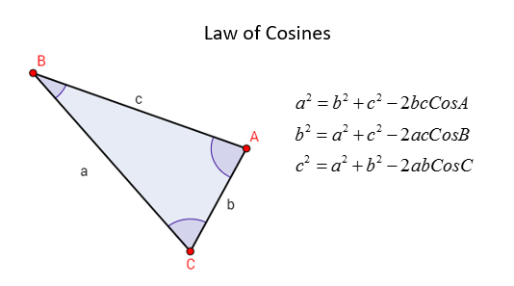
Part 1 – Solving for a Side
Q1: Solve for x. Q2: Solve for x.
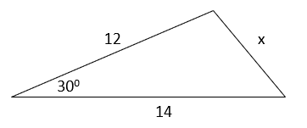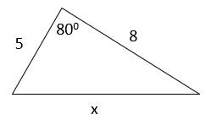

Part 2 – Solving for an Angle
Q3: Solve for θ. Q4: Solve for θ.
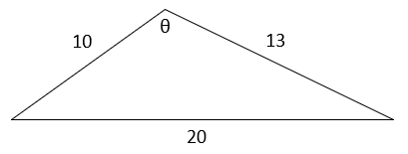
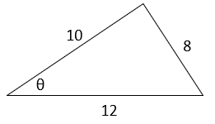

Part 3 – Solving a Triangle (Cosine Law, then Sine Law)
Q5: Solve the triangle.
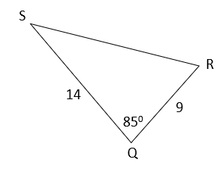

Part 4 – Derivation of Cosine Law
Q6: Derive the Cosine Law.
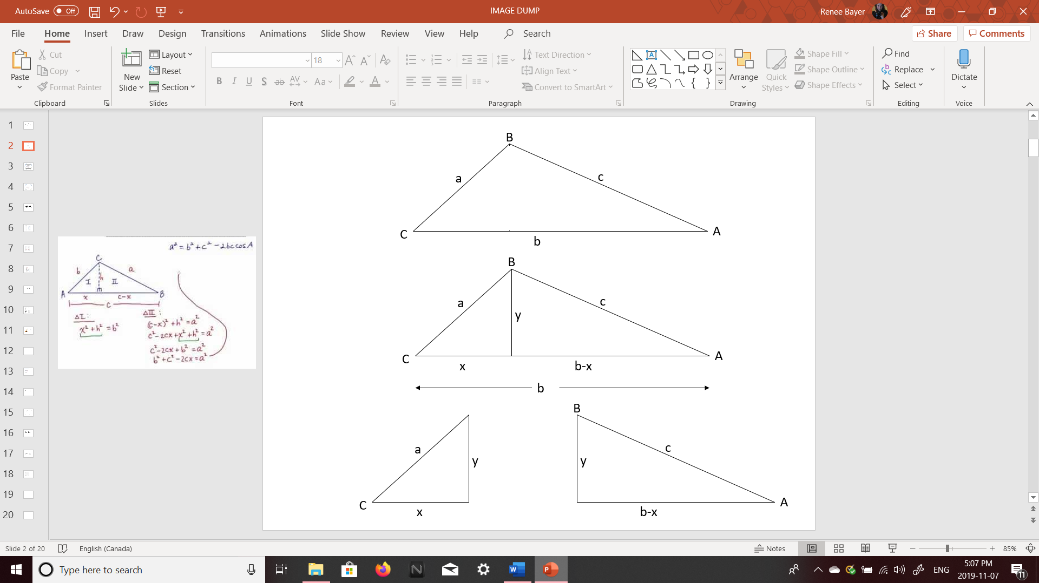
Step #1: Split the triangle into two.
Step #2: Perform Pythagoras Theorem on each triangle, solving for y². Set up the Cosine Ratio for the left triangle.

