L51 – Worksheet – 2.4 The Cosine Law
Part 1 – Overview of Sine Law and Cosine Law
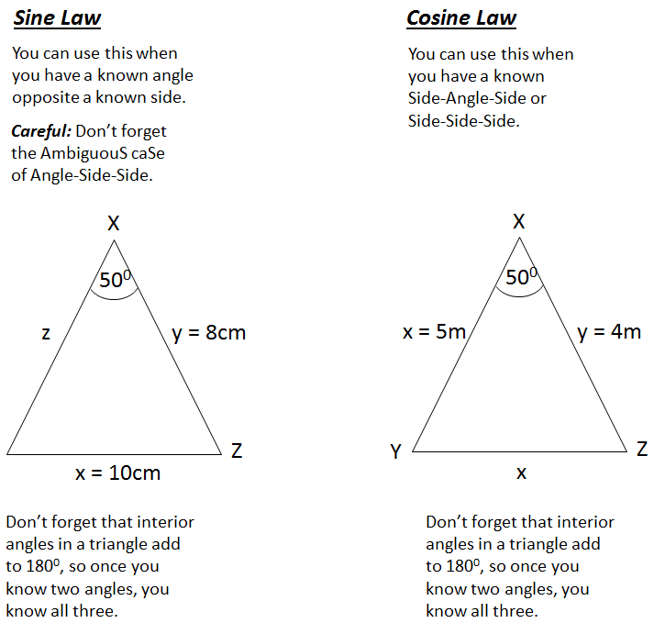

Part 2 – Textbook Questions
Pg 120 #3: Determine the lengths of the unknown sides and the measure of the unknown angles.
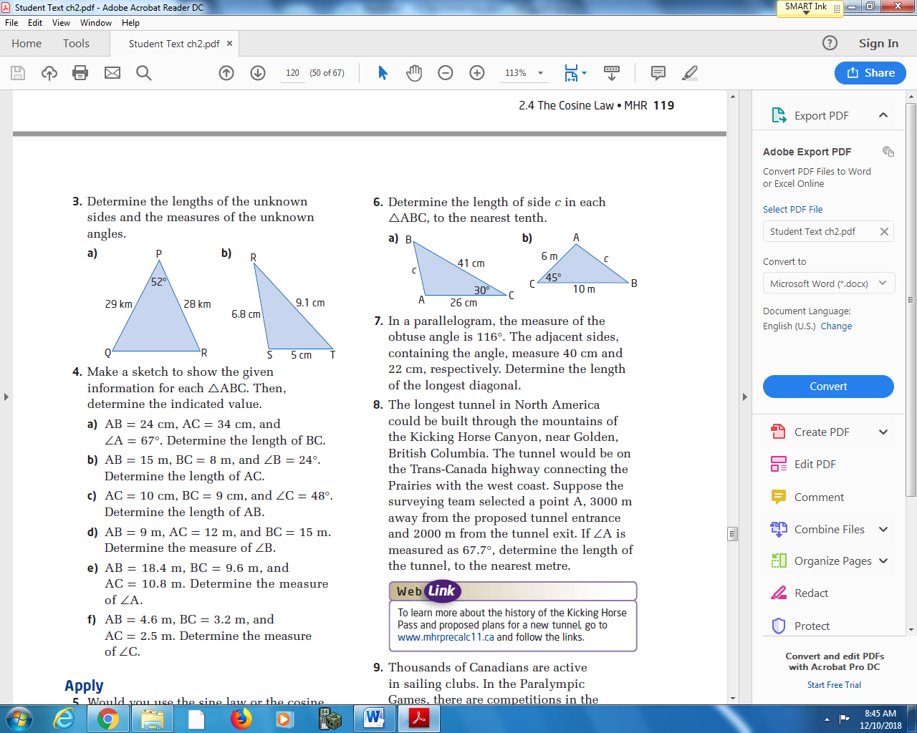

Pg 120 #4ace: Make a sketch to show the given information for each ΔABC. Then, determine the indicated value.
AB = 24cm, AC = 34cm, AC = 10cm, BC = 9cm, AB = 18.4m, BC = 9.6m,
and ∠A = 67⁰. Determine and ∠C = 48⁰. Determine and AC = 10.8m. Determine
the length of BC. the length of AB. The measure of ∠A.

Pg 120 #5: Would you use the sine law or the cosine law to determine each indicated side length or angle measure? Give reasons for your choice.
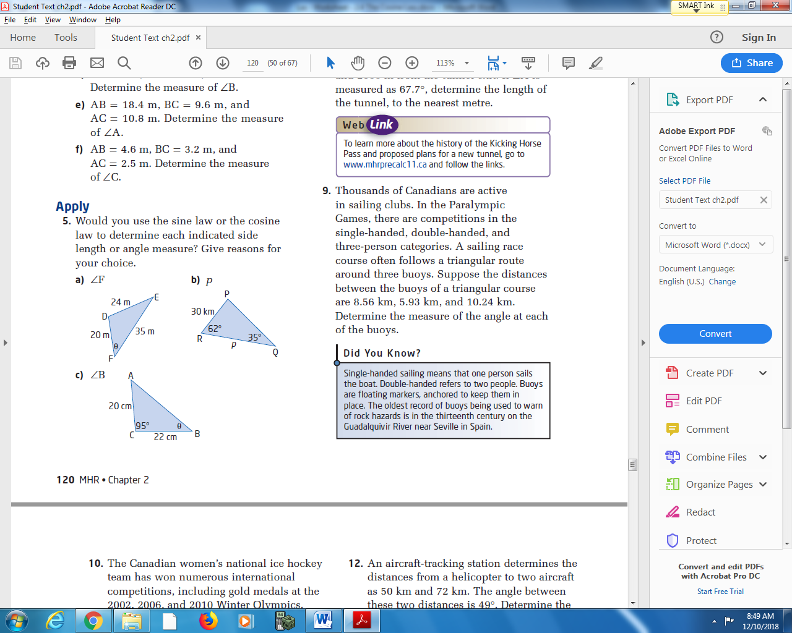

Pg 120 #8: The longest tunnel in North America could be built through the mountains of the Kicking Horse Canyon, near Golden, British Columbia. The tunnel would be on the Trans-Canada highway connecting the Prairies with the west coast. Suppose the surveying team selected a point A, 3000 m away from the proposed tunnel entrance and 2000 m from the tunnel exit. If ∠A is measured as 67.7⁰, determine the length of the tunnel, to the nearest meter.

Pg 120 #10: The Canadian women’s national ice hockey team has won numerous international competitions, including gold metals at the 2002, 2006, and 2010 Winter Olympics. A player on the blue line shoots a puck towards the 1.83-m-wide net from a point 20.3 m from one goal post and 21.3 m from the other. Within what angle must she shoot to hit the net? Answer to the nearest tenth of a degree.
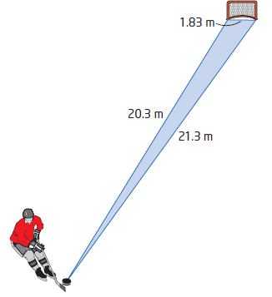

Pg 120 #15: A spotlight is 8 m away from a mirror on the floor. A beam of light shines into the mirror, forming an angle of 80⁰ with the reflected light. The light is reflected a distance of 7 m to shine onto a wall. Determine the distance from the spotlight to the point where the light is reflected onto the wall.
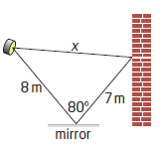

Pg 120 #23: Two ships leave port a 4pm. One is headed N38⁰E (38⁰ E of N) and is travelling at 11.5 km/h. The other is travelling at 13km/h, with a heading S47⁰E (47⁰ E of S). How far apart are the two ships at 6pm?
