L53 – FQ – Trigonometry Review
Use the following information to answer Q1:
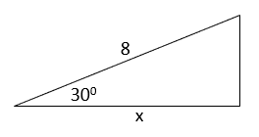

Q1: Determine the exact value of x. (1 marks)

Q2: Determine the exact values for the Sin 300⁰ and Cos 300⁰ ratios. (2 mark)
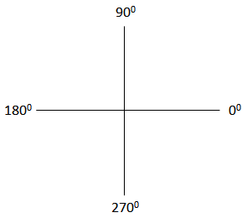

Q3: Solve $Sinθ=-\frac{1}{2}$ equation, for $0≤θ<360 deg$ , using a diagram involving a special right triangle.
(2 marks)

Use the following information to answer Q4:
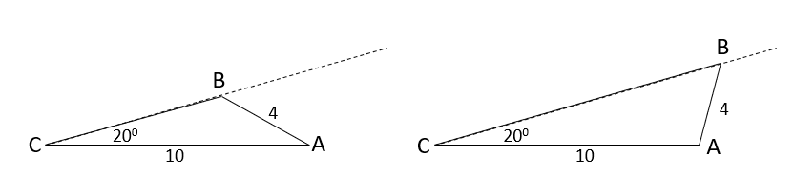
Q4: Determine the two possible values of ∠B. (2 marks)

Q5: Solve the triangle. (3 marks)
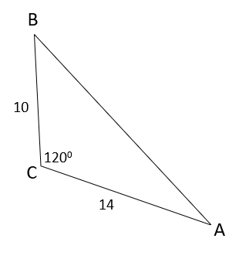

MARKING:
Beginning 0.0 – 4.5
Progressing 5.0 – 7.0
Competent 7.5 – 9.5
Exemplary 10.0

