First Name:__________________________ Last Name:______________________________

L54&55 – Worksheet – Chapter 6-9 Review /40 marks

Part 1: Graphing – Chapter 6 ___/8 marks
Part 2: Graphing – Chapter 7 ___/6 marks
Part 3: Graphing – Chapter 8&9 ___/6 marks
Part 4: Algebra – Chapter 6 ___/5 marks
Part 5: Algebra – Chapter 7 ___/8 marks
Part 6: Algebra – Chapter 8&9 ___/7 marks

(Checklist) What areas do I need to study?
Chapter 6 Chapter 7 Chapter 8&9
□ Linear and Non-Linear □ Slope y-Intercept □ Solving Systems using Graphs
□ Relations and Functions □ Slope-Point □ Solving Systems using Substitution
□ Domain and Range □ General Form □ Solving Systems using Elimination
□ Slope □ Converting Forms
(Notes) What types of questions do I need to ask for additional help understanding?

Part 1: Graphing – Chapter 6
Use the following information to answer Q1-Q4:
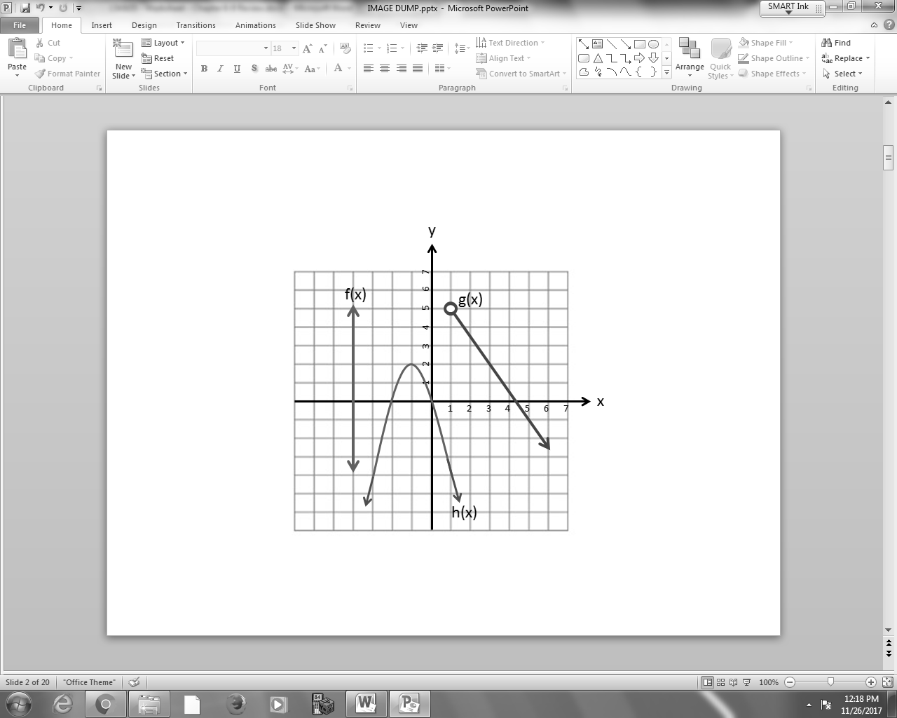

Q1: In the diagram above, there is/are __i__ linear relation(s), and __ii__ function(s) represented.
 | i | ii
A. | 1 | 1
B. | 1 | 2
C. | 2 | 1
D. | 2 | 2
Q2: Using Interval Notation, which best describes the Range of g(x)?
- (1,∞)
- [1,∞]
- (-∞,5)
- [-∞,5]
Q3: (Long Answer) Using Set Notation, give the Domain & Range of h(x). (2 marks)

Q4: (Long Answer) Determine the slope of g(x). (2 marks)

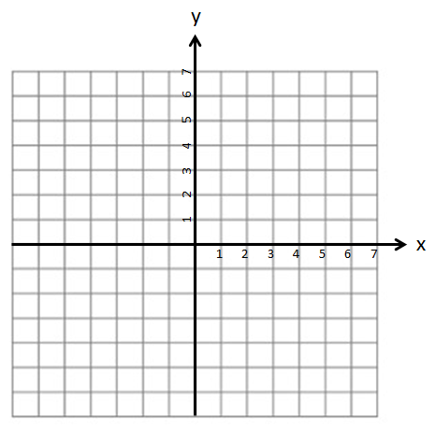
Q5: (Long Answer) Sketch a graph with the following constraints: (1 mark)
Domain: {x|-3 ≤ x ≤ 4, xƐR}
Range: {y| 2 ≤ y ≤ 5, yƐR}

Use the following information to answer Q6:
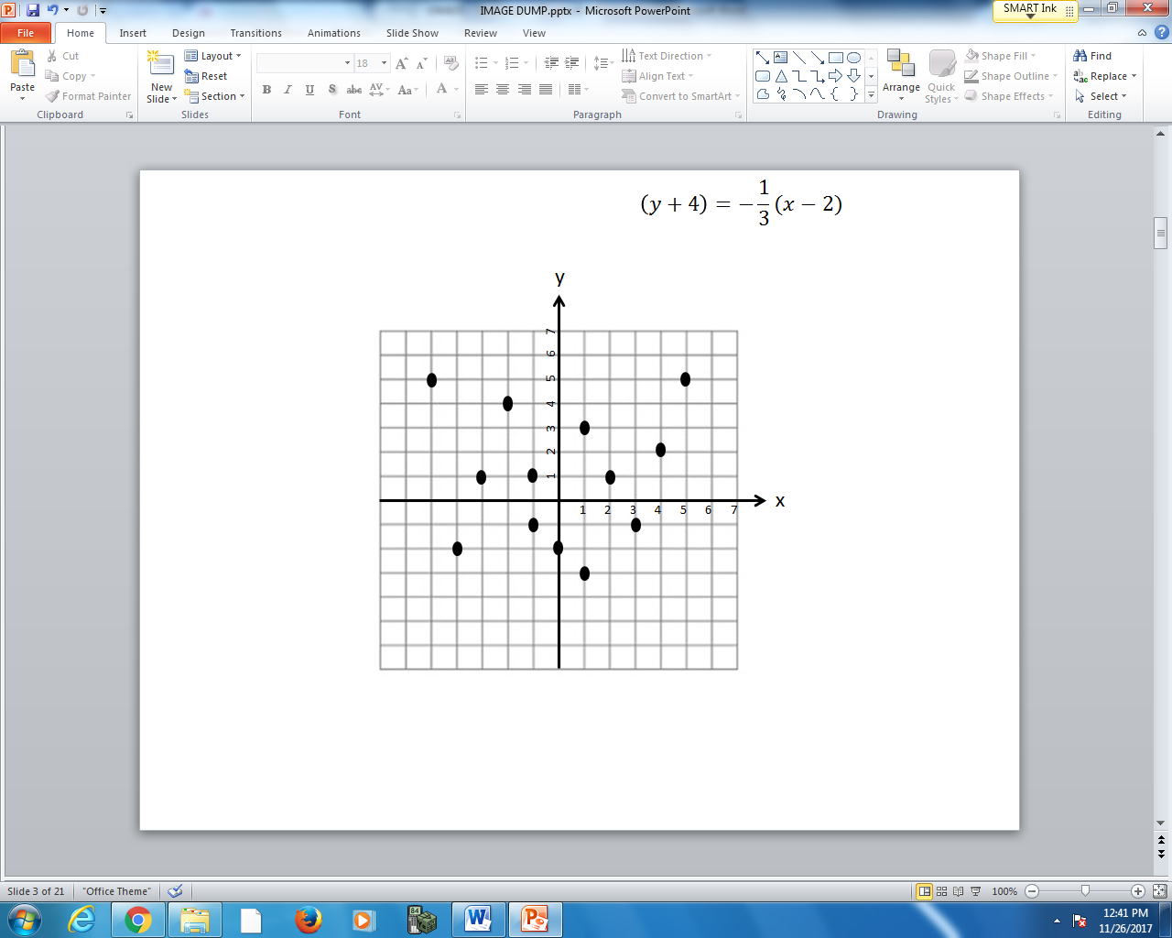
Domain: (-2,4]
Range: [-3,5]

Q6: How many data points are within the specified Domain and Range?
(Record your one digit answer in the Numerical Response boxes below)

Part 2: Graphing – Chapter 7
Use the following information to answer Q7-Q8:
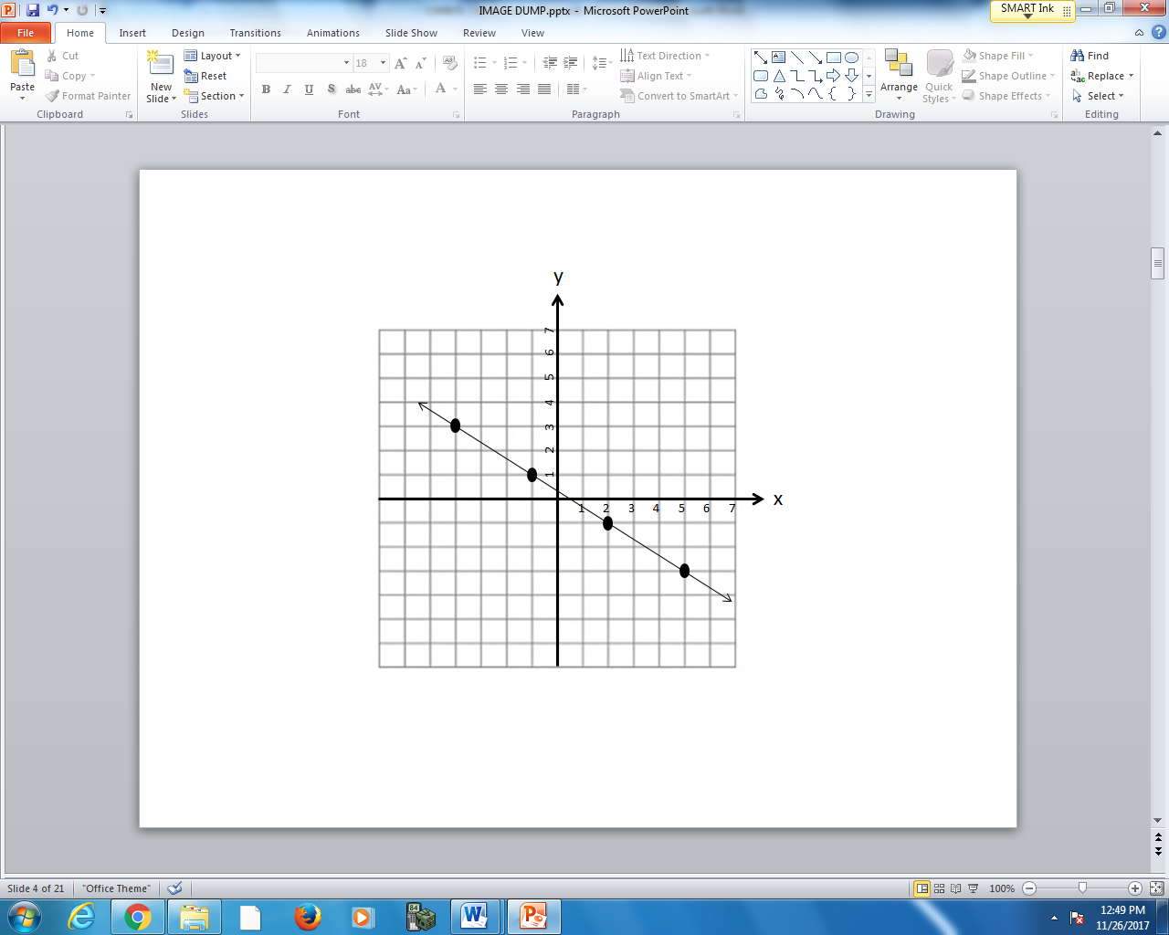

Q7: The equation, in Slope-Point Form, can be written in the form $\left(y-a\right)=-\frac{b}{c}\left(x+d\right)$ , where a, b, c, and d are ___, ___, ___, and ___.
(Record your four digit answer in the Numerical Response boxes below)

Q8: The equation, written in Slope y-Intercept Form is $y=-\frac{e}{f}x+\frac{g}{h}$ , where e, f, g and h are ___, ___, ___, and ___.
(Record your four digit answer in the Numerical Response boxes below)

Q9: (Long Answer) Graph the equation $5x-4y+20=0$ below. (2 marks).
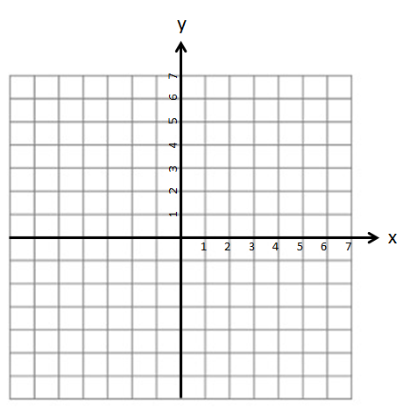
Q10: (Long Answer) Graph the line that is both perpendicular to $y=2x-5$ and passes through the point (4,5). (2 marks)

Part 3: Graphing – Chapter 8&9
Q11: (Long Answer) Find the solution to the system of equations via graphing. (3 marks)
$$3x-2y+12=0$$
$$y=-\frac{1}{2}x+2$$

Q12: (Long Answer) Find the solution to the system of equations via graphing. (3 marks)
$$y=\frac{5}{3}x+5$$
$$\left(y+3\right)=-1(x-2)$$

Part 4: Algebra – Chapter 6
Use the following information to answer Q13-Q15:
$f\left(x\right)=\frac{1}{2}x+3$ $g\left(x\right)=x^{2}+1$ $h\left(x\right)=-\frac{3}{2}x+5$

Q13: How many of the functions are linear?
- 0
- 1
- 2
- 3
Q14: What is f(8)= ?
(Record your one digit answer in the Numerical Response boxes below)

Q15: h(3) = $\frac{a}{b}$ , where a and b are ___ and ___.
(Record your two digit answer in the Numerical Response boxes below)

Q16: (Long Answer) A line passes through the points (-2,4) and (3,7). What is the slope of the line? (2 marks)

Part 5: Algebra – Chapter 7
Q17: (Long Answer) Write the equation of the line that passes through the points (4,-2) and (10,3) in Slope y-Intercept Form. (2 marks)

Q18: The equation $y=-\frac{1}{2}x+4$ can be written in the form A $+By-C=0$ , where A, B, and C are ___, ___, and ___.
(Record your three digit answer in the Numerical Response boxes below)

Q19: (Long Answer) A line is perpendicular to $3x-4y+10=0$ and passes through the point (4,8). Write the equation of the line in General Form. (2 marks)

Use the following information to answer Q20-Q21:
A Stettler resident leaves their home to travel to Red Deer. At 10 minutes they are 30km outside of town. At 20 minutes they are 45km outside of town.

Q20: (Long Answer) Calculate the slope and explain what it represents. (2 marks)

Q21: (Long Answer) Calculate the y-intercept and explain what it represents. (1 marks)

Part 6: Algebra – Chapter 8&9
Q22: (Long Answer) Solve the system of equations using Substitution. (2 marks)
$$2x+y+8=0$$
$$3x-4y+10=0$$

Q23: (Long Answer) A restaurant sells 2 hotdogs and 3 burgers for $12.80 to one customer, and 5 hotdogs and 1 burger for $11.85 to a second customer. What is the price of each hotdog and each burger? Solve using Elimination. (5 marks)

