L55 – Worksheet – Absolute Values, Reciprocal Functions, and Trigonometry
Part 1 – 7.1 Absolute Value
Q1: Evaluate the following expressions:
$|9-2(6)|$ $4-\left|5-11\right|$ $3+2\left|4-3^{2}\right|$

Q2: The expression $6-\left|7-3^{2}\right|$ evaluates to _____.
(Record your answer in the Numerical Response boxes below)

Part 2 – 7.2 Absolute Value Functions
Q3: Graph $y=\left|\frac{1}{2}x-1\right|$
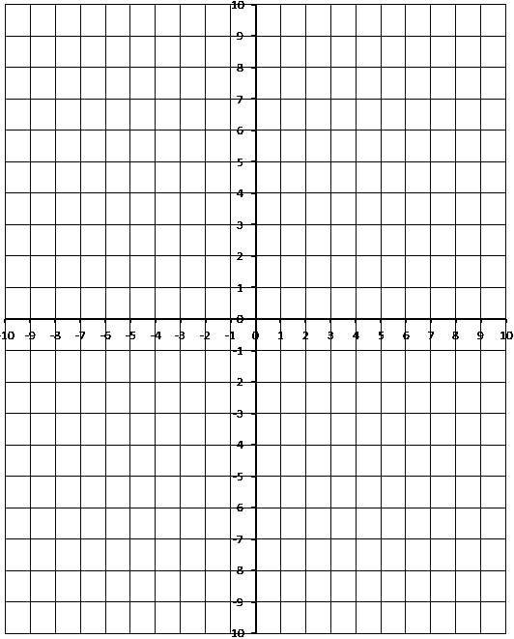
Use the following information to answer Q4:
A absolute value function is graphed below:
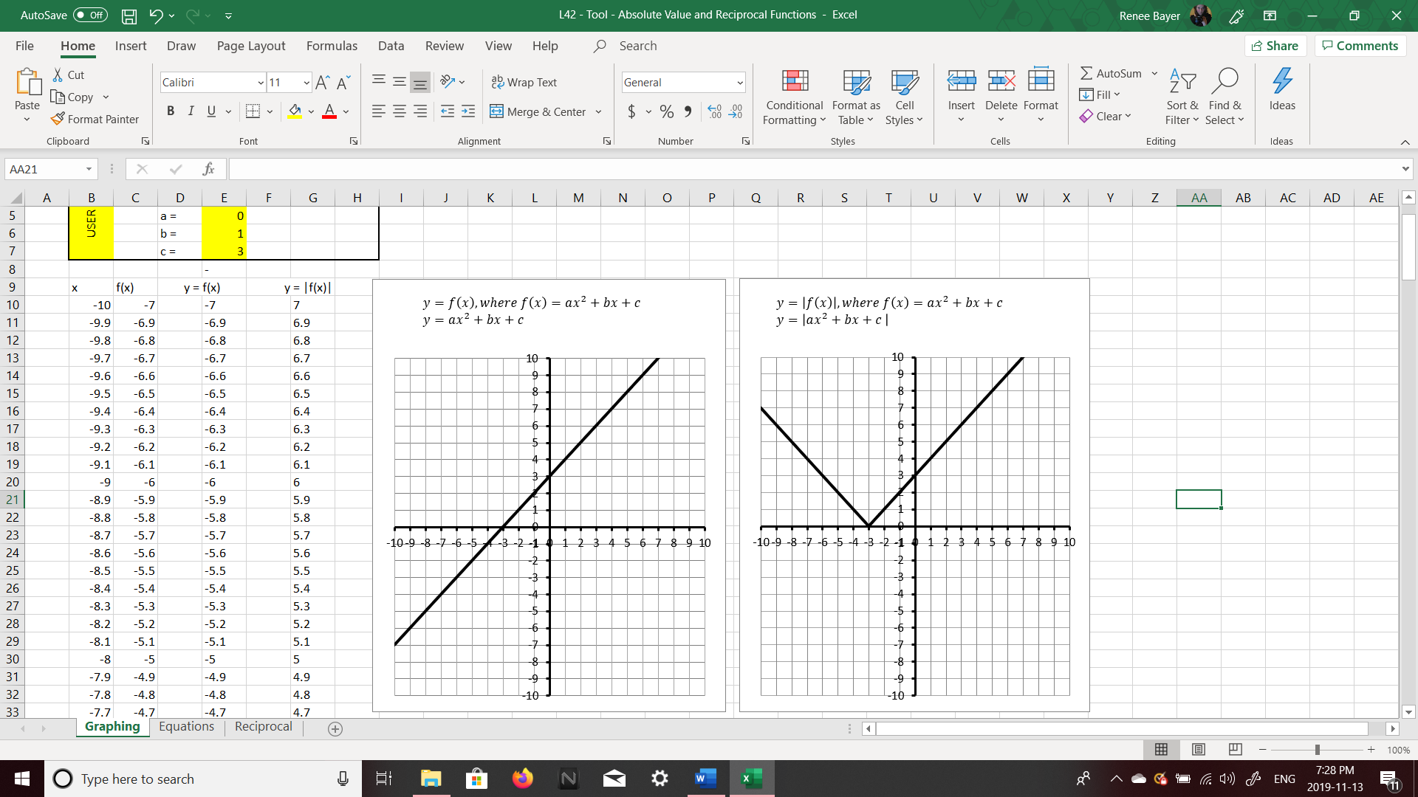

Q4: A piecewise function can be written for this function as
$$f\left(x\right)=\left\{\begin{aligned}ax+b, &x>-3 \\ -cx-d, &x≤-3\end{aligned}\right.$$
Where a, b, c, and d are ___, ___, ___, and ___.
(Record your four digit answer in the Numerical Response boxes below)

Use the following information to answer Q5:
An absolute value function is graphed below:
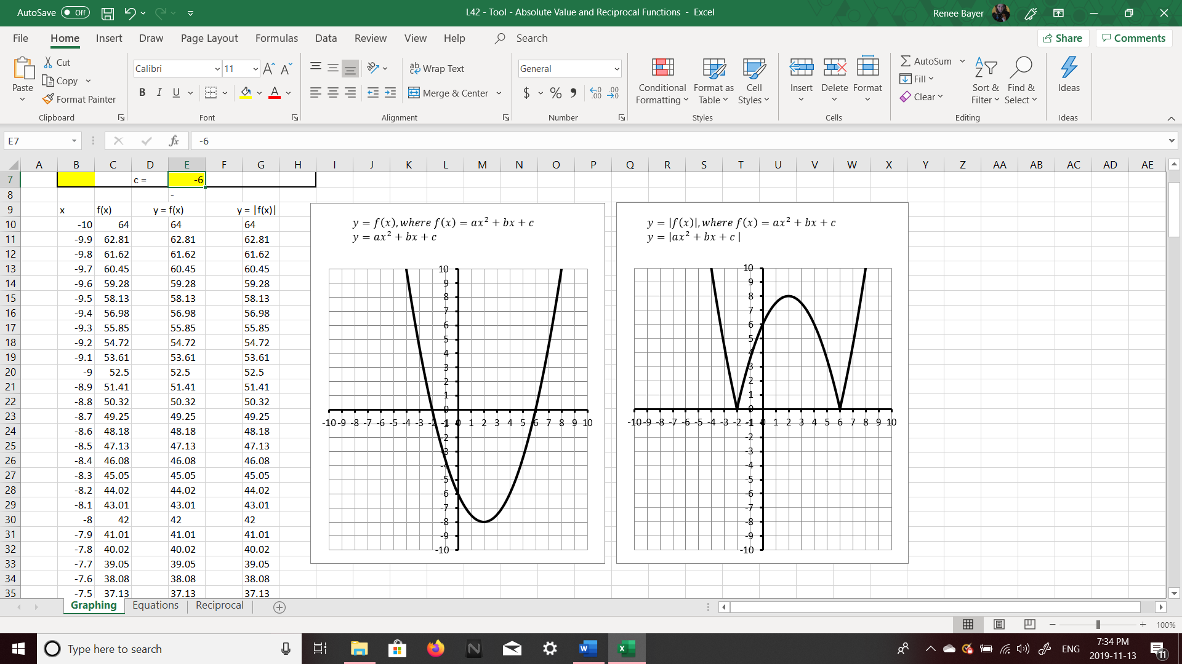

Q5: Write a piecewise function to describe the function.

Part 3 – 7.3 Absolute Value Equations
Q6: Solve $\left|2x-8\right|=-2x^{2}+6x+2$ algebraically. Verify your answers.

Q7: Solve $\left|x^{2}-4\right|=x+2$ algebraically. Verify your answers.

Q8: Solve $\left|x\right|=x^{2}-6$ algebraically. Verify your answers. Confirm by graphing.
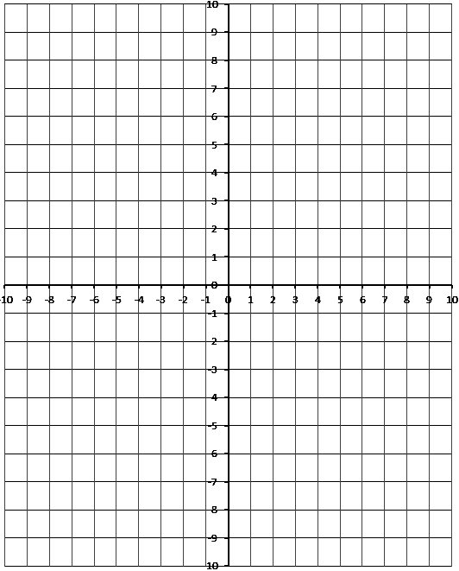

Part 4 – 7.4 Reciprocal Functions
Use the following information to answer Q9:
The graph below depicts an inverse function, $y=\frac{1}{f(x)}$
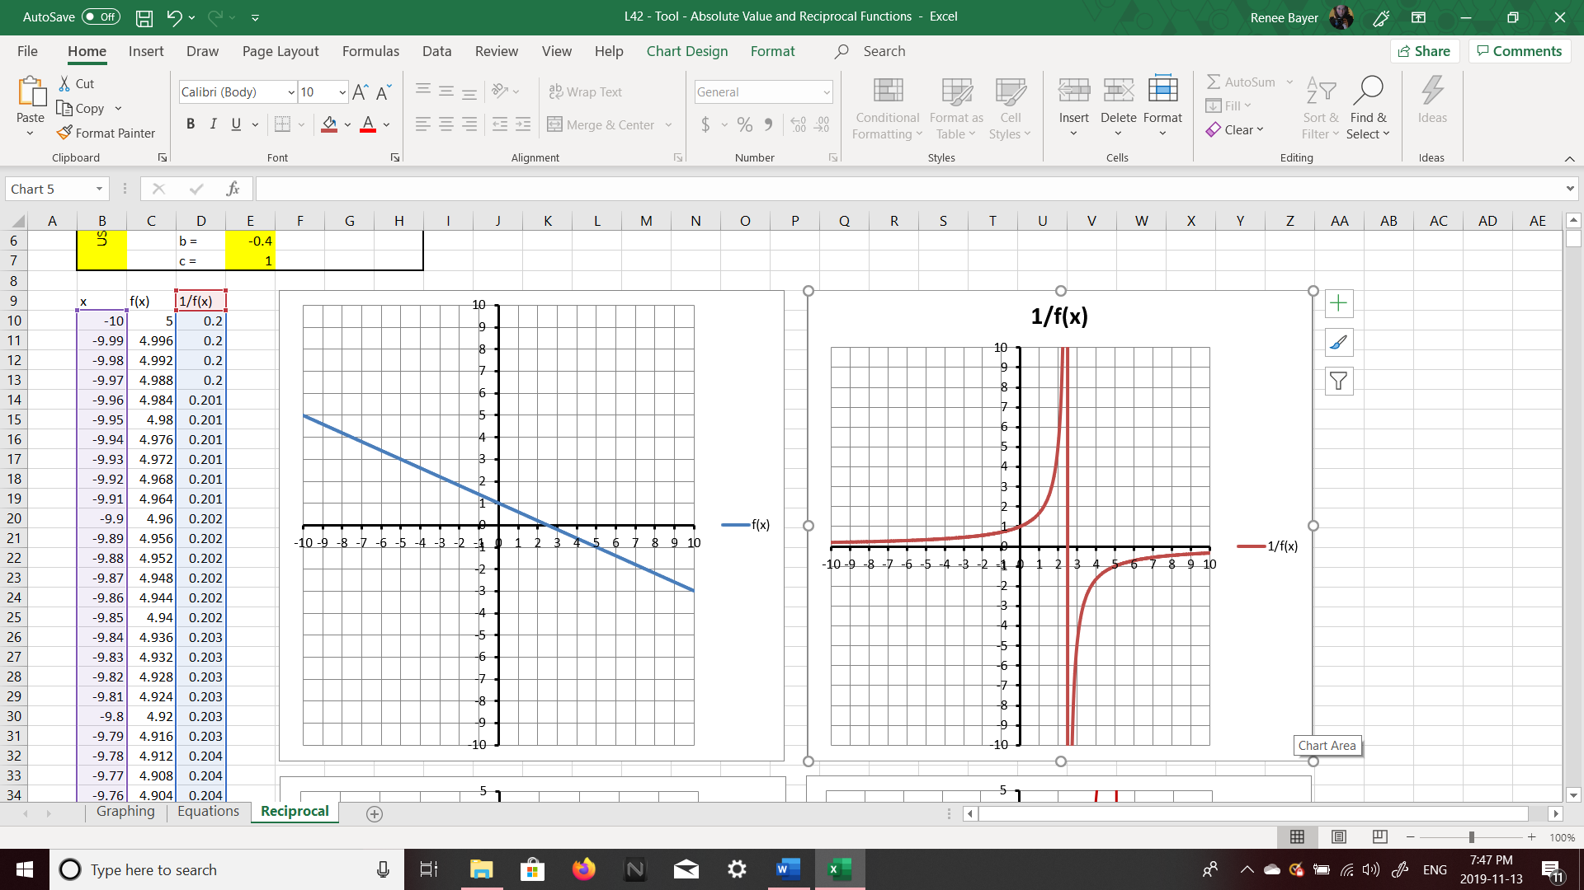

Q9: The original function can be written as $f\left(x\right)=-\frac{a}{b}x+c$ , where a, b, and c are ___, ___, and ___.
(Record your three digit answer in the Numerical Response boxes below)

Q10: If $f\left(x\right)=x^{2}-2$ , graph the reciprocal function $y=\frac{1}{f(x)}$
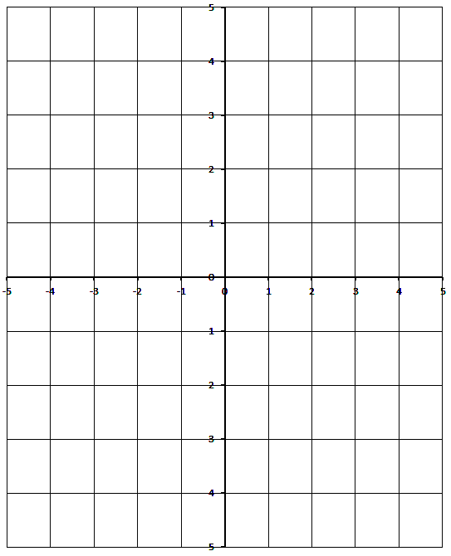

Part 5 – 2.1 Angles in Standard Position
Use the following information to answer Q11-Q12:
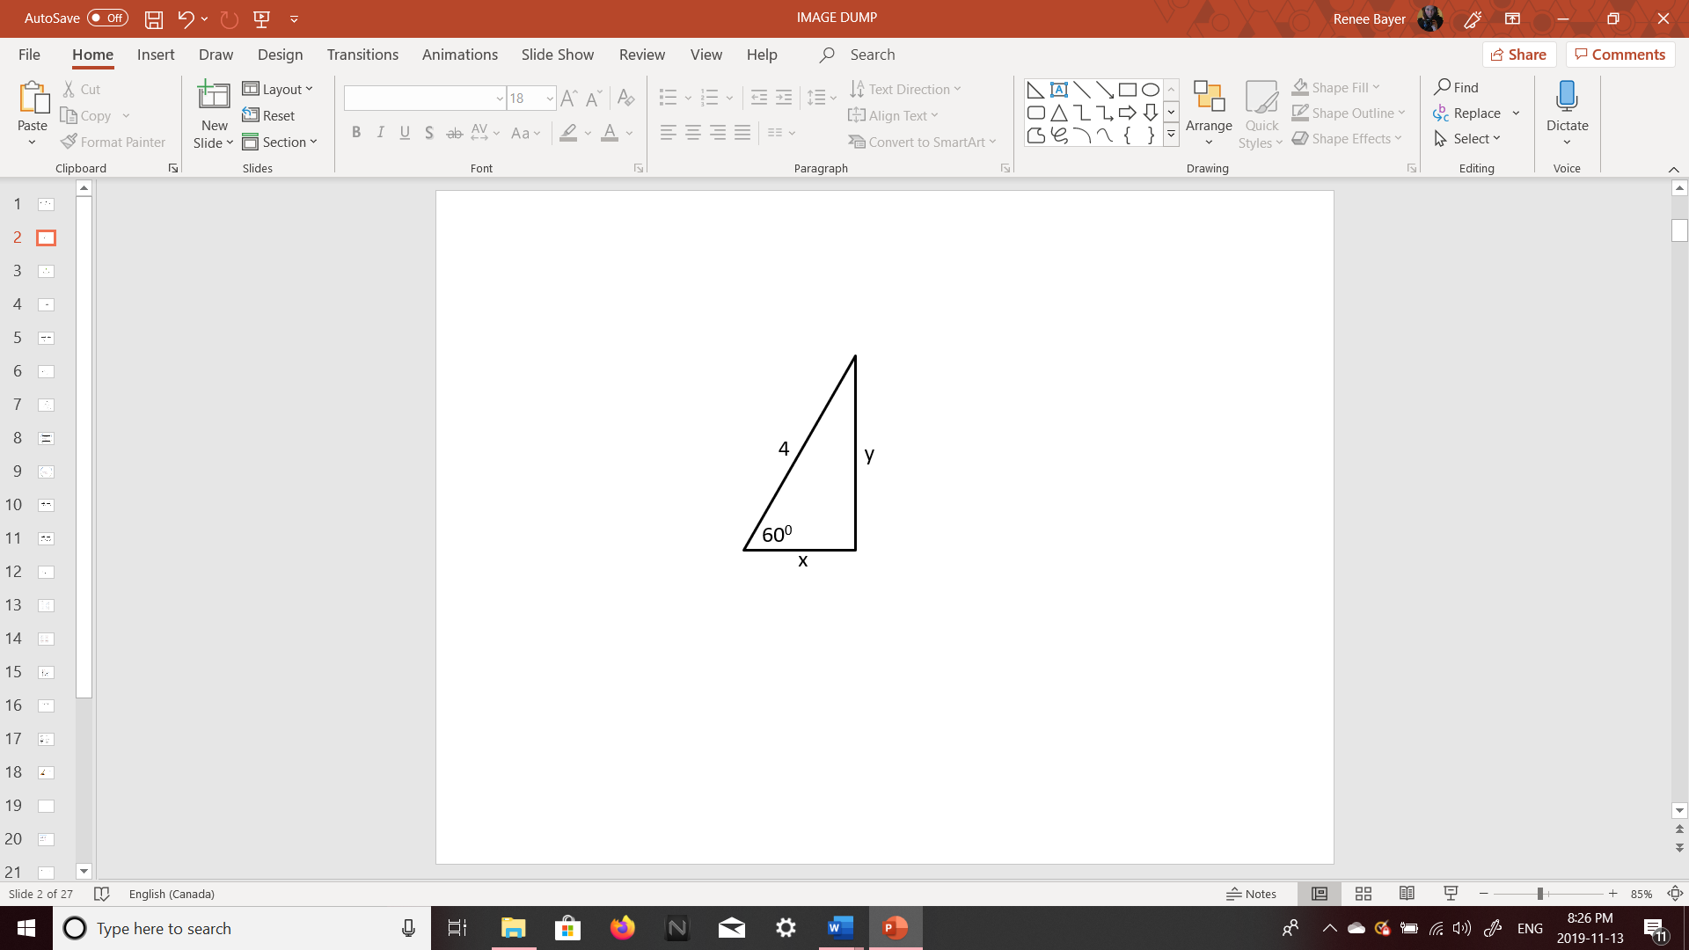

Q11: Determine the exact value of x.

Q12: Determine the exact value of y.

Q13: The angle of 220⁰ has the terminal arm in which quadrant? What is the reference angle?

Part 6 – 2.2 Trigonometric Ratios of Any Angle
Q14: Determine the exact values for the Sin 150⁰, Cos 150⁰, and Tan 150⁰ ratios.
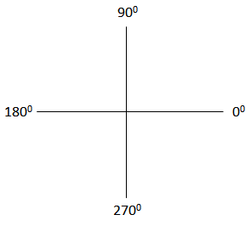

Q15: Determine the exact values for the Sin 240⁰, Cos 240⁰, and Tan 240⁰ ratios.

Q16: Determine the exact values for the Sin 315⁰, Cos 315⁰, and Tan 315⁰ ratios.

Q17: Solve $Sinθ=\frac{1}{2}$ equation, for $0≤θ<360 deg$ , using a diagram involving a special right triangle.

Q18: Solve $Sinθ=\frac{\sqrt{3}}{2}$ equation, for $0≤θ<360 deg$ , using a diagram involving a special right triangle.

Q19: Solve $Sinθ=-\frac{\sqrt{3}}{2}$ equation, for $0≤θ<360 deg$ , using a diagram involving a special right triangle.

Q20: Solve $Cosθ=\frac{\sqrt{2}}{2}$ equation, for $0≤θ<360 deg$ , using a diagram involving a special right triangle.

Q21: Solve $Cosθ=-\frac{\sqrt{2}}{2}$ equation, for $0≤θ<360 deg$ , using a diagram involving a special right triangle.

Q22: Solve $Tanθ=-1$ equation, for $0≤θ<360 deg$ , using a diagram involving a special right triangle.

Part 7 – 2.3 The Sine Law
Use the following information to answer Q23:
The AmbiguouS caSe, Angle-Side-Side
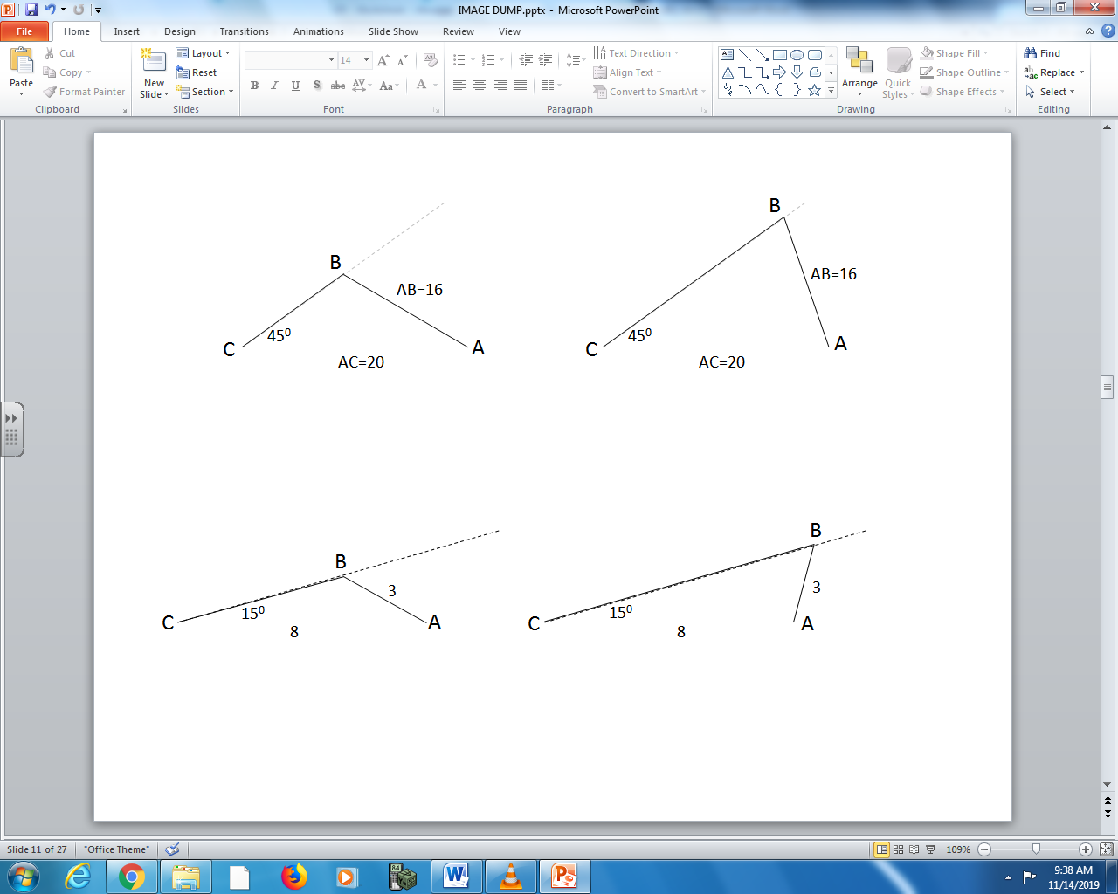
Q23: Determine the two possible values of ∠B.

Q24: Solve the triangle below.
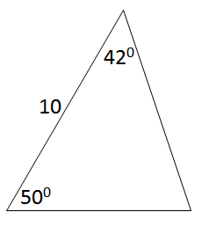

Part 8 – 2.4 The Cosine Law
Q25: Solve the triangle below.
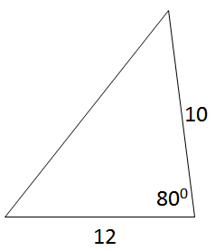

Q26: Solve the triangle below.
