L58 – Worksheet - 5.1 Working with Radicals
Pg 278 #2: Express each radical as a mixed radical in simplest form.
$\sqrt{56}$ $3\sqrt{75}$ $\sqrt[3]{24}$ $\sqrt{c^{3}d^{2}} , c≥0, d≥0$

Pg 278 #4: Complete the table. State the values of the variable for which the radical represents a real number.
Mixed Radical Form | Entire Radical Form | Values of the Variable
$$3n\sqrt{5}$$
 | $$\sqrt[3]{-432}$$
$$\frac{1}{2a}\sqrt[3]{7a}$$
 | $$\sqrt[3]{128x^{4}}$$

Pg 278 #5ab: Express each pair of terms as like radicals. Explain your strategy.
$15\sqrt{5} and 8\sqrt{125}$ $8\sqrt{112z^{8}} and 48\sqrt{7z^{4}}$

Pg 278 #5cd: Express each pair of terms as like radicals. Explain your strategy.
$-35\sqrt[4]{w^{2}} and 3\sqrt[4]{81w^{10}}$ $6\sqrt[3]{2} and 6\sqrt[3]{54}$

Pg 278 #6ab: Order each set of numbers from least to greatest.
$3\sqrt{6} , 10 , 7\sqrt{2}$ $-2\sqrt{3} , -4 , -3\sqrt{2} , -2\sqrt{\frac{7}{2}}$

Pg 278 #8ad: Simplify each expression.
$-\sqrt{5}+9\sqrt{5}-4\sqrt{5}$ $-\sqrt{6}+\frac{9}{2}\sqrt{10}-\frac{5}{2}\sqrt{10}+\frac{1}{3}\sqrt{6}$

Pg 278 #9ab: Simplify each expression.
$3\sqrt{75}-\sqrt{27}$ $2\sqrt{18}+9\sqrt{7}-\sqrt{63}$

Pg 278 #9cd: Simplify each expression.
$-8\sqrt{45}+5.1-\sqrt{80}+17.4$ $\frac{2}{3}\sqrt[3]{81}+\frac{\sqrt[3]{375}}{4}-4\sqrt{99}+5\sqrt{11}$

Pg 278 #14: The speed, s, in meters per second, of a tsunami is related to the depth, d, in meters, of the water through which it travels. This relationship can be modelled with the formula $s= \sqrt{10d} , d≥0$. A tsunami has a depth of 12m. What is the speed as a mixed radical and an approximation to the nearest meter per second?

Pg 278 #15: A square is inscribed in a circle. The area of the circle is $38π$ m².
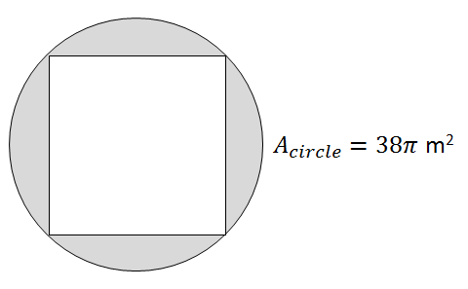
- What is the exact length of the diagonal of the square?
- Determine the exact perimeter of the square.

