First Name:_____________________________ Last Name:_____________________________

L58&59 – Cumulative Review

Part 1: Chapter 4 - Exponent Laws
Q1: Simplify $x^{2}{\left({3x}^{4}\right)}^{2}$

Q2: Simplify $\frac{{\left(x^{2}y^{3}* x^{6}\right)}^{2}}{x^{5}}$

Part 2: Chapter 4 - Integral Exponents
Q3: Simplify ${\left(x^{-2}y^{5}\right)}^{-2}$ using only positive exponents

Q4: Simplify $\frac{{\left(2x^{2}\right)}^{-3}x^{4}}{2x^{-5}}$ using only positive exponents

Part 3: Chapter 4 - Rational Laws
Q5: Simplify $\frac{x^{\frac{1}{2}}}{x^{- \frac{2}{3}}}$ using only positive exponents

Q6: Simplify $\frac{{\left(x^{\frac{1}{3}}\right)}^{- \frac{3}{4}}}{x^{- \frac{5}{6}}}$ using only positive exponents

Part 4: Chapter 4 - Entire to Mixed Radicals
Q7: Convert $\sqrt{24x^{5}y^{4}}$ to a mixed radical

Q8: Convert $\sqrt[3]{16x^{8}y^{2}z^{6}}$ to a mixed radical

Part 5: Chapter 4 - Mixed to Entire Radicals
Q9: Convert $5x^{2}y \sqrt{5x}$ to an entire radical

Q10: Convert $4x^{2}y \sqrt[3]{2x^{2}y}$ to an entire radical

Part 6: Chapter 4 - Radicals to Exponents, Exponents to Radicals
Q11: Convert $5x^{2} \sqrt[3]{5x}$ to an exponent

Q12: Convert $7^{\frac{2}{3}}x^{\frac{4}{3}}$ to a mixed radical

Part 7: Chapter 4 - Exponential Growth and Decay
Q13: Initially there are 200 bacteria in a sample. Every 5 hours the bacteria double. How many bacteria after 18 hours?

Q14: Initially there are 500g of Carbon-14 in a sample. Every 5730 years the amount of Carbon-14 halves. How much Carbon-14 exists after 12,000 years?

Part 8: Chapter 5 - Multiplying Polynomials
Q15: Simplify $(x-5)(2x+1)$

Q16: Simplify ${(x-5)}^{2}-(x+2)(x-3)$

Part 9: Chapter 5 - Common Factors
Q17: Common factor $2x^{2}y-8xy$

Q18: Common factor $27x^{2}\left(y-3\right)+3x(y-3)$

Part 10: Chapter 5 - Factoring Trinomials (a=1)
Q19: Factor $x^{2}+2x-24$

Q20: Factor $2x^{3}+10x^{2}-48x$

Part 11: Chapter 5 - Factoring Trinomials (a>1)
Q21: Factor $2x^{2}+x-3$

Q22: Factor $6x^{2}-11x-10$

Part 12: Chapter 5 - Factoring Special Trinomials
Q23: Factor $9x^{2}-16$

Q24: Factor $3x^{3}y-75xy$

Part 13: Chapter 5 - Word Problems
Use the following information to answer Q25-Q26:
A portion of a field is fenced for a dog. The dimensions are given below, in meters.
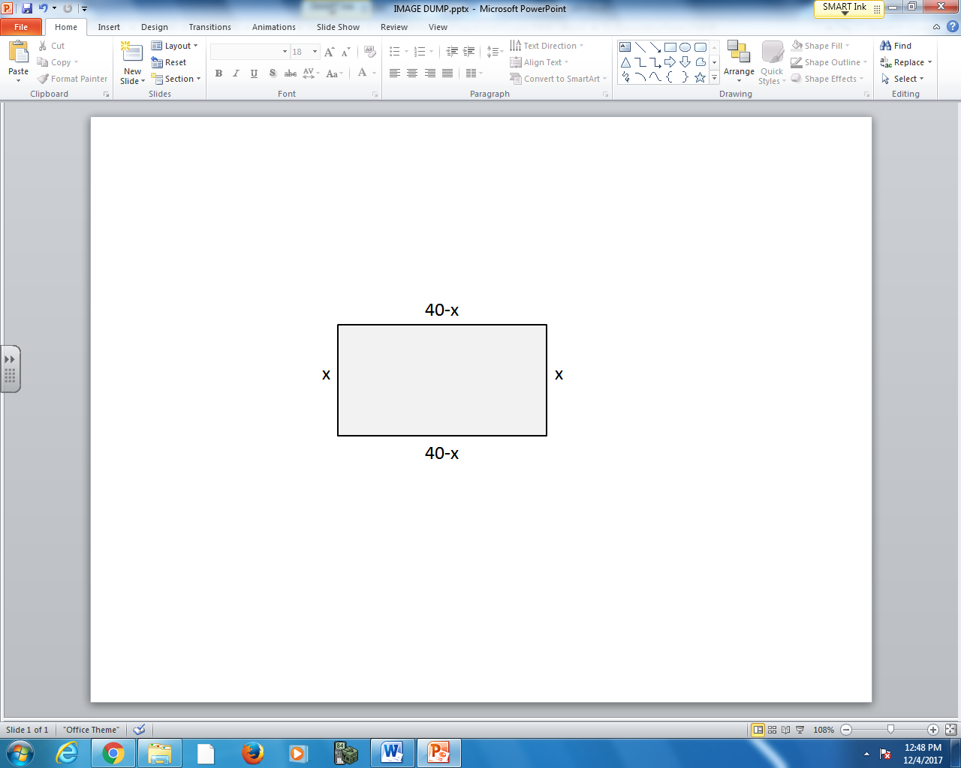

Q25: What is the perimeter of the fence?

Q26: What is the area surrounded by the fence?

Part 14: Chapter 6 - Domain and Range
Use the following information to answer Q27-Q28:
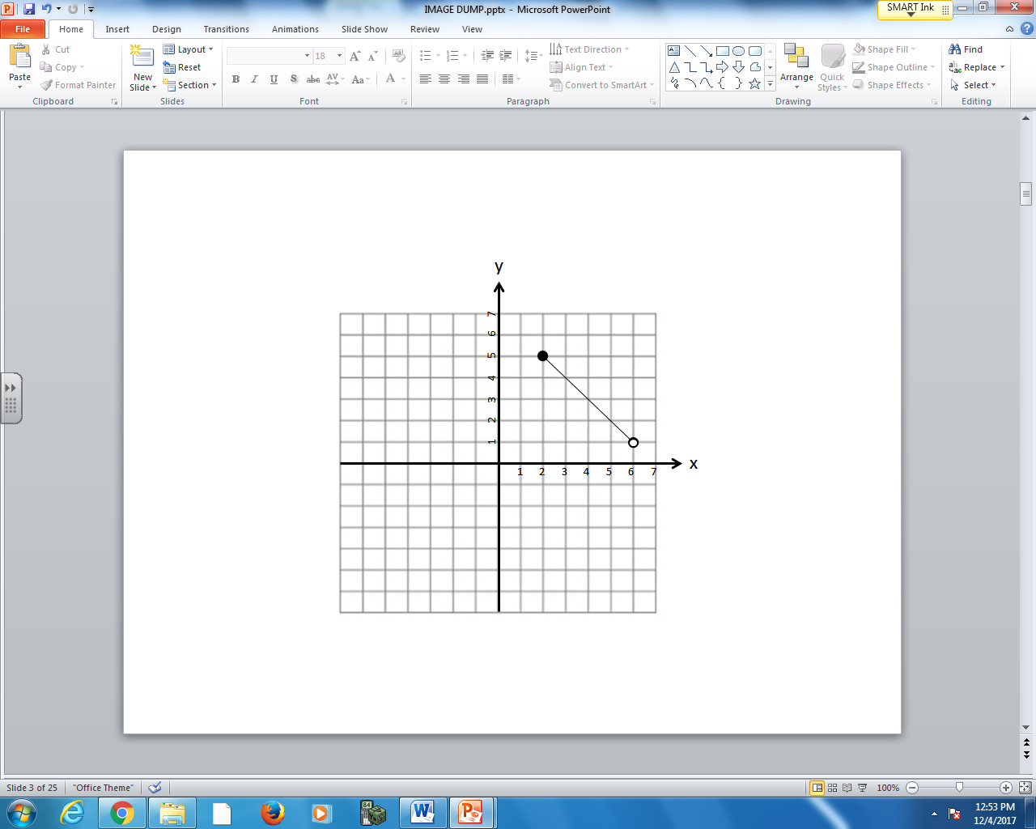

Q27: Write the Domain in Set Notation.

Q28: Write the Range in Interval Notation.

Part 15: Chapter 6 - Function Notation
Use the following information to answer Q29-Q30:
$f\left(x\right)=\frac{2}{3}x-\frac{5}{3}$ $g\left(x\right)=\frac{1}{2}x-6$

Q29: What is $f\left(7\right)=?$ Q30: If $g\left(x\right)=10$, then $x=?$

Part 16: Chapter 7 – Graphing
Q31: Graph the line $\left(y+2\right)=\frac{1}{3}(x-5)$ Q32: Graph the line perpendicular to $y=\frac{3}{2}x+1$ that
passes through the point (1,1).
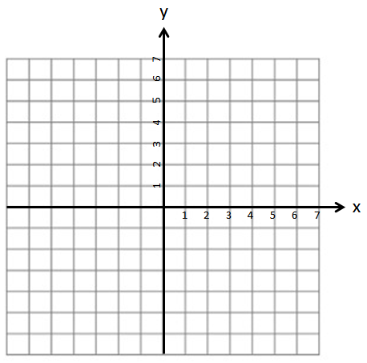
Part 17: Chapter 7 – Algebra
Q33: Convert $y=-\frac{1}{3}x+4$ into General Form.

Q34: A line passes through the points (5,2) and (8,-4). Write the equation of the line in Slope y-Intercept form.

Part 18: Chapter 8 – Solving Systems of Equations using Graphing

Q35: Find the solution to the system of equations:
$y=\frac{3}{2}x-1$ $y=-\frac{1}{2}x+4$
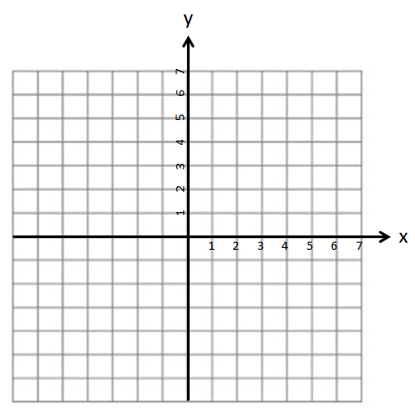
Q36: Find the solution to the system of equations:
$5x-3y+15=0$ $y=-\frac{1}{2}x-2$

Part 19: Chapter 9 – Solving Systems of Equations using Algebra
Q37: Solve using Substitution:
$x+3y-9=0$ $y=-2x+8$

Q38: Solve using Elimination:
$x-y-2=0$ $3x+2y-4=0$

Part 20: Chapter 9 – Word Problems involving Systems of Equations
Q39: Dan and Dillon go to the fair and buy snacks. Dan buys 3 hotdogs and 2 bags of chips for $7.75. Dillon buys 2 hotdogs and 5 bags of chips for $9.75. What is the cost of a hotdog? What is the cost of a bag of chips?

Q40: Sam and Dillon also buy beverages. Dan buys 2 coffees and 1 soda for $2.80. Dillon buys 1 coffee and 4 sodas for $5.25. What is the cost of a coffee? What is the cost of a soda?

