L62 – 5.3 Radical Equations
Part 1 – Key Ideas
Extraneous Roots – A solution to an equation that appears to be correct, but when we attempt to verify it, we discover that it does not work.
To identify whether a root is extraneous, substitute the value into the original equation. Raising both sides of an equation to an even exponent may introduce an extraneous root.
When determining restrictions on the values for variables, remember:
- Denominators cannot be equal to zero.
- For radicals to be real numbers, radicands (the number under the root) must be non-negative if the index is an even number.
Part 2 – What is a Radical Equation?
Q1: Consider the equations $f\left(x\right)=x+2$ and $g\left(x\right)=\sqrt{x+2}$.
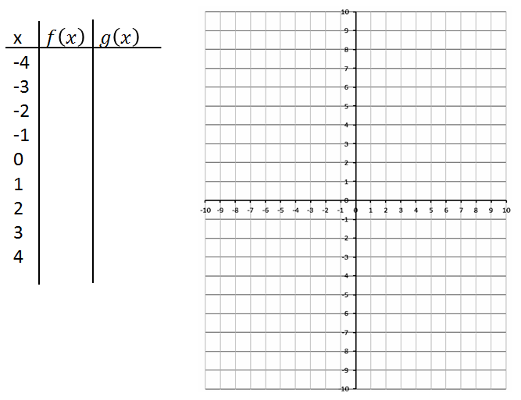
Q2: Consider the radical equation $\sqrt{x+5}=x+3$ as a system of equations. We can approach the question by graphing $f\left(x\right)=\sqrt{x+5}$ and $g\left(x\right)=x+3$, and look for the solutions to the system.
Create a table of values using your Graphing Calculator.
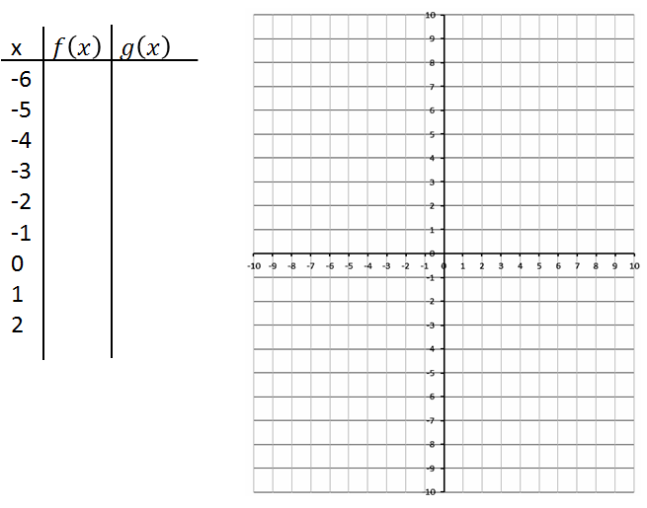

Teacher Note: Introduce “L62 – Tool – Math 30-1 Radicals Preview” Excel sheet to demonstrate shapes of Radical Functions.
Part 3 – Radical Equations in the Form $\sqrt{cx+d}=x+f$ simplifying to $\left(x+a\right)\left(x+b\right)=0$
Q3: Solve the radical equation $\sqrt{x+5}=x+3$ and verify your solution(s).

Q4: Solve the radical equation $\sqrt{-2x+13}=x+1$ and verify your solution(s).

Part 4 – Radical Equations in the Form $\sqrt{cx+d}=ax+e$ simplifying to $\left(ax+b\right)\left(ax+b\right)=0$
Q5: Solve the radical equation $\sqrt{2x+5}=x+3$ and verify your solution(s).

Q6: Solve the radical equation $\sqrt{4x-5}=2x-2$ and verify your solution(s).

Part 5 – Radical Equations in the Form $\sqrt{ex+f}=gx+h$ simplifying to $\left(ax+b\right)\left(cx+d\right)=0$
Q7: Solve the radical equation $\sqrt{2x+5}=2x+3$ and verify your solution(s).

Q8: Solve the radical equation $\sqrt{15x-1}=3x+1$ and verify your solution(s).

Part 6 – Radical Equations in the Form $\sqrt{x^{2}+ex}=fx+g$ simplifying to $\left(ax+b\right)\left(cx+d\right)=0$
Q9: Solve the radical equation $\sqrt{x^{2}-5x}=2x+2$ and verify your solution(s).

Q10: Solve the radical equation $\sqrt{x^{2}-16x}=2x+3$ and verify your solution(s).

Part 7 – Harder Radical Equations
Q11: Solve the radical equation $-8+\sqrt{5x-5}=-3$ and verify your solution(s).

Q12: Solve the radical equation $-10\sqrt{x-10}=-60$ and verify your solution(s).

Q13: Solve the radical equation $\sqrt{5x-9}-3=\sqrt{x+4}-2$ and verify your solution(s).

