L63 – Word Problems
Part 1 – Circle Geometry and Angles Inscribed in a Semi-Circle
Q1: Calculate the area of the shaded region:
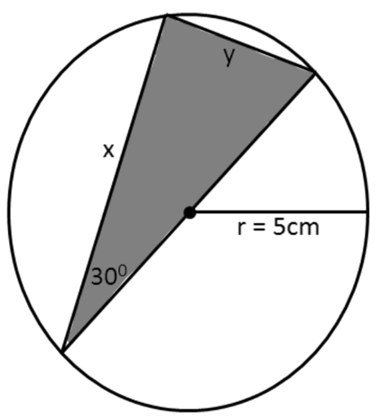

Part 2 – Radical Equations
Use the following information to answer Q2:
Two go-carts are racing. One go-cart has a constant rate of acceleration, and it’s speed is modelled by the equation:
$$v_{A}=t$$
Shortly after the first go-cart starts, the second go-cart accelerates at a non-uniform rate. It’s speed is modelled by the equation:
$$v_{B}=\sqrt{10t-16}$$

Q2: Algebraically determine the time(s) that the carts are travelling at the same speed.

