L66 –Arithmetic Sequences and Series
Part 1 – Arithmetic Sequences
Use the following information to answer Q1-Q2:
An Arithmetic Sequence is shown below:
58, 61, 64, 67…
Q1: Determine the 20th term in the sequence.

Q2: What term is the number 196?

Use the following information to answer Q3-Q4:
An Arithmetic Sequence is shown below:
17, 13, 9, 5…
Q3: Determine the 50th term in the sequence.

Q4: What term is the number -67?

Use the following information to answer Q5-7:
The 17th term of an Arithmetic Sequence is 76. The 28th term is 131.
Q5: What is the Common Difference?

Q6: What is the first term in the sequence?

Q7: What is the 100th term in the sequence?

Use the following information to answer Q8:
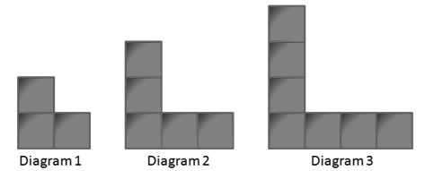

Q8: Write an equation to describe the Arithmetic Sequence.

Part 2 – Arithmetic Series
Use the following information to answer Q9-10:
An Arithmetic Sequence is shown below:
6 + 10 + 14 + 18 + …

Q9: What is the Common Difference?

Q10: What is the sum of the first 20 terms?

Use the following information to answer Q11-12:
An Arithmetic Sequence is shown below:
6 + 2 - 2 - 6 + …

Q11: What is the Common Difference?

Q12: What is the sum of the first 20 terms?

Use the following information to answer Q13:

Q13: How many block are required to display Diagrams 1-10 all at the same time?

Q14: In an Arithmetic Series, the first term is 5 and the tenth term is 59. What is the sum of the first 10 terms? Determine the answer using two different methods.

Part 3 – Review – Chapter 6 Rational Expressions
Q15: Simplify the expression $\frac{x^{2}+x-20}{x^{2}+x-6}÷\frac{x^{2}-10x+24}{x^{2}+4x+3}$ and identify all non-permissible values.

Q16: Solve the rational equation $1= \frac{3}{m+3}+\frac{3m}{m+3}$ and identify all non-permissible values.

Part 4 – Review – Chapter 3 Quadratic Functions
Q17: Convert $f\left(x\right)={3x}^{2}-5x+1000$ into Vertex Form using fractions.

Q18: A house owner is building a fence against their barn for chickens to run around. They have 26m of fence. What is the maximum area they can build for their chicken coup?
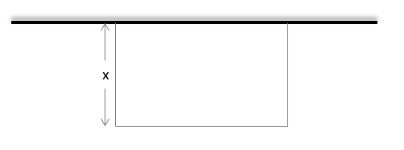

Q19: A cat jumps off a 10ft tall ledge, reaching a maximum height of 15m after travelling a horizontal distance of 5m. What horizontal distance, d_{x} , does the cat cover before landing?
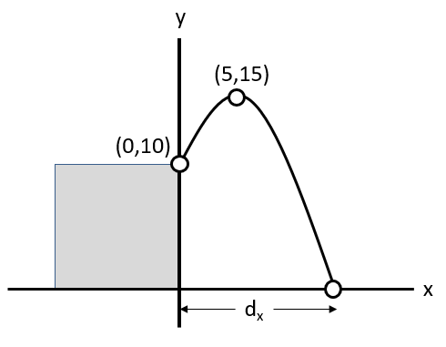

Part 5 – Review – Chapter 4 Quadratic Equations
Use the following information to answer Q20:
A patio has a total area of 33m², and is proportioned per the diagram below.
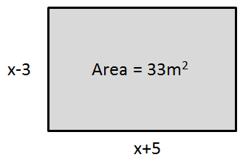

Q20: Set up a quadratic equation and solve to determine the value(s) of x.

Use the following information to answer Q21:
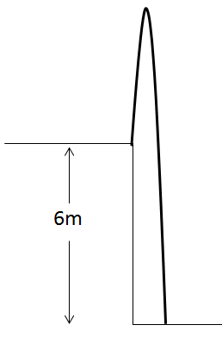
An object is launched vertically at 13m/s off a 6m tall ledge. The Physics 20 equation that can be used to determine time is given by:
$$∆d=v_{i}t+\frac{1}{2}at^{2}$$
Where the acceleration due to gravity is approximately -10 m/s². In Math 20-1, we can write this function as follows:
$$h\left(t\right)=-5t^{2}+13t+6$$

Q21: How long does it take the object to land? Support your work algebraically.
Using Factoring Using Vertex Form Using Quadratic Formula

Part 6 – Review – Chapter 8 Systems of Equations
Use the following information to answer Q22:
A frog jumps off of a 4cm tall ledge onto a downward sloped hill, per the diagram below.
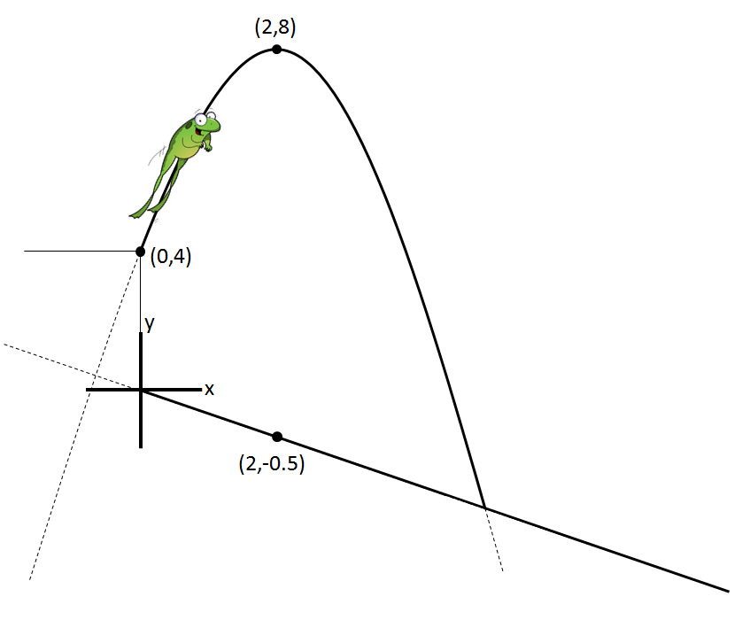
All coordinates are in centimeters.

Q22: The frog lands on the hill after travelling a horizontal distance of a.bc centimeters, where a, b, and c are ___, ___, and ___.
(Record your 3-digit answer in the Numerical Response boxes below)

Part 7 – Review – Chapter 9 Inequalities
Q23: Solve each of the following inequalities.
$y<\frac{3}{2}x+2$ $\frac{1}{2}x^{2}+5x+\frac{9}{2}≥0$ $y<-x^{2}+12x-27$
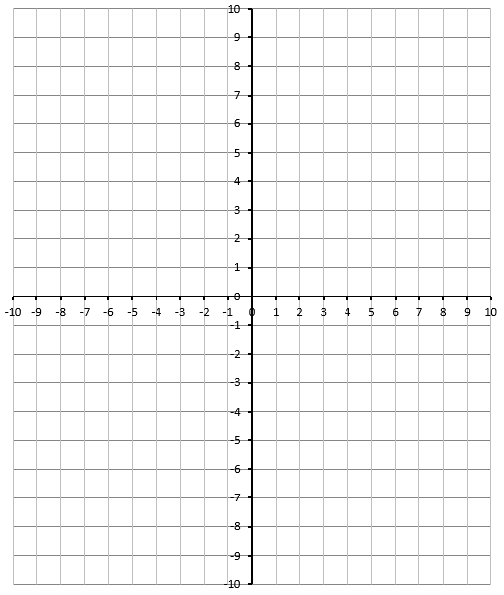

Part 8 – Review – Chapter 7 Absolute Values
Q24: Solve $\left|x^{2}+2x-8\right|=x+4$ algebraically. Verify your answers. Confirm by graphing.

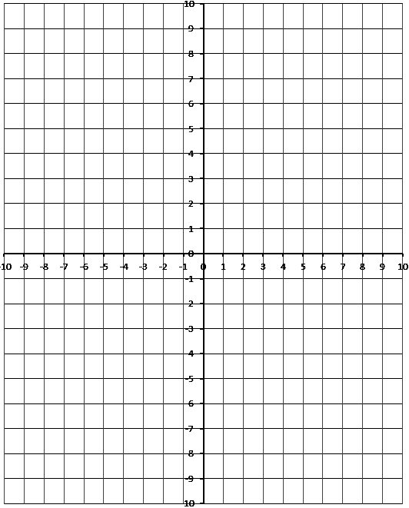
Part 9 – Review – Chapter 2 Trigonometry
Q25: Determine the exact values for the Sin 315⁰, Cos 315⁰, and Tan 315⁰ ratios.
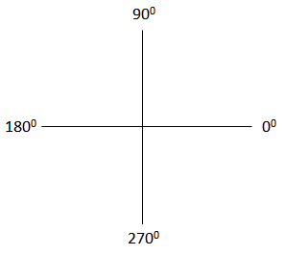
Q26: Solve $Cosθ=-\frac{\sqrt{2}}{2}$ equation, for $0≤θ<360 deg$ , using a diagram involving a special right triangle.
Q27: Solve the triangle below.
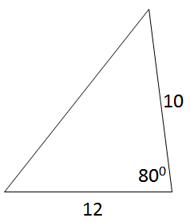

Part 10 – Review – Chapter 5 Radicals
Q28: The expression $\sqrt{60}+\sqrt{36}+\sqrt{135}$ simplifies to $\sqrt{bc}+d$ , where a, b, c, and d are ___, ___, ___, and ___.
(Record your four digit answer in the Numerical Response boxes below)

Q29: The expression $\frac{\sqrt{150}}{\sqrt{12}}$ simplifies to $\frac{a\sqrt{b}}{c}$ , where a, b, and c are ___, ___, and ___.
(Record your three digit answer in the Numerical Response boxes below)

Q30: State the restrictions on x and solve:
$\sqrt{x+3}=2x+3$

