L66.5 – Review of School Year
Unit 1 – Rational Expressions (Ch6)
L04Q5: Multiply, simplify, and determine any Non-Permissible Values (NPV).
$\frac{{2x}^{2}+5x-3}{x^{2}-x-6}*\frac{x^{2}+x-2}{{2x}^{2}+x-1}$ ${2x}^{2}+5x-3$ $x^{2}-x-6$

$x^{2}+x-2$ $2x^{2}+x-1$

L05Q7: Simplify the following expressions. State NPV’s.
$\frac{(x-3)}{(x+1)}-\frac{(x-4)}{(x+2)}$ $\frac{(x-6)}{(x+1)}-\frac{(x-2)}{(x+2)}$

L07Q4: Solve for the variable.
$\frac{1}{3x^{2}}=\frac{x+3}{2x^{2}}-\frac{1}{6x^{2}}$ $\frac{2}{x^{2}-4}+\frac{10}{6x+12}=\frac{1}{x-2}$

Unit 1 – Quadratic Functions (Ch3)
Use the following information to answer L11Q11-L11Q15:
$$g\left(x\right)=1{\left(x-1\right)}^{2}-9$$

L11Q11: Determine the coordinate of the Vertex.

L11Q12: Determine the equation of the Axis of Symmetry.

L11Q13: Convert to Standard Form to find the y-Intercept.

L11Q14: Determine the zeroes.
From Vertex Form From Standard Form

L11Q15: Sketch the function g(x) below.
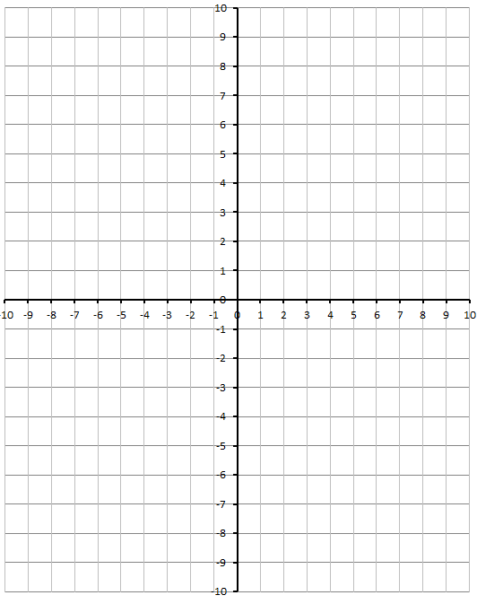

Unit 1 – Quadratic Equations (Ch4)
Use the following information to answer L12Q8-L12Q9:
A diver jumps off of a 8m tall diving board. The equation that models their height, h, as a function of horizontal distance, x, is given by:
$$h\left(x\right)=-x^{2}+2x+8$$
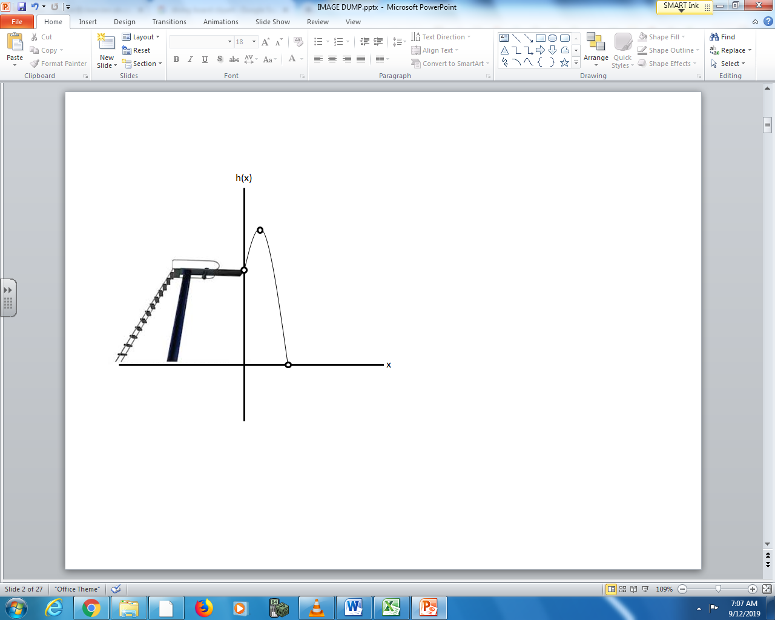

L12Q8: Working with Standard Form…
- Factor to find the zeroes. Which one is significant, and why?
- Determine the y-intercept. What is the significance?
- Use the zeroes to find the axis of symmetry.
- Use the axis of symmetry to find the Vertex. What is the significance?

Use the following information to answer L12Q8-L12Q9:
A diver jumps off of a 8m tall diving board. The equation that models their height, h, as a function of horizontal distance, x, is given by:
$$h\left(x\right)=-x^{2}+2x+8$$

L12Q9: Working with Vertex Form…
- Convert the function to Vertex Form.
- Find the zeroes. Which one is significant, and why?
- Find the Vertex. What is the significance?

Unit 2 – Systems of Equations (Ch8)
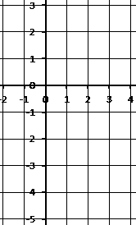
L16Q3: Solve the equation $-2x^{2}+4x+1=0$ graphically.
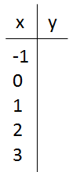

L17Q3: Factor the following:
${(x-2)}^{2}+5\left(x-2\right)-6$ $\frac{1}{2}{(x+3)}^{2}+\frac{1}{2}\left(x+3\right)-10$

L18Q1: Given the equation $x^{2}+8x+15=0$, determine the roots.
Standard Form Vertex Form

L20Q1: Solve $x^{2}+13x+40=0$ using each method.
Factoring Converting to Vertex Form Quadratic Formula

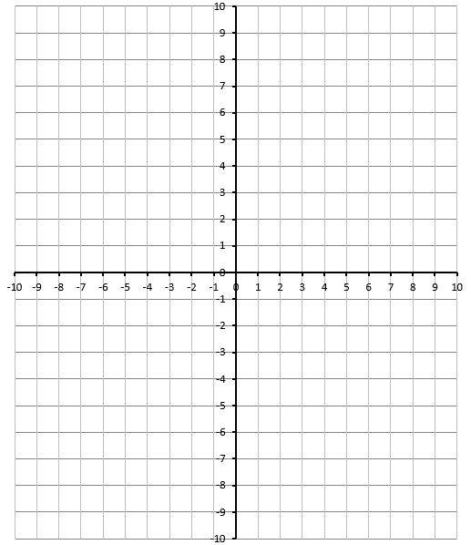
L28&29Q2: Solve the system of equations graphically.
$$f\left(x\right)=1{(x-2)}^{2}-5$$
$$g\left(x\right)=x-1$$
Verify using your calculator.

L30&31Q8: Solve using Substitution. L30&31Q9: Solve using Elimination.
$y=x^{2}+2x-5$ $y={3x}^{2}+2x+5$
$y=-2x^{2}-7x-11$ $y=2x^{2}+4x+13$

Unit 2 – Inequalities (Ch9)
L34Q4: Graph the following equations:
$y≤\frac{2}{3}x-7$ $y>-\frac{1}{3}x+1$
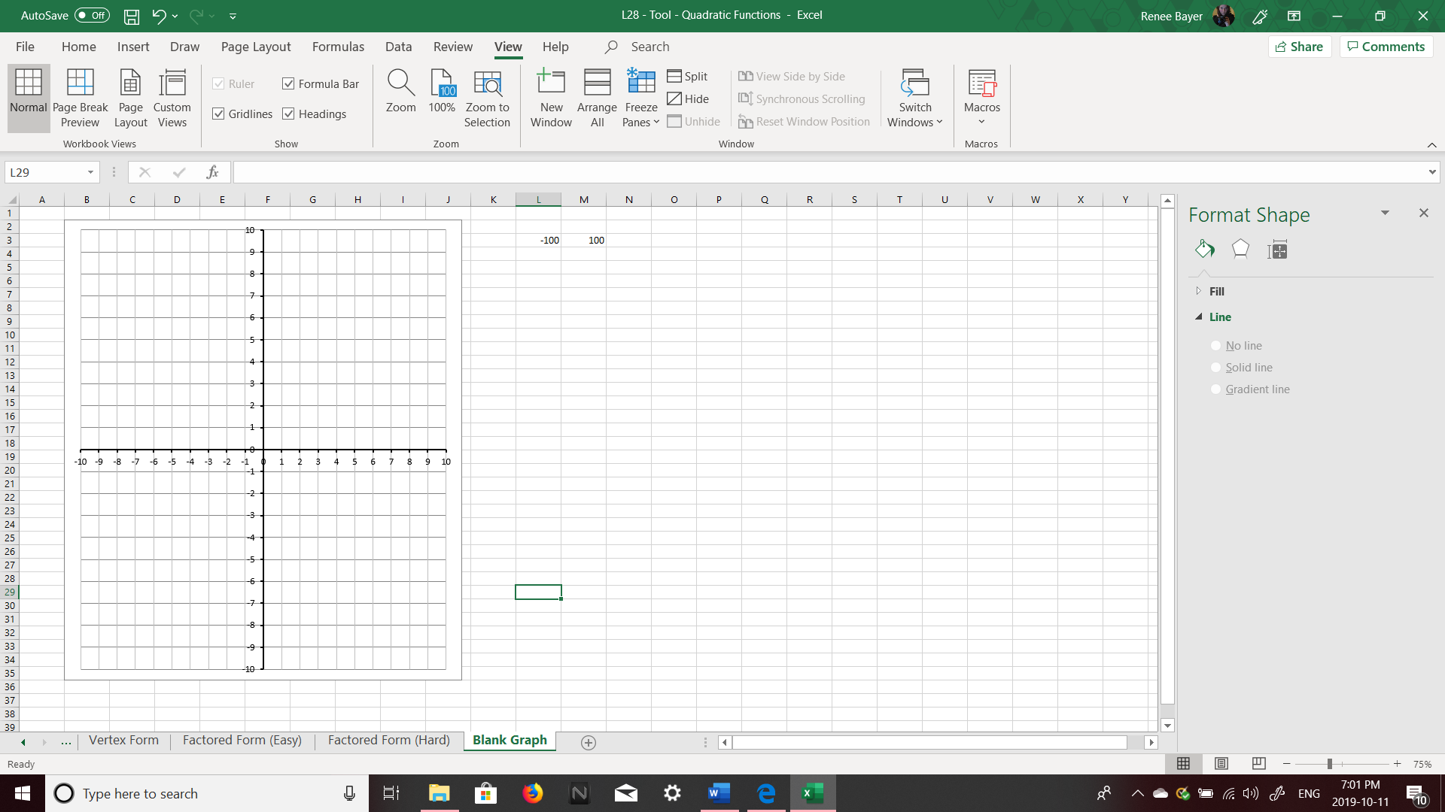
L35Q4: Use graphing to solve the inequality $-2x^{2}+12x-10≥0$.
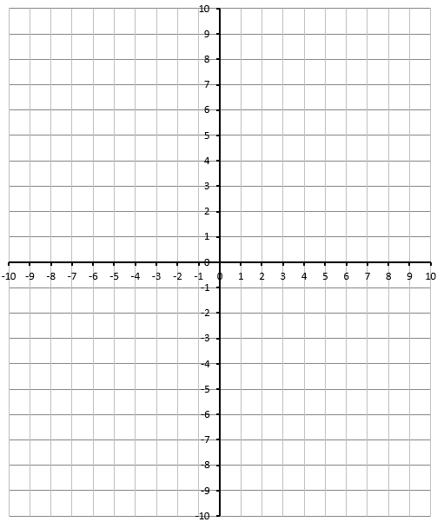
L36Q2: Solve the inequality $\frac{1}{2}x^{2}+2x-6<0$ L36Q3: Graph the inequality $y<\frac{1}{2}x^{2}+2x-6$

Unit 3 – Absolute Values (Ch7)
L42Q3: Given the function, sketch the absolute value function on the same graph paper.
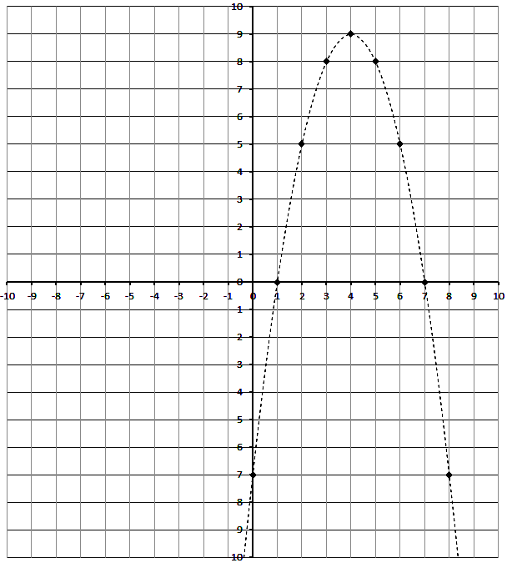
L42Q4: For the given graph, determine the piecewise function.
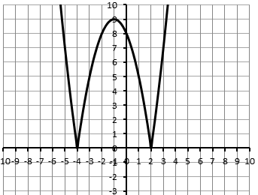

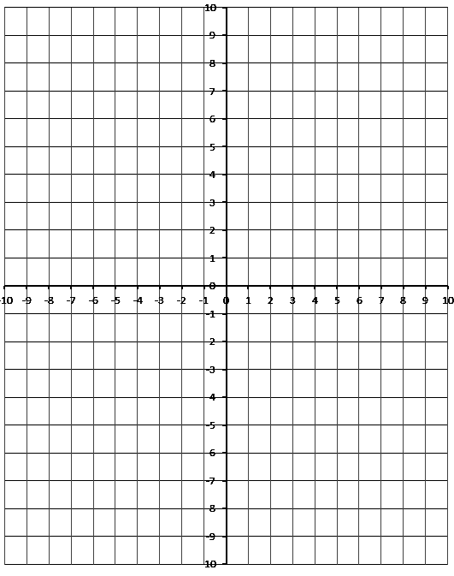
L43Q4: Solve $\left|x^{2}+4x-6\right|=6$

L45Q3: Given the function $f\left(x\right)=2x+1$
- Build a table for $y=f(x)$ and $y=\frac{1}{f(x)}$ .
$$x$$ | $$y=f(x)$$ | $$y=\frac{1}{f(x)}$$
-3
-2
-1
0
1
2
3

- Sketch both functions on the graph paper.
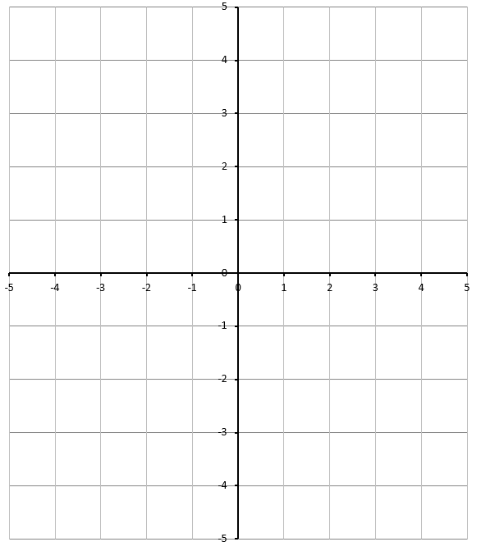

- Identify (a) the NPV’s for the reciprocal function, (b) the equation of the vertical asymptote of the reciprocal function, (c) the Invariant Point(s).

Unit 3 – Trigonometry (Ch2)
Use the following information to answer L48Q13:
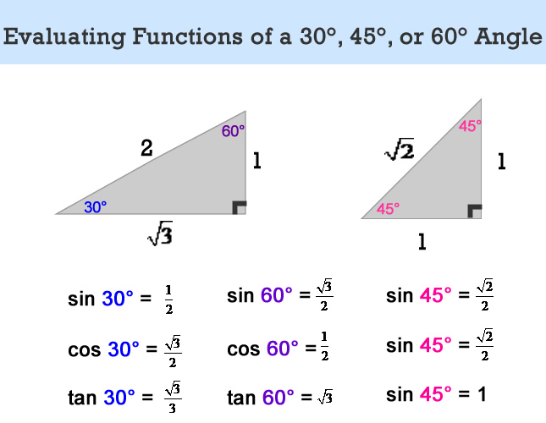
L48Q13: Given the triangles below, determine the exact value of x.
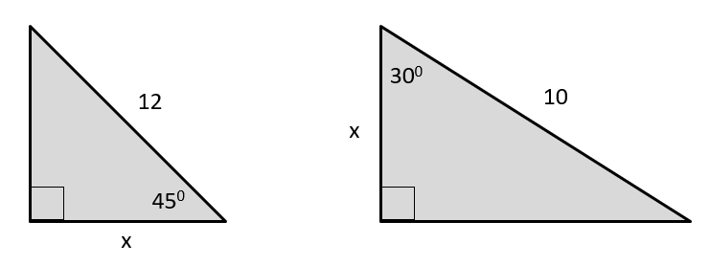

L49Q2: Determine the trigonometric ratios for each triangle.
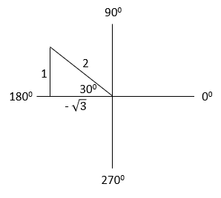
L49Q4: Solve each equation, for $0≤θ<360 deg$ , using a diagram involving a special right triangle.
 | Sketch of Angle in Standard Position | Sketch of Special Right Triangle | Solution to Equation
$$Tanθ=\frac{1}{\sqrt{3}}$$ | 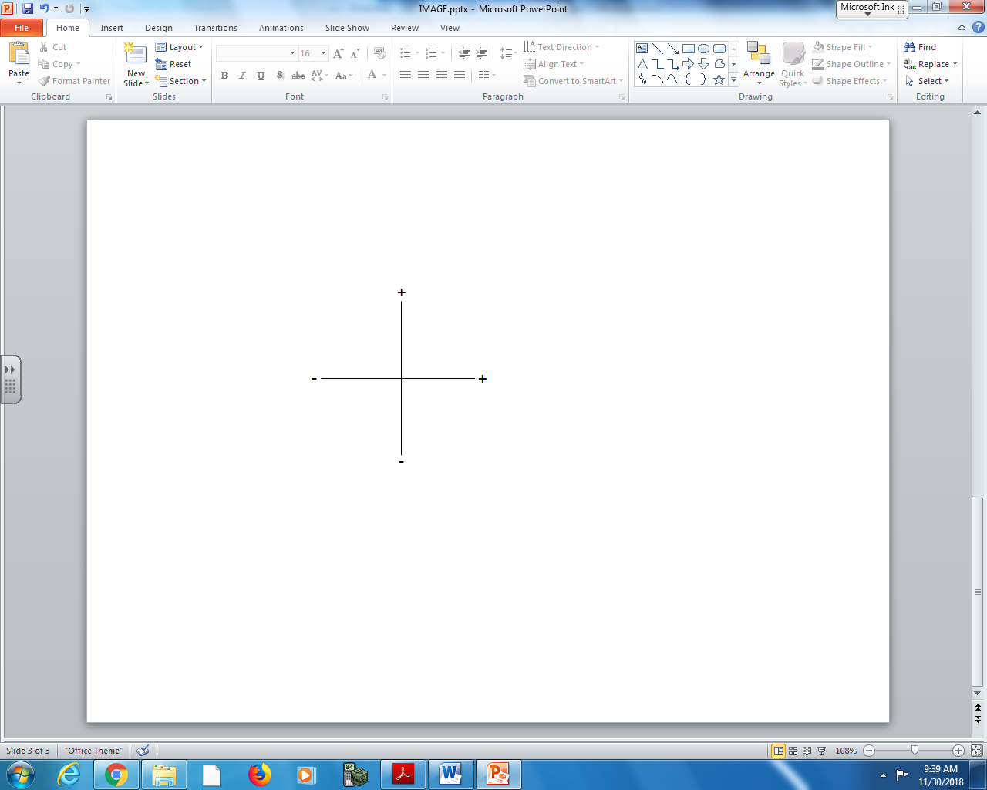
$$Cosθ=-\frac{1}{2}$$

L51Q5: Solve the triangle.
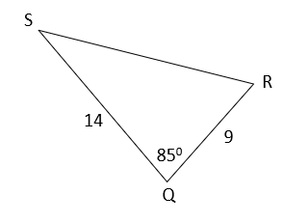

Unit 4 – Radicals (Ch5)
L58Q9: Simplify the expression $\sqrt{98}+\sqrt{12}+\sqrt{18}-\sqrt{75}$

L59Q3: Simplify each of the following:
$(\sqrt{50x^{2}})(5\sqrt{3x}+\sqrt{2})$

L60Q1: Simplify the following expressions:
$\frac{\sqrt{40}}{\sqrt{10}}$ $\frac{2\sqrt{18}}{4\sqrt{2}}$ $\frac{3\sqrt{26}}{\sqrt{13}}$

L60Q4: Rationalize the Denominator:
$\frac{2+\sqrt{5}}{\sqrt{5}+3}$ $\frac{\sqrt{3}-2}{5-\sqrt{3}}$

L62Q4: Solve the radical equation $\sqrt{-2x+13}=x+1$ and verify your solution(s).

Unit 4 – Sequences and Series (Ch1)
Arithmetic Sequences $t_{n}=t_{1}+\left(n-1\right)d$ $t_{1}$ is the first term
$n$ is the number of terms $\left(n∈N\right)$ $d$ is the common difference $t_{n}$ is the general term or n^{th} term
Use the following information to answer L65Q3:
An Arithmetic Sequence is shown below:
100, 96, 92, 88…
L65Q3: Determine the 18th term in the sequence.

Use the following information to answer L65Q18:
An Arithmetic Sequence is shown below:
-2 + 3 + 8 + 13 + …

L65Q18: What is the sum of the first 10 terms?

