L68 –Geometric Sequences and Series
Part 1 – Arithmetic Sequences
Use the following information to answer Q1-Q2:
An Arithmetic Sequence is shown below:
23, 27, 31, 35…
Q1: Determine the 20th term in the sequence.

Q2: What term is the number 131?

Part 2 – Arithmetic Series
Use the following information to answer Q3-4:
An Arithmetic Series is shown below:
-10 – 4 + 2 + 8 + …

Q3: What is the Common Difference?

Q4: What is the sum of the first 20 terms?

Part 3 – Geometric Sequences
Use the following information to answer Q5-Q6:
A Geometric Sequence is shown below:
5, -10, 20, -40…
Q5: Determine the 20th term in the sequence.

Q6: What term is the number 81,920?

Use the following information to answer Q7-Q8:
A Geometric Sequence is shown below:
-5, -15, -45, -135…
Q7: What is the Common Ratio?

Q8: What is the value of the 18th term in the sequence?

Part 4 – Geometric Series
Use the following information to answer Q9-10:
A Geometric Series is shown below:
20 + 10 + 5 + 2.5 + …

Q9: What is the Common Ratio?

Q10: What is the sum of the first 20 terms?

Use the following information to answer Q11-12:
A Geometric Series is shown below:
8 + 12.8 + 20.48 + 32.768 + …

Q11: What is the Common Ratio?

Q12: What is the sum of the first 15 terms?

Part 5 – Mix of Questions
Use the following information to answer Q13-14:
In a sequence, the 5th term is 200 and the 7th term is 450.

Q13: If this was an Arithmetic Sequence, what is the common difference?

Q14: If this was a Geometric Sequence, what is the common ratio?

Use the following information to answer Q15:
A Series is shown below:
$$\frac{1}{2}+\frac{1}{4}+\frac{1}{8}+…$$

Q15: Determine the sum of the first 12 terms.

Part 6 – Cumulative Review
L08, Pg 348 #8: The sum of two numbers is 25. The sum of their reciprocals is $\frac{1}{4}$. Determine the two numbers.

L21, Q14: Solve the equation $2x^{2}=3x+4$ graphically. (3 marks)
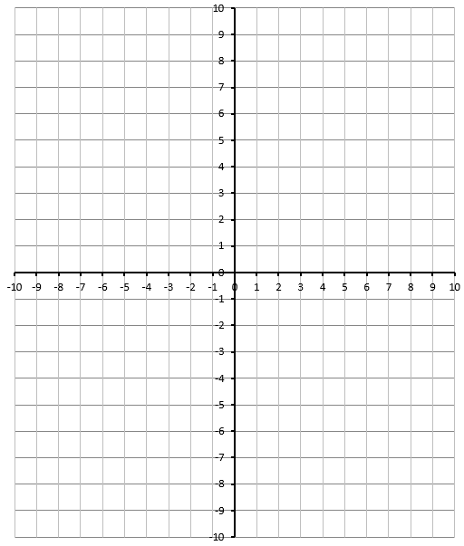

L24&25, Q6: The equation $f\left(x\right)=x^{2}+2x-8$ can be written in several different forms:
Standard Form Vertex Form Factored Form

L24&25, Q7: Using each of form of the equation above (from L24&25, Q6), complete the table.
Equation Form | Information | How did you find this information?
Standard Form | y-Intercept
Vertex Form | Axis of Symmetry
Vertex Form | Vertex Coordinate
Factored Form | Zeroes
Factored Form | Axis of Symmetry
Factored Form | Vertex Coordinate

Use the following information to answer L24&25, Q10-14:
$$f\left(x\right)=3(x-1)(x+5)$$

L24&25, Q10: Determine the x-intercept(s) of this function.

L24&25, Q11: Using the x-intercepts, determine the coordinates of the vertex.

L24&25, Q12: Determine the y-intercept of this function.

L24&25, Q13: Convert to Standard Form to confirm the y-intercept.

L24&25, Q14: Convert to Vertex Form to confirm the coordinates of the vertex.

Use the following information to answer L32, Q11:
Use the following equations for Q11:
$$f\left(x\right)=2x^{2}+5x-10$$
$$g\left(x\right)={-x}^{2}+3x+7$$

L32, Q11: Use Elimination to determine the exact solution to the system of equations.

Use the following information to answer L32, Q12
A kangaroo is jumping horizontally. The height as a function of horizontal distance, in meters, is:
$$h\left(x\right)=-x^{2}+5x$$
The kangaroo is jumping uphill. The height of the hill as a function of horizontal distance, in meters, is:
$$g\left(x\right)=\frac{1}{2}x$$
The quick sketch of the jump is as follows:
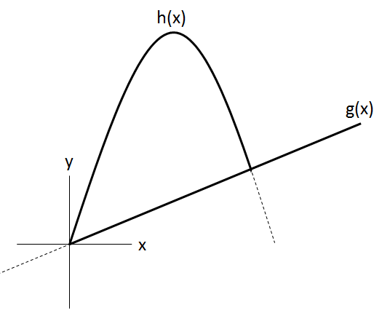

L32, Q12: Algebraically determine the horizontal distance travelled by the kangaroo.

L37, Pg 496 #13: A highway goes under a bridge formed by a parabolic arch, as shown. The highest point of the arch is 5 m high. The road is 10 m wide, and the minimum height of the bridge over the road is 4 m.
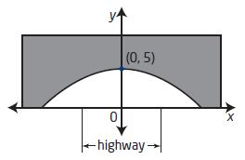
- Determine the quadratic function that models the parabolic arch of the bridge.
- What is the inequality that represents the space under the bridge in quadrants I and II?

