L70 – Worksheet – Arithmetic and Geometric Sequences and Series
Part 1 – Arithmetic Sequences and Series (Easy)
Use the following information to answer Q1-Q2:
A sequence and series are shown below:
Arithmetic Sequence: 5.2, 6.8, 8.4, 10, …
Arithmetic Series: 5.2 + 6.8 + 8.4 + 10 + …
Q1: What is the value of the fifth term, to the nearest tenth?
(Record your answer in the Numerical Response boxes below)

Q2: The value of the 12th term is $t_{12}=ab.c$ , where a, b, and c are ___, ___, and ___.
(Record your three-digit answer in the Numerical Response boxes below)

Q3: The sum of the first 15 terms is
- 27.6
- 74.4
- 246
- 570

Part 2 – Geometric Sequences and Series (Easy)
Use the following information to answer Q4-Q6:
A sequence and series are shown below:
Geometric Sequence: 40, 60, 90, 135, …
Geometric Series: 40 + 60 + 90 + 135 + …

Q4: What is the value of the fifth term?
- 155
- 165
- 180
- 202.5

Q5: Determine the value of the 12th term, rounded to the nearest whole number.
(Record your three-digit answer in the Numerical Response boxes below)

Q6: Determine the sum of the first 8 terms, rounded to the nearest whole number.
(Record your three-digit answer in the Numerical Response boxes below)

Part 3 – Infinite Geometric Series (Easy)
Use the following information to answer Q7-Q9:
Several Series are listed below:
Series A: 5 + 10 + 20 + 40 + …
Series B: 20 + 10 + 5 + 2.5 + …
Series C: 81 – 54 + 36 – 24 + …
Series D: 10 + 10.5 + 11 + 11.5 + …
Q7: How many of the series listed above are converging series?
- 1
- 2
- 3
- 4

Q8: Determine the sum of Series B.
(Record your three-digit answer in the Numerical Response boxes below)

Q9: Determine the sum of Series C.
(Record your three-digit answer in the Numerical Response boxes below)

Part 6 – Word Problems (Medium)
Q10: Billy decides to do 3 good deeds. Every recipient of one of his good deeds decides to “pay it forward” and do 3 good deeds of their own.
- Build a Series showing the first 4 terms, in the form $S_{n}=t_{1}+t_{2}+t_{3}+t_{4}+…$
- Is this an Arithmetic or Geometric Series? Explain.
- Sally is the 10th person in the chain to commit 3 good deeds. Once she completes her 3 good deeds, how many good deeds have been done, in total?

Use the following information to answer Q11:
A fractal is a curve or geometric figure, each part of which has the same statistical character as the whole. Fractals are useful in modeling structures (such as eroded coastlines or snowflakes) in which similar patterns recur at progressively smaller scales, and in describing partly random or chaotic phenomena such as crystal growth, fluid turbulence, and galaxy formation.
A fractal pattern is depicted below:
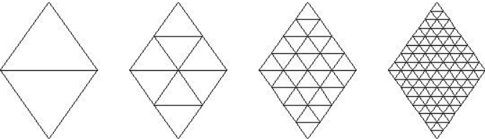

Q11: How many tiny triangles are required to make the 8th shape in the sequence?

Use the following information to answer Q12:
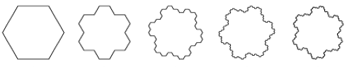
Figure 1 Figure 2 Figure 3 Figure 4 Figure 5
Q12: In the fractal pattern shown above, how many sides does Figure 10 have?

Part 7 – Arithmetic and Geometric Sequences and Series (Hard)
Use the following information to answer Q13-Q15:
$$\frac{5}{8}-\frac{5}{12}+\frac{5}{18}-\frac{5}{27}+…$$
Q13: Which best describes the information in the textbox above?
- Arithmetic Sequence
- Arithmetic Series
- Geometric Sequence
- Geometric Series (Diverging)
- Geometric Series (Converging)
- None of the above
Q14: The value of the 5th term is $t_{5}=\frac{ab}{cd}$ , where a, b, c, and d are ___, ___, ___, and ___.
(Record your four-digit answer in the Numerical Response boxes below)

Q15: The sum of the first 8 terms is approximately a.bc, where a, b, and c are ___, ___, and ___.
(Record your three-digit answer in the Numerical Response boxes below)

Use the following information to answer Q16:
The fourth term in a sequence is 192. The seventh term is 1029.
Q16: If the sequence is an Arithmetic Sequence, determine the sum of the first 10 terms.

Q17: If the sequence is a Geometric Sequence, determine the sum of the first 10 terms.

