L72 – Worksheet –Unit Review

Part 1: Entire to Mixed Radicals
Q1: For each entire radical, write it as a mixed radical.
$\sqrt{75x^{3}y^{2}}$ $\sqrt{8x^{4}y^{3}z^{2}}$

Part 2: Non-Permissible Values and Restrictions
Q2: For each of the following radicals, state the restrictions on the variable x.
$\sqrt{2x+1}$ $\sqrt{3x-1}$

Q3: For each of the following radicals, state the restrictions on the variable $x$
$\sqrt{2x+7}$ $\sqrt{5-3x}$

Q4: Given the expression $\sqrt{x^{2}-4}$ , which of the following correctly describes the restrictions on x?
- $x>2$
- $x≥2$
- $x>2$ or $x<-2$
- $x≥2$ or $x≤-2$

Part 3: Adding and Subtracting Radicals
Q5: Simplify radicals and combine like terms.
$2\sqrt{5}+7\sqrt{5}$ $\sqrt{28}+\sqrt{63}$

Q6: Simplify radicals and combine like terms.
$\sqrt{75x}-\sqrt{12x}$ $\sqrt{50}-\sqrt{27}+\sqrt{18}-\sqrt{3}$

Q7: The expression $\sqrt{60}+\sqrt{36}+\sqrt{135}$ simplifies to $\sqrt{bc}+d$ , where a, b, c, and d are ___, ___, ___, and ___.
(Record your four digit answer in the Numerical Response boxes below)

Part 4: Rationalizing the Denominator
Q8: For each expression, rationalize the denominator.
$\frac{\sqrt{5}}{\sqrt{7}}$ $\frac{\sqrt{5}-1}{\sqrt{5}}$

Q9: For each expression, rationalize the denominator.
$\frac{\sqrt{7}-3}{\sqrt{7}+2}$ $\frac{\sqrt{3}-1}{1+\sqrt{6}}$

Q10: When rationalizing the denominator of the expression $\frac{\sqrt{5}+3}{\sqrt{5}-1}$ , the expression can be simplified to $a+\sqrt{b}$ , where a and b are ___ and ___.
(Record your two digit answer in the Numerical Response boxes below)

Part 5: Multiplying Radicals
Q11: Multiply. Simplify the products where possible.
$\left(3\sqrt{2}\right)\left(4\sqrt{6}\right)$ $\left(\sqrt{5}+1\right)\left(3-2\sqrt{2}\right)$

Q12: Multiply. Simplify the products where possible.
$\left(2\sqrt{x}+5\right)\left(3\sqrt{x}-4\right)$ $\left(x\sqrt{x}-5\right)\left(4+2\sqrt{x}\right)$

Use the following information to answer Q13-Q15:
An equilateral triangle, ΔABD, is placed inside a square.
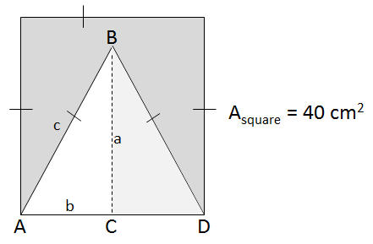
The area of the square is 40 cm².

Q13: The side length of the square, as a mixed radical, is $\sqrt{bc}$ , where a, b, and c are ___, ___, and ___.
(Record your four digit answer in the Numerical Response boxes below)

Q14: The height of the equilateral triangle is
- $5\sqrt{2}$
- $3\sqrt{10}$
- $5\sqrt{10}$
- $\sqrt{30}$

Q15: The area of the equilateral triangle, ΔABD, is $ab\sqrt{c}$ cm², where a, b, and c are ___, ___, and ___.
(Record your three digit answer in the Numerical Response boxes below)

Part 6: Dividing Radicals
Q16: Simplify each expression.
$\frac{4\sqrt{10}}{6\sqrt{5}}$ $\frac{\sqrt{60}}{\sqrt{20}}$

Q17: Simplify each expression using two different methods.
$\frac{\sqrt{90}}{\sqrt{20}}$ $\frac{\sqrt{90}}{\sqrt{20}}$

Q18: The expression $\frac{\sqrt{150}}{\sqrt{12}}$ simplifies to $\frac{a\sqrt{b}}{c}$ , where a, b, and c are ___, ___, and ___.
(Record your three digit answer in the Numerical Response boxes below)

Part 7: Radical Equations (Factorable)
Q19: State the restrictions on x and solve:
$\sqrt{11x+67}=x+7$ $\sqrt{5x+11}=x+3$

Q20: State the restrictions on x and solve:
$\sqrt{-2x+10}=x-1$ $\sqrt{-3x+6}=x-2$

Q21: State the restrictions on x and solve:
$\sqrt{-8x-8}=2x+1$ $\sqrt{18x+3}=3x+2$

Q22: State the restrictions on x and solve:
$\sqrt{x+3}=2x+3$ $\sqrt{-15x-1}=3x-1$

Q23: State the restrictions on x and solve:
$\sqrt{x^{2}+2x}=2x+4$ $\sqrt{x^{2}}=2x+2$

Q24: The expression $\sqrt{-12x-2}=2x-1$ simplifies to $\left(ax+b\right)\left(cx+d\right)=0$ , where the values of a, b, c, and d are ___, ___, ___, and ___.
(Record your four digit answer in the Numerical Response boxes below)

Part 8: Word Problems
Use the following information to answer Q25:
When analyzing car crashes, police use a formula that relates the stopping distance and the initial velocity of the car prior to braking:
$$v_{i}=\sqrt{2μ_{k}gd}$$
Where $v_{i}$ is the initial velocity $μ_{k}$ is the coefficient of kinetic friction, $g$ is the gravitational field strength, and $d$ is the stopping distance.
Additionally, the kinematics equation $d=\left(\frac{v_{i}+v_{f}}{2}\right)t$ , when modelling a braking object coming to a stop, can simplify to
$$v_{i}=\frac{2d}{t}$$
These two equations can be set equal to each other to solve for stopping distance:
$$\sqrt{2μ_{k}gd}=\frac{2d}{t}$$

Q25: A car is travelling at a moderate velocity on wet concrete ($μ_{k}=0.60$) on Earth ($g=9.81)$ before it slams on its brakes, coming to a stop after 3.20 seconds ($t=3.20$). Determine the distance it takes the car to stop, to the nearest tenth of a meter.

Part 9: Radical Equations (Quadratic Equation)
Q26: State the restrictions on x and solve:
$\sqrt{3x+\frac{23}{2}}=x+\frac{1}{2}$

Q27: State the restrictions on x and solve:
$$\sqrt{x+\frac{7}{9}}=x+1$$

Part 10: Arithmetic Sequences and Series (Easy)
Use the following information to answer Q28-Q30:
A sequence and series are shown below:
Arithmetic Sequence: 5.2, 6.8, 8.4, 10, …
Arithmetic Series: 5.2 + 6.8 + 8.4 + 10 + …
Q28: What is the value of the fifth term, to the nearest tenth?
(Record your answer in the Numerical Response boxes below)

Q29: The value of the 12th term is $t_{12}=ab.c$ , where a, b, and c are ___, ___, and ___.
(Record your three-digit answer in the Numerical Response boxes below)

Q30: The sum of the first 15 terms is
- 27.6
- 74.4
- 246
- 570

Part 11: Geometric Sequences and Series (Easy)
Use the following information to answer Q31-Q33:
A sequence and series are shown below:
Geometric Sequence: 40, 60, 90, 135, …
Geometric Series: 40 + 60 + 90 + 135 + …

Q31: What is the value of the fifth term?
- 155
- 165
- 180
- 202.5

Q32: Determine the value of the 12th term, rounded to the nearest whole number.
(Record your three-digit answer in the Numerical Response boxes below)

Q33: Determine the sum of the first 8 terms, rounded to the nearest whole number.
(Record your three-digit answer in the Numerical Response boxes below)

Part 12: Infinite Geometric Series (Easy)
Use the following information to answer Q34-36:
Several Series are listed below:
Series A: 5 + 10 + 20 + 40 + …
Series B: 20 + 10 + 5 + 2.5 + …
Series C: 81 – 54 + 36 – 24 + …
Series D: 10 + 10.5 + 11 + 11.5 + …
Q34: How many of the series listed above are converging series?
- 1
- 2
- 3
- 4

Q35: Determine the sum of Series B.
(Record your three-digit answer in the Numerical Response boxes below)

Q36: Determine the sum of Series C.
(Record your three-digit answer in the Numerical Response boxes below)

Part 13: Word Problems (Medium)
Q37: Billy decides to do 3 good deeds. Every recipient of one of his good deeds decides to “pay it forward” and do 3 good deeds of their own.
- Build a Series showing the first 4 terms, in the form $S_{n}=t_{1}+t_{2}+t_{3}+t_{4}+…$
- Is this an Arithmetic or Geometric Series? Explain.
- Sally is the 10th person in the chain to commit 3 good deeds. Once she completes her 3 good deeds, how many good deeds have been done, in total?

Use the following information to answer Q38:
A fractal is a curve or geometric figure, each part of which has the same statistical character as the whole. Fractals are useful in modeling structures (such as eroded coastlines or snowflakes) in which similar patterns recur at progressively smaller scales, and in describing partly random or chaotic phenomena such as crystal growth, fluid turbulence, and galaxy formation.
A fractal pattern is depicted below:
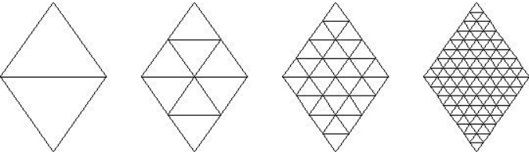

Q38: How many tiny triangles are required to make the 8th shape in the sequence?

Use the following information to answer Q39:
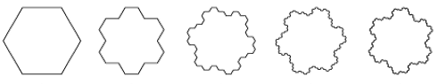
Figure 1 Figure 2 Figure 3 Figure 4 Figure 5
Q39: In the fractal pattern shown above, how many sides does Figure 10 have?

Part 14: Arithmetic and Geometric Sequences and Series (Hard)
Use the following information to answer Q40-Q42:
$$\frac{5}{8}-\frac{5}{12}+\frac{5}{18}-\frac{5}{27}+…$$
Q40: Which best describes the information in the textbox above?
- Arithmetic Sequence
- Arithmetic Series
- Geometric Sequence
- Geometric Series (Diverging)
- Geometric Series (Converging)
- None of the above
Q41: The value of the 5th term is $t_{5}=\frac{ab}{cd}$ , where a, b, c, and d are ___, ___, ___, and ___.
(Record your four-digit answer in the Numerical Response boxes below)

Q42: The sum of the first 8 terms is approximately a.bc, where a, b, and c are ___, ___, and ___.
(Record your three-digit answer in the Numerical Response boxes below)

Use the following information to answer Q43-Q44:
The fourth term in a sequence is 192. The seventh term is 1029.
Q43: If the sequence is an Arithmetic Sequence, determine the sum of the first 10 terms.

Q44: If the sequence is a Geometric Sequence, determine the sum of the first 10 terms.

Part 15: Challenge Questions (Very hard… especially the last one)
Use the following information to answer Q45:
Students will determine the length of side AB, conveniently labelled x.
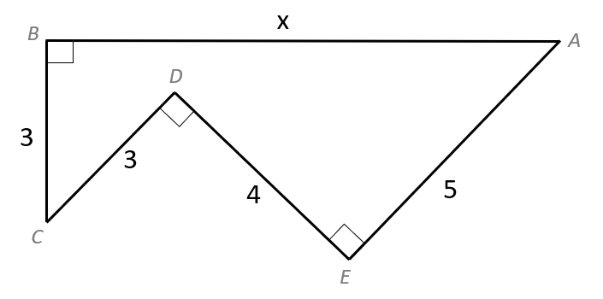

Original problem posted by “MindYourDecisions” on YouTube.
(https://www.youtube.com/watch?v=kfijuP5HDjU)
Q45: Students will determine the length of side AB.
- Draw line AC.
- Draw a triangle, with AC as its hypotenuse and one side passing through point E, and determine the length and height of the triangle.
- Use Pythagoras Theorem to determine the length of AC.
- Use triangle ABC to determine the length of side AB.
Use the following information to answer Q46
Determine the side length of the square, AF, conveniently labelled x.
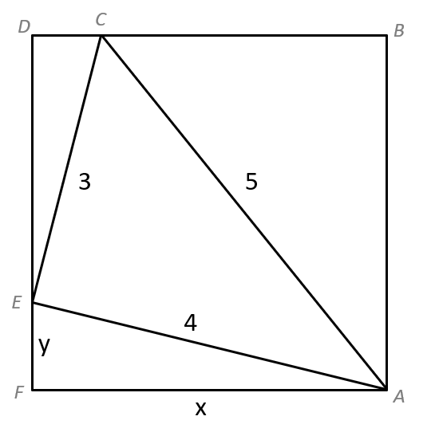
Original problem posted by “MindYourDecisions” on YouTube.
(https://www.youtube.com/watch?v=aQsb5jfqSYo)
Q46: Students will determine the length of the square, AF.
- Prove that ∠EAF has the same value as ∠CED.
- Determine the length of side DE in terms of x and y.
- Using similar triangles ΔEAF and ΔCED, write y in terms of x.
- Use ΔEAF to determine the value of x.

Space to work on Q46.
Use the following information to answer Q47:
Five squares are depicted below. Determine the area of the largest square.
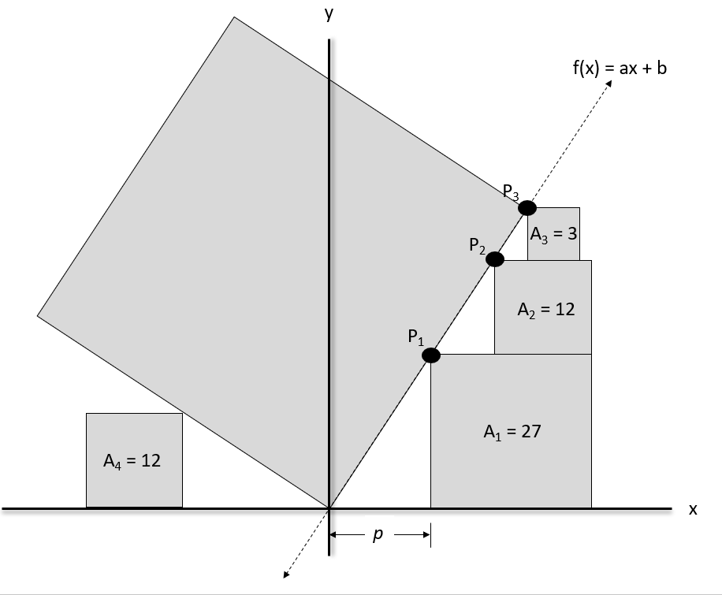
Original problem posed by “Flammable Maths” on YouTube.
(https://www.youtube.com/watch?v=cD9FsAAaKnE)
Q47: Students will determine the area of the largest square.
- Determine the side length, as a mixed radical, for the three small squares on the right side.
- Determine the coordinates of P₁ and P₂ in terms of the value p.
- Use points P₁ and P₂ , along with your Slope Equation, to determine the function f(x).
- Use the function f(x) to determine the coordinates of point P₃.
- Use the coordinates of point P₃ to determine the side length of the largest square.
- Use the side length of the largest square to determine its area.

Space to work on Q47.

