First Name:______________________________ Last Name:______________________________

Math 10C – Practice Final Exam

Competency #C3 – Connect numbers to real-life problems. ___ /5 marks
Competency #C4 – Communicate ideas effectively using graphs. ___ / 6 marks
Competency #C2 – Use algebra to solve real-life problems. ___ / 13 marks
Competency #C6 – Use tools and estimation to determine measurement ___ / 6 marks
Competency #C7 – Use trigonometry to solve real-life problems ___ / 4 marks

Competency 3 – Connect numbers to real-life problems. 5 POINTS
- Write $3xy^{2}\sqrt{2x}$ as an entire radical. (2 marks)

- Simplify with positive exponents. (3 marks)

$$\frac{{\left(x^{5}y^{-2}z^{\frac{1}{2}}\right)}^{3}}{{\left[{\left(x^{\frac{2}{3}}y^{-1}\right)}^{2}\left(z\right)\right]}^{5}}$$

Competency 4 – Communicate ideas effectively using graphs. 6 POINTS
- Mr. Bayer’s cat David is getting old. He was originally 20 lbs when he moved to Alberta, and has since lost 0.5lbs per year. He has lived in Alberta for 6 years. (6 points)
- Sketch a graph of David’s weight versus time to represent David’s weight over the last 6 years, where w represents David’s weight, in pounds, and t represents time, in years. (2 points)
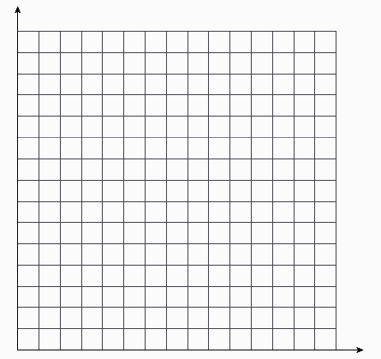

- State the dependent and independent variables. (1 point)

- Determine the range using Set Notation. (1 point)

- What does the w-intercept represent (1 point)

- Determine the domain using Interval Notation. (1 point)

Competency 2 – Use algebra to solve real-life problems. 13 POINTS
- Factor the following equations. (2 marks)
- $x^{2}+x-12$ b) $x^{2}+4x-12$

- Below is a three-dimensional box with a volume of $2x^{3}+5x^{2}+2x$. (3 marks)
Note: None of the side lengths are 1 unit.

- Write expressions for the dimensions of the box by fully factoring the volume.

- If x= 8cm, what is the length of the shortest of the three sides?

- If x = 8cm, what is the volume of the box?

- Use the data table below to write an equation in the form y=mx+b. (3 marks)
x | y
15 | 100
18 | 90
21 | 80

- Arming for the zombie apocalypse, Bill and Ted purchase weapons.
- Bill buys 3 hatchets and 5 shovels for $81.75
- Ted buys 1 hatchet and 3 shovels for $38.25
What are the prices of hatchets and shovels? (5 marks)

Competency 6 – Use tools and estimation to determine measurement. 6 POINTS
- Calculate the Volume and Surface Area for each shape. Convert to inch² or inch³ when you are done.
- The rectangular prism (3 marks)
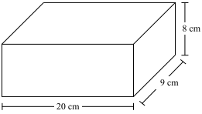

- The cone (3 marks)
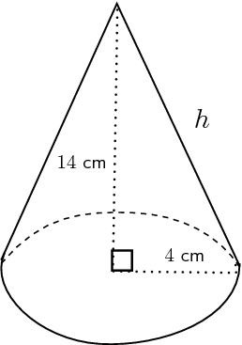

Competency 7 – Use trigonometry to solve real-life problems. 4 POINTS
Two buildings are depicted below.
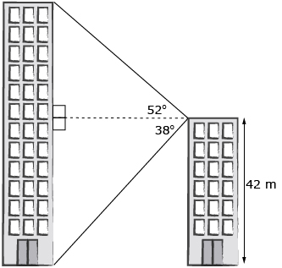
- A) How far apart are the two buildings? Express your answer to the nearest tenth of a meter (1 mark)

b) What is the height of the tallest building? Express your answer to the nearest tenth of a meter. (3 marks)

