First Name:______________________________ Last Name:______________________________

L01 – Worksheet – Electrical Interactions and Electroscopes

Textbook Questions
None
Diploma Worksheet Questions – Definitions and Electronegativity
Q53: The statement that the net amount of charge in a closed system is constant is an expression of the law of conservation of
- Charge
- Energy
- Mass-energy
- Electrostatic forces

Q54: The coulomb is defined as one
- Ampere-second
- Volt per second
- Electronic charge
- Ampere per second

Q55: Two objects can become charged when rubbed together because
- Like charges repel and unlike charges attract
- Negative charges redistribute but positive charges remain fixed
- Both positive and negative charges redistribute when the objects touch
- Positive charges move from one object to another when the objects touch

Diploma Worksheet Questions – Conduction and Conservation of Charge
Use the following information to answer Q61:
Two conducting spheres have identical surface areas. Sphere A has a charge of 4.50 μC. Sphere B has a charge of -2.40 μC. Spheres A and B are brought into momentary contact and separated to a distance of 2.50 cm.

Q61: After contact, the charge on sphere A is
- 1.05 μC
- 2.10 μC
- 3.45 μC
- 6.90 μC

Diploma Worksheet Questions – Induction and Electroscopes
Use the following information to answer Q63:
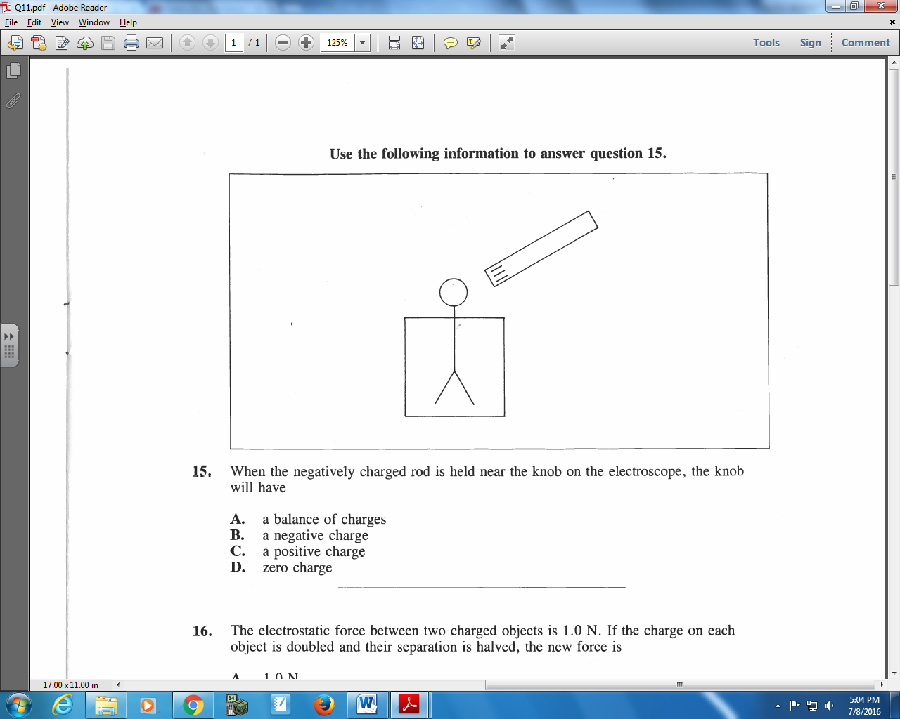

Q63: When the negatively charged rod is held near the knob on the electroscope, the knob will have
- A balance of charges
- A negative charge
- A positive charge
- Zero charge

Q64: A negatively-charged rod is brought near an uncharged piece of paper. A force of attraction results because the
- Paper gains protons
- Paper loses electrons
- Protons rearrange themselves
- Electrons rearrange themselves

Use the following information to answer Q70:
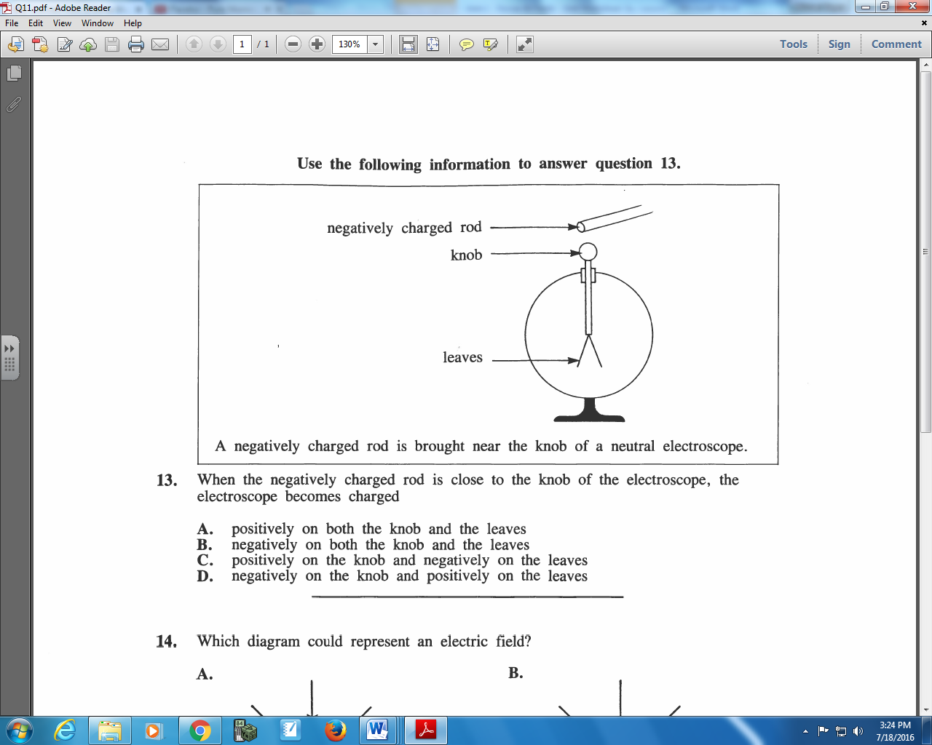

Q70: When the negatively charged rod is close to the knob of the electroscope, the electroscope becomes charged
- Positively on both the knob and the leaves
- Negatively on both the knob and the leaves
- Positively on the knob and negatively on the leaves
- Negatively on the knob and positively on the leaves

Use the following information to answer Q74:
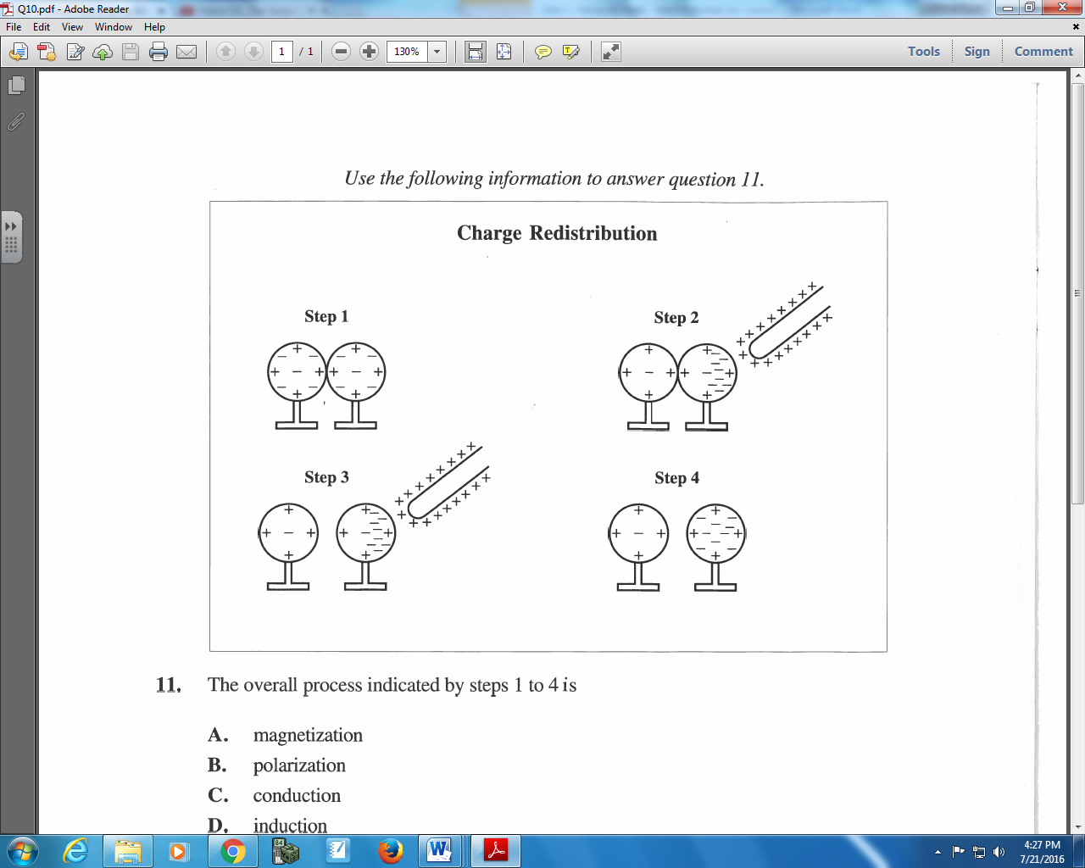

Q74: The overall process indicated by steps 1 to 4 is
- Magnetization
- Polarization
- Conduction
- Induction

Use the following information to answer Q75:
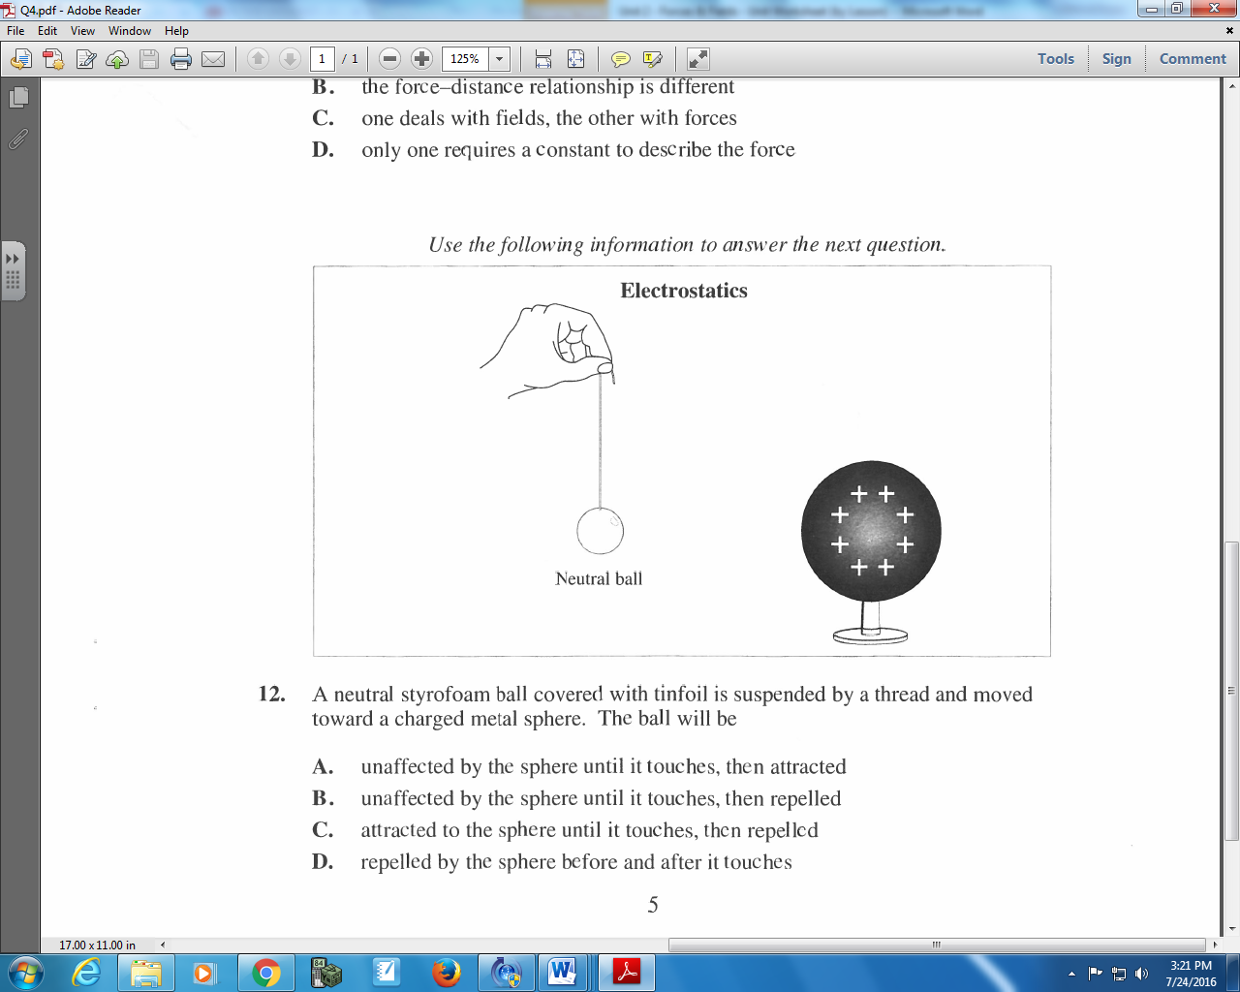

Q75: A neutral Styrofoam ball covered with tinfoil is suspended by a thread and moved toward a charged metal sphere. The ball will be
- Unaffected by the sphere until it touches, then attracted
- Unaffected by the sphere until it touches, then repelled
- Attracted to the sphere until it touches, then repelled
- Repelled by the sphere before and after it touches

Use the following information to answer Q80:
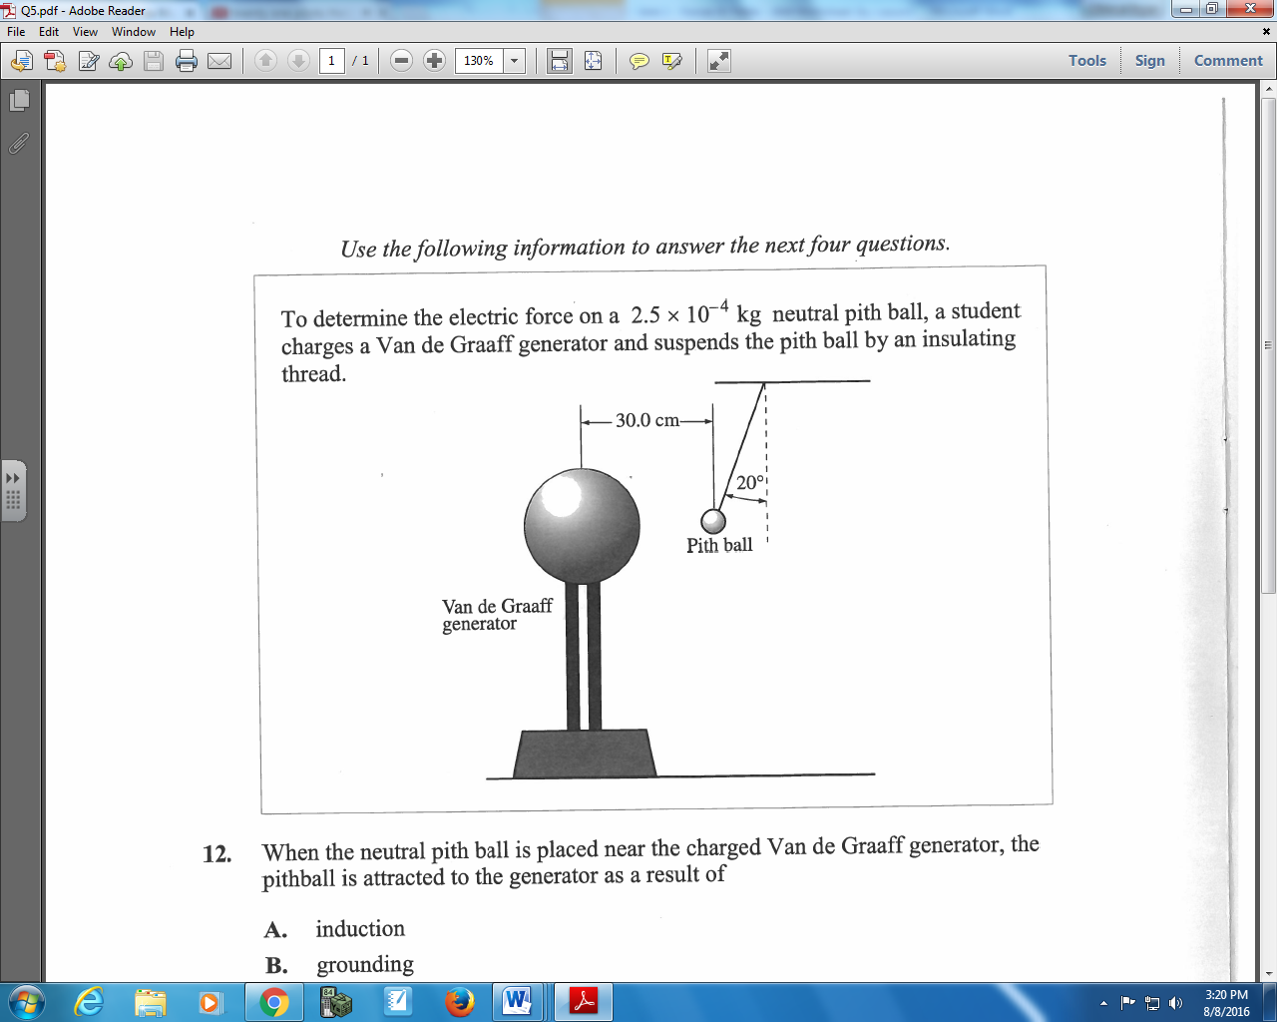

Q80: When the neutral pith ball is placed near the charged Van de Graaff generator, the pithball is attracted to the generator as a result of
- Induction
- Grounding
- Conduction
- Induction and grounding
Use the following information to answer Q83:
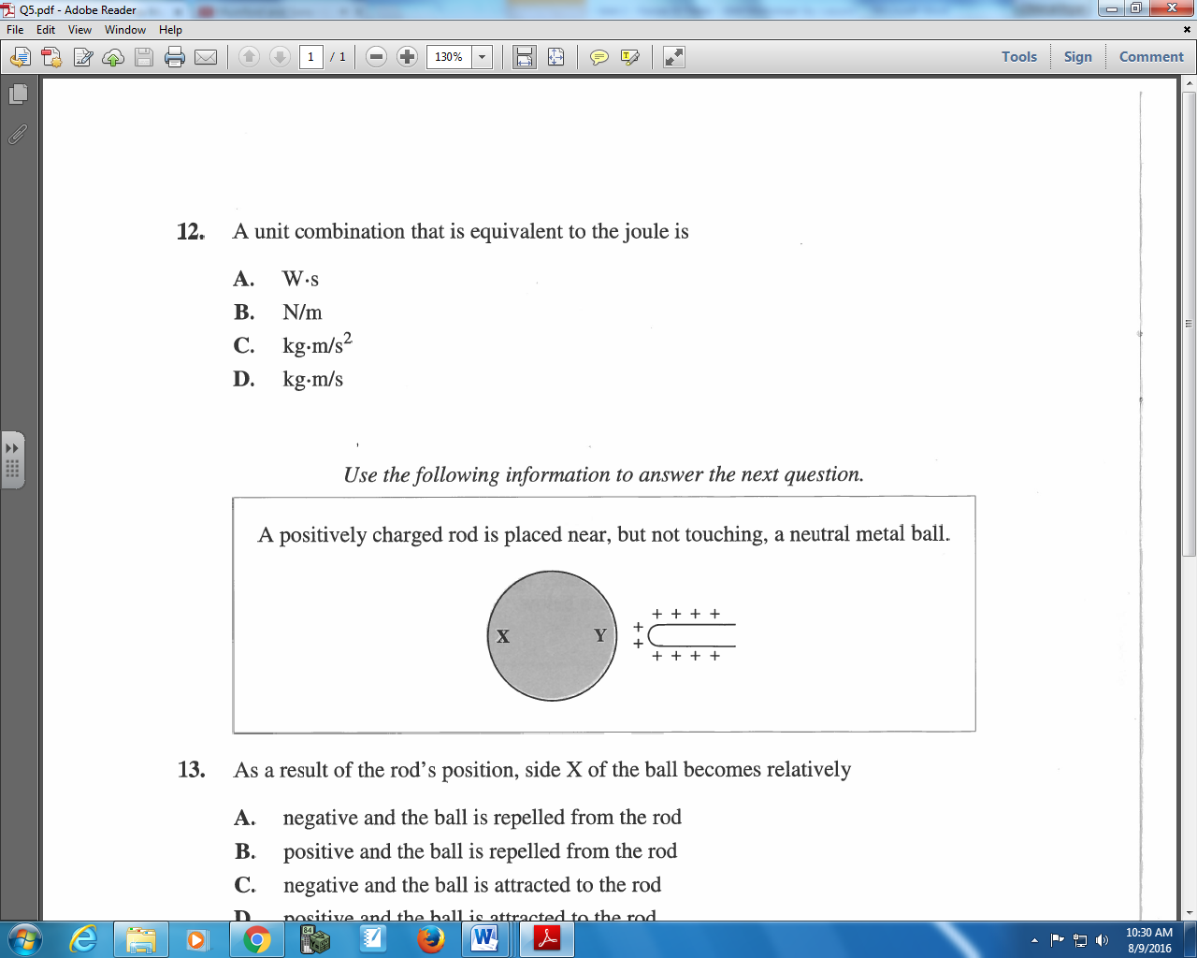

Q83: As a result of the rod’s position, side X of the ball becomes relatively
- Negative and the ball is repelled from the rod
- Positive and the ball is repelled from the rod
- Negative and the ball is attracted to the rod
- Positive and the ball is attracted to the rod
Cumulative Review from Previous Units
Use the following information to answer Q1-Q2:
Two objects collide, per the diagram below:
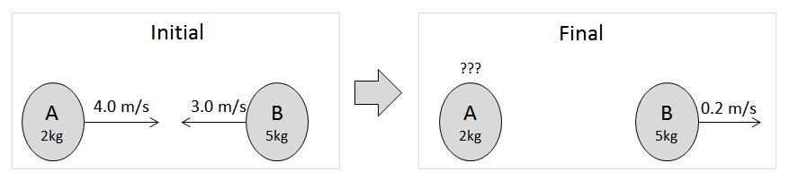

Q1: The final speed of Object A is ____ m/s.
(Record your three digit answer in the Numerical Response boxes below)

Q2: is the collision elastic? Explain.

