First Name:______________________________ Last Name:______________________________
L01 – Worksheet – EMR
EMR (Basic Concepts)
Q399: In an electromagnetic wave, the electric field $\vec{E}$ and the magnetic field $\vec{B}$ are
- Perpendicular
- Parallel
- Constant
- Equal

Use the following information to answer Q400:
A student proposed the following list of possible properties of electromagnetic radiation:
I Electromagnetic radiation travels at the speed of light in free space.
II Electromagnetic radiation has a fixed frequency and wavelength.
III Electromagnetic radiation propagates through the creation of mutually perpendicular
electric and magnetic fields.
IV Electromagnetic radiation has constant electric and magnetic fields which do not vary with
time.

Q400: Which are properties of ALL forms of electromagnetic radiation?
- I only
- I and II
- I and III
- I and IV

Use the following information to answer Q402:
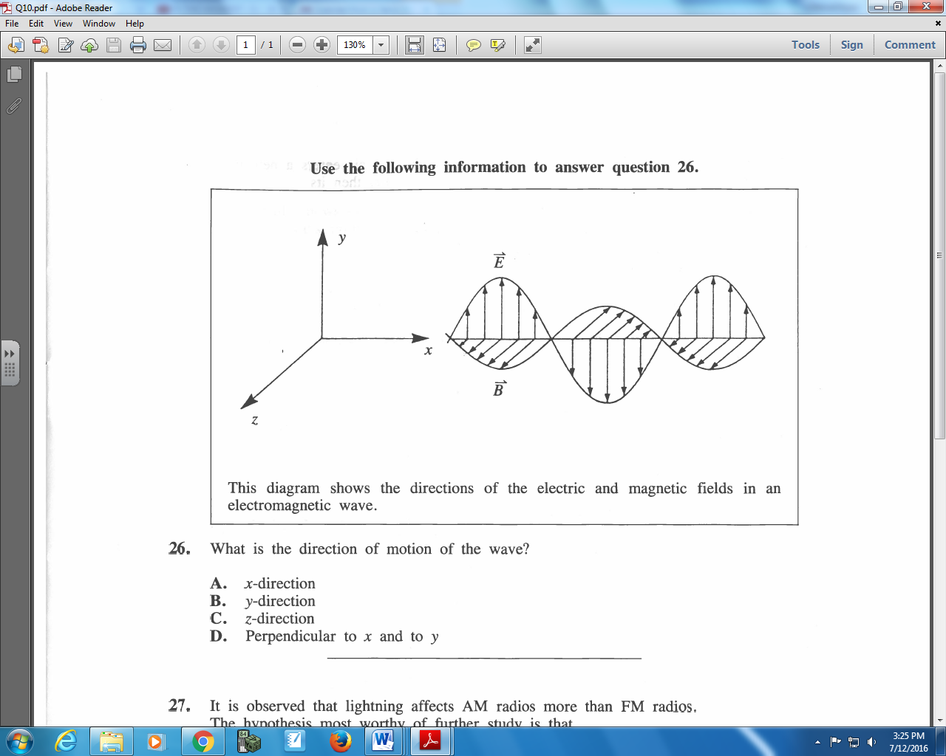

Q402: What is the direction of motion of the wave?
- x-direction
- y-direction
- z-direction
- Perpendicular to x and to y

Use the following information to answer Q404:
Possible Descriptions of Light Waves
- Transverse waves with the magnetic field direction at 180⁰ to the electric field direction.
- Transverse waves with the magnetic field direction at 90⁰ to the electric field direction.
- Longitudinal waves with the magnetic field direction at 180⁰ to the electric field direction.
- Longitudinal waves with the magnetic field direction at 90⁰ to the electric field direction.

Q404: The statement that correctly describes light waves is
- I
- II
- III
- IV
Use the following information to answer Q406:
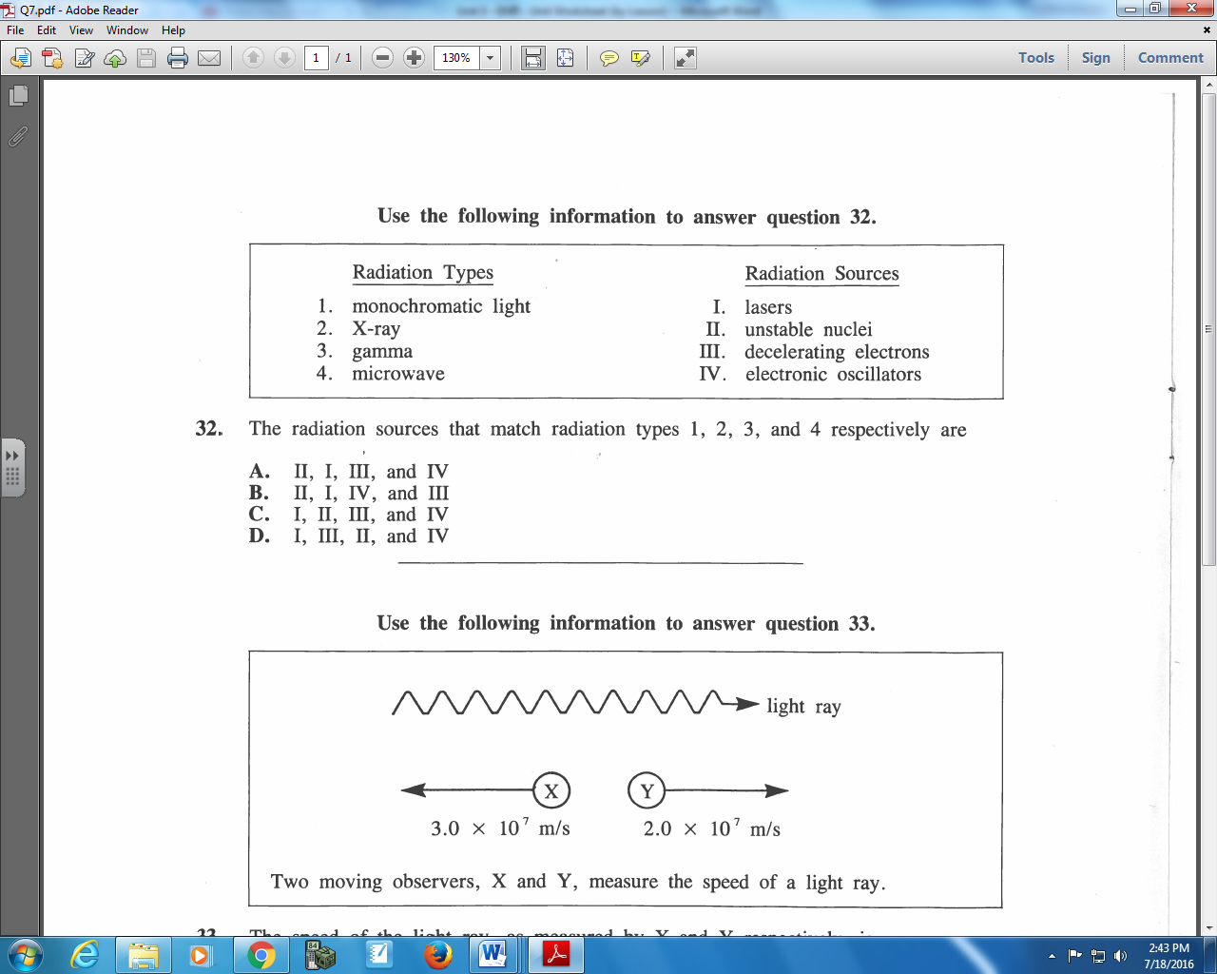

Q406: The radiation sources that match radiation types 1, 2, 3, and 4 respectively are
- II, I, III, and IV
- II, I, IV, and III
- I, II, III, and IV
- I, III, II, and IV

Q407: Visible light travels at the same speed in a vacuum as do
- X-rays
- Beta rays
- Alpha rays
- Cathode rays

Use the following information to answer Q408:
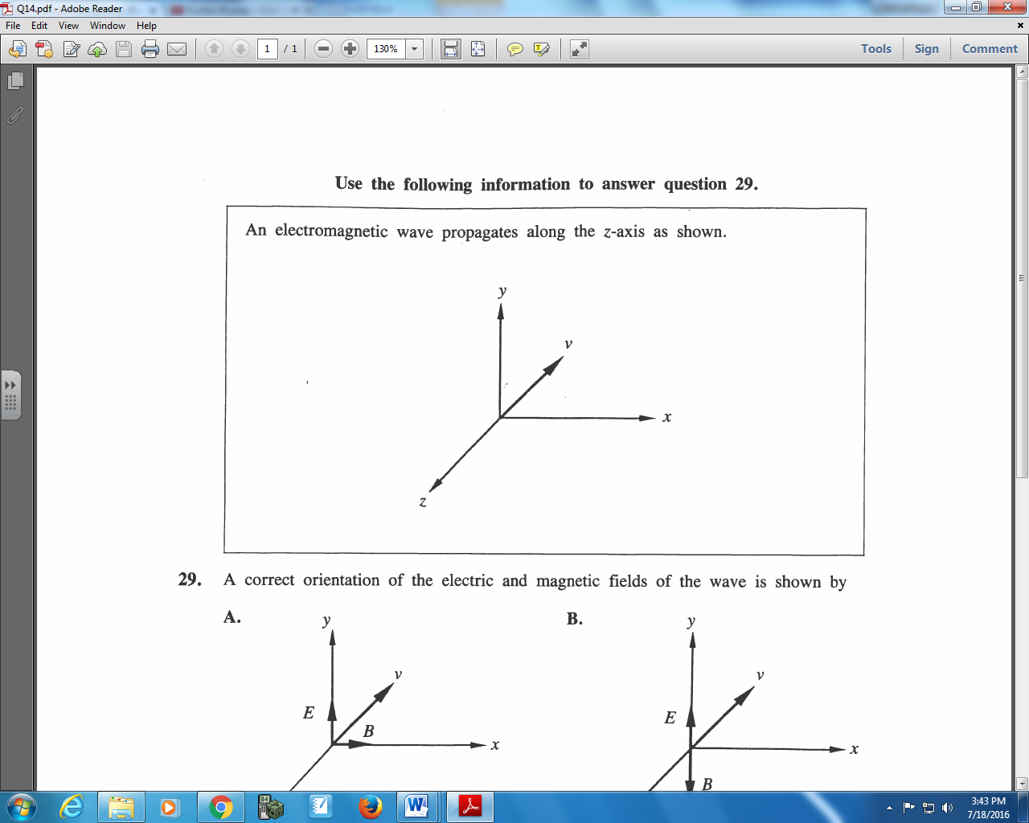

Q408: A correct orientation of the electric and magnetic fields of the wave is shown by
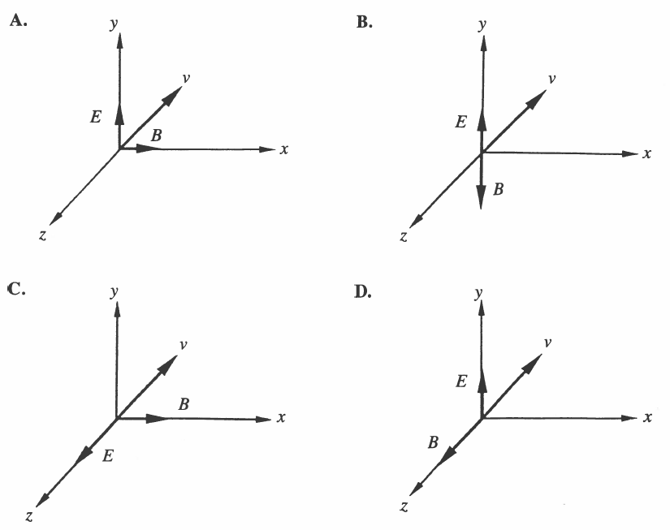

EMR (Order of EMR)
Q433: The color orders from higher to lower frequencies is
- Green, yellow, orange
- Blue, orange, violet
- Yellow, blue, red
- Violet, red, blue

Q438: Compared with visible light waves, ultraviolet waves have a
- Higher speed
- Greater period
- Lower frequency
- Shorter wavelength

Use the following information to answer Q444:
Selected Regions of the Electromagnetic Spectrum
- Television
- Am radio
- Gamma radiation
- Ultraviolet light
- Visible light

Q444: When the regions of the electromagnetic spectrum listed above are arranged in order of increasing wavelength, this order is
- III, I, V, II, IV
- II, I, V, IV, III
- III, IV, V, I, II
- IV, V, III, I, II
EMR (Simple Calculations)
Q446: The period of vibration for a 4.0 x 10⁻⁷ m light source is
- 1.3 x 10⁻¹⁵ s
- 3.0 x 10⁻⁸ s
- 1.2 x 10² s
- 7.5 x 10¹⁴ s

Q448: If gamma radiation has a period of 1.0 x 10⁻²⁴ s, its wavelength
- is 3.0 x 10³² m
- is 3.0 x 10⁻¹⁶ m
- is 3.0 x 10⁻¹⁸ m
- cannot be calculated

Q450: An FM radio station’s broadcast frequency is 90.3 MHz. What is the wavelength of the station’s radio waves?
- 3.01 x 10⁻¹ m
- 3.32 m
- 3.32 x 10⁶ m
- 2.71 x 10¹⁰ m

Q451: A laser beam is transmitted to a satellite and back. If the time of travel there and back is
1.23 x 10⁻² seconds, the distance between the satellite and the surface of the Earth is
- 7.39 x 10⁷ m
- 3.69 x 10⁶ m
- 1.85 x 10⁶ m
- 1.20 x 10⁶ m

EMR (Graphs)
Q489: Of the following graphs showing the relationship of frequency to wavelength, the one that is true for ALL forms of electromagnetic radiation is
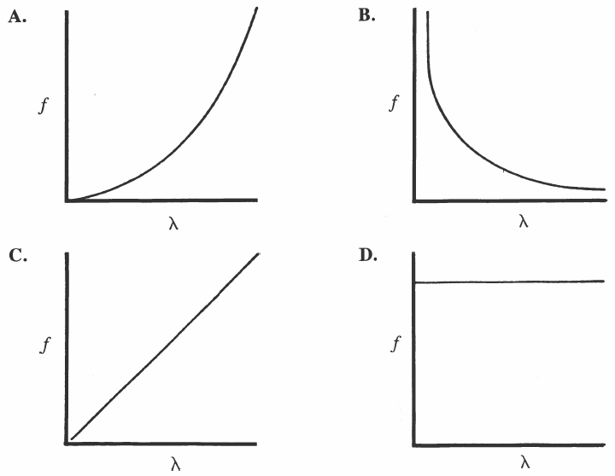

Q491: If the frequency-time graph for a particular electromagnetic wave generator is
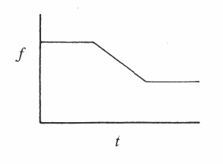
Then the corresponding wavelength-time graph is
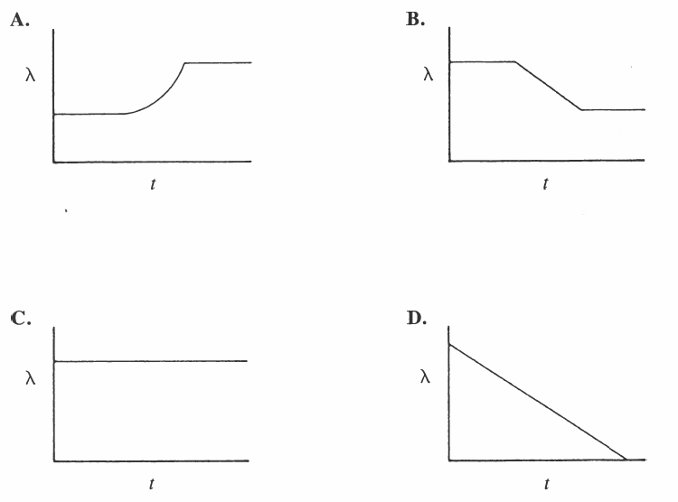

Q492: The graph that relates velocity in a vacuum to frequency for electromagnetic radiation is
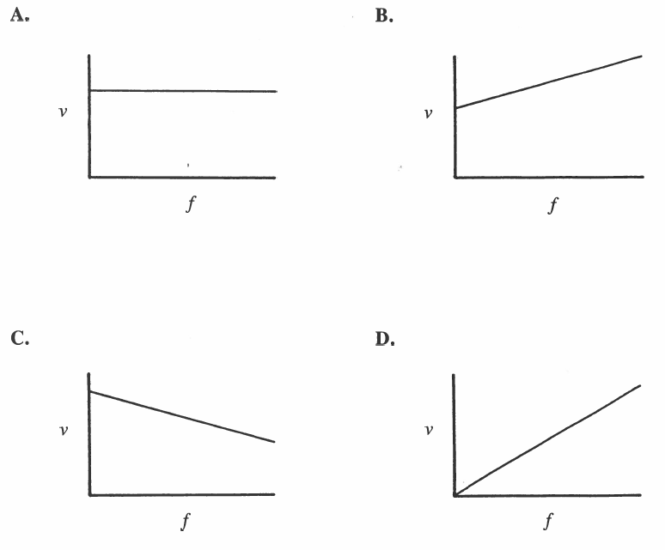

Use the following information to answer Q496:
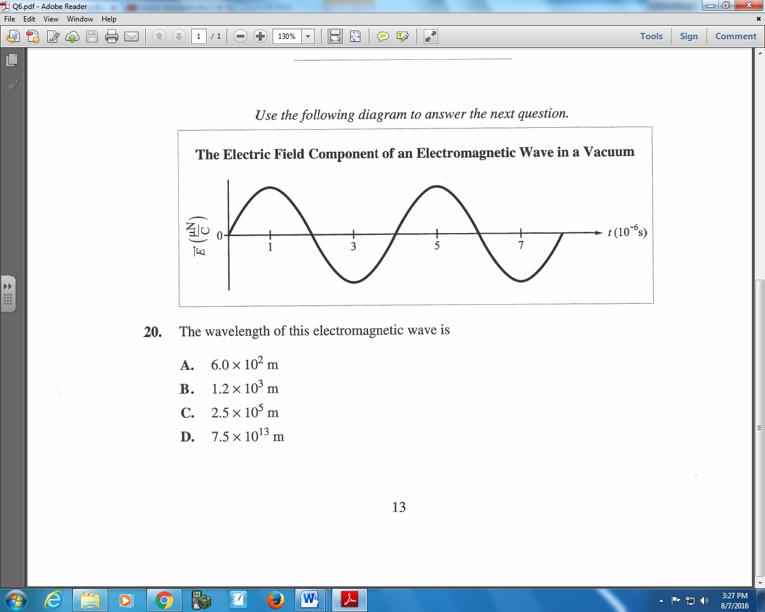

Q496: The wavelength of this electromagnetic wave is
- 6.0 x 10² m
- 1.2 x 10³ m
- 2.5 x 10⁵ m
- 7.5 x 10¹³ m

