First Name:______________________________ Last Name:______________________________
L01 – Worksheet – The Electron
Textbook Questions
Pg 756 #1: A beam of electrons passes undeflected through a 2.50-T magnetic field at right angles to a 60-kN/C electric field. How fast are the electrons travelling?

Pg 756 #2: What magnitude of electric field will keep protons from being deflected while they move at a speed of 1.0 x 10⁵ m/s through a 0.05-T magnetic field?

Pg 756 #3: What magnitude of magnetic field will stop ions from being deflected while they move at a speed of 75 km/s through an electric field with a magnitude of 150 N/C?

Pg 758 #1: Find the charge-to-mass ratio for an ion that travels in an arc of radius 1.00 cm while moving at 1.0 x 10⁶ m/s perpendicular to a 1.0-T magnetic field.

Pg 758 #2: Find the speed of an electron moving in an arc of radius 0.10 m perpendicular to a magnetic field with a magnitude of 1.0 x 10⁻⁴ T.

Pg 758 #3: A carbon-12 ion has a charge-to-mass ratio of 8.04 x 10⁶ C/kg. Calculate the radius of the ion’s path when the ion travels at 150 km/s perpendicular to a 0.50-T magnetic field.

Pg 760 #4: A beam of electrons enters a vacuum chamber that has a 100-kN/C electric field and a
0.250-T magnetic field.
- Sketch an orientation of electric and magnetic fields that will let the electrons pass undeflected through the chamber.

- At what speed would electrons pass undeflected through the fields in part (a)?

Pg 760 #5: Electrons are observed to travel in a circular path of radius 0.040 m when placed in a magnetic field of strength 0.0025 T. How fast are the electrons moving?

Pg 760 #6: How large a magnetic field is needed to deflect a beam of protons moving at 1.50 x 10⁵ m/s in a path of radius 1.00 m?

L01 – The Electron (Basic Concepts)
Q765: In which fields will a beam of electrons experience a force?
- Electric and magnetic only
- Electric and gravitational only
- Magnetic and gravitational only
- Electric, magnetic, and gravitational

Q767: Cathode rays can be deflected by
- Electric or magnetic fields
- Magnetic fields only
- Ultraviolet radiation
- Electric fields only

Q768: The FALSE statement regarding cathode rays is that
- Cathode rays can be accelerated by electric and gravitational fields
- Magnetic fields similarly affect visible light beams and cathode rays
- Some chemical reactions are similarly affected by cathode rays and by visible light beams
- The nature of the cathode material does not affect the charges or the masses of the rays emitted

Use the following information to answer Q772:
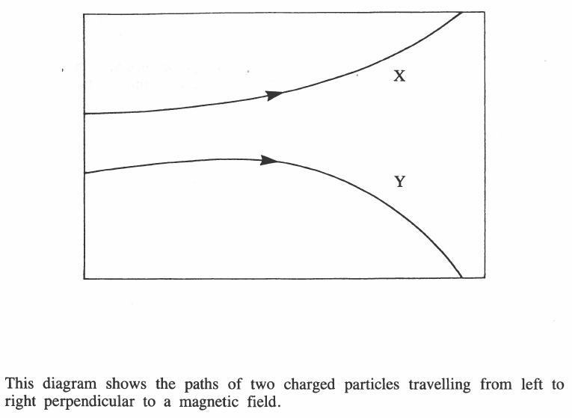

Q772: A necessary conclusion from this diagram is that the particles
- Have different masses
- Travel at different speeds
- Have charges of opposite sign
- Have different amounts of charge

Use the following information to answer Q775:
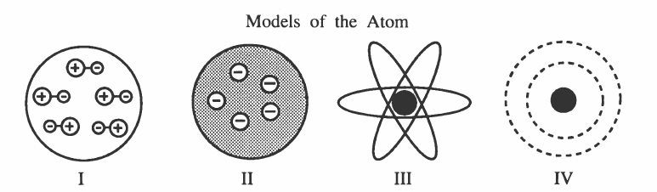

Q775: Thomson’s model of the atom is best represented by diagram
- I
- II
- III
- IV
L01 – The Electron (Charge to Mass Ratio)
Q782: A charged particle used in an experiment with Thomson’s apparatus enters a magnetic field of 0.20T at a speed of 5.0 x 10⁵ m/s and is curved into a circular orbit with a 5.0 cm radius. The charge-to-mass ratio of this particle is
- 1.0 x 10⁶ C/kg
- 2.5 x 10⁶ C/kg
- 2.5 x 10⁷ C/kg
- 5.0 x 10⁷ C/kg

Q783: What is the charge-to-mass ratio of a particle travelling at 2.29 x 10⁶ m/s perpendicularly to a magnetic field of intensity 0.200 T if its circular path has a radius of 12.0 cm?
- 5.50 x 10⁴ C/kg
- 1.37 x 10⁶ C/kg
- 3.82 x 10⁶ C/kg
- 9.54 x 10⁷ C/kg

L01 – The Electron (Millikan Oil Drop)
Q797: In Millikan’s oil drop experiment, the electrical force was balanced by the
- Gravitational force
- Magnetic force
- Centripetal force
- Nuclear force

Use the following information to answer Q800:
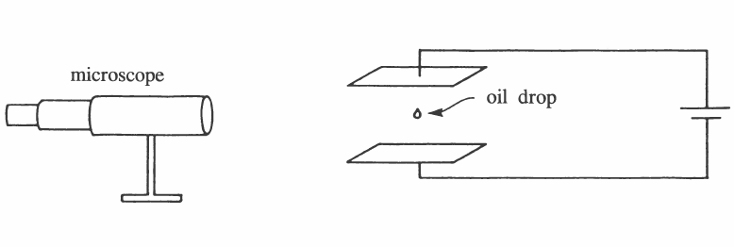

Q800: Which equation is associated with the apparatus in the diagram?
- $q_{e}\left|\vec{E}\right|=mg$
- $E_{k(max)}=q_{e}V_{stop}$
- $q_{e}\left|\vec{E}\right|=q_{e}vB$
- $q_{e}vB=mv^{2}/r$

