First Name:__________________________ Last Name:______________________________

L01 – Worksheet – Work and Energy /14 marks

Part 1: Work in 1-Dimension
Use the following information to answer Q1 – Q3:
Fluffy the dog is being used to pull a sled full of children across the snow. Jack weighs 50kg, Jill weighs 45kg, and the sled weighs 2kg. Fluffy is applying a force of 200N.
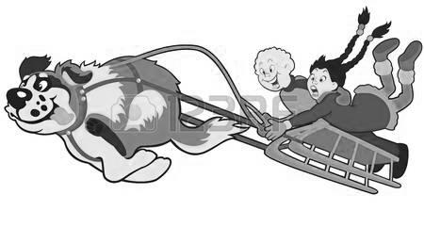

Q1: What energy conversion is being depicted above?
- Chemical potential energy to kinetic energy.
- Chemical potential energy to thermal energy.
- Thermal energy to chemical potential energy.
- Thermal energy to kinetic energy.
Q2: If Fluffy pulls the sled for a total distance of 50m, how much work has Fluffy done?

Q3: The next day, a tired Fluffy tries to pull the sled again. This time she does 2500J of work before giving up and taking a nap. How far did Fluffy pull the sled?

Part 2: Work in 2-Dimensions
Use the following information to answer Q4:
Force Acting on an Object
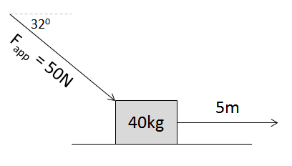

Q4: How much work is being done by the force?
- 132 J
- 156 J
- 212 J
- 250 J
Use the following information to answer Q5:
Force and Distance Vectors
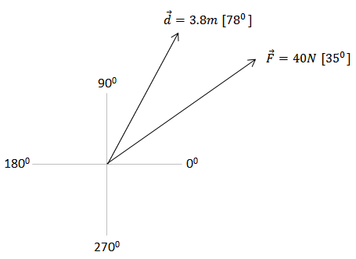

Q5: How much work is being done by the force?
- 31.60 J
- 103.7 J
- 111.2 J
- 124.5 J
Q6: A force of 200N [300⁰] is acting on an object over a distance of 6m [0⁰]. The work done on the object is a.bc x 10^{d} J, where a, b, c, and d are ___, ___, ___, and ___.
(Record your four-digit answer in the Numerical Response boxes below)

Use the following information to answer Q7:
Force Acting on an Object
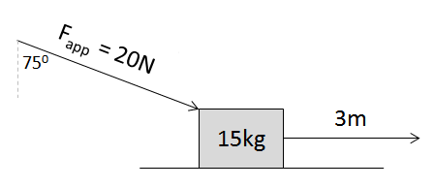

Q7: The work done on the object is a.bc x 10^{d} J, where a, b, c, and d are ___, ___, ___, and ___.
(Record your four-digit answer in the Numerical Response boxes below)

Part 3: Graphical Interpretations of Work
Use the following information to answer Q8-Q10:
Force-Distance graph depicting effort required to drag a box across a carpet.
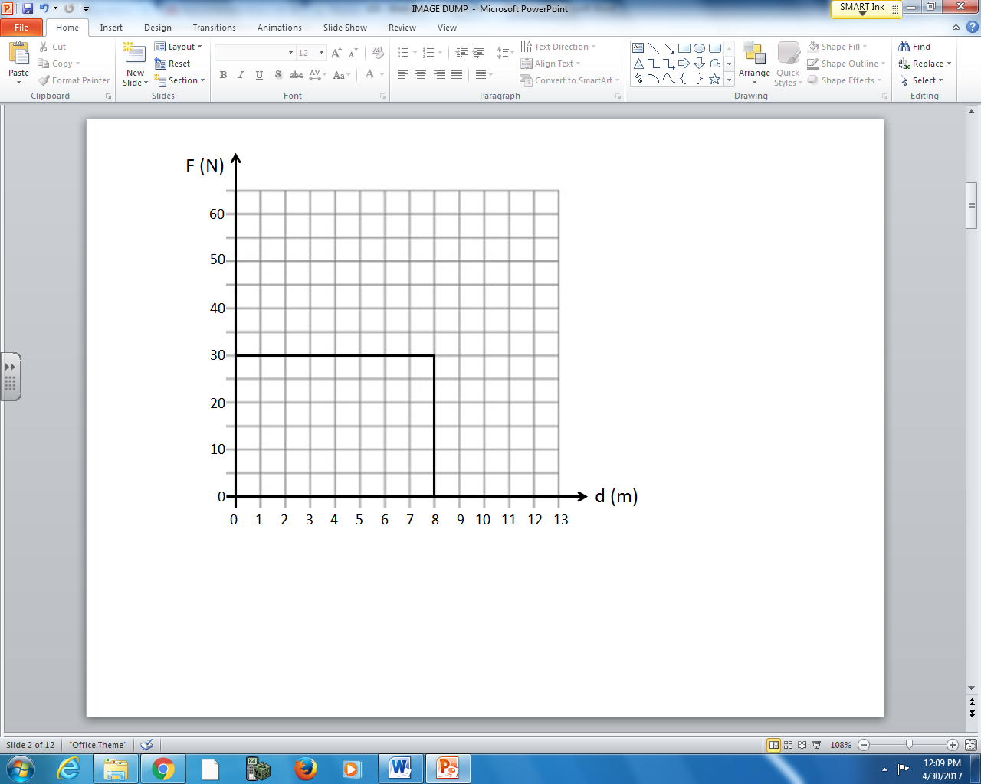

Q8: How much work was done in the first 3 meters?
- 10J
- 33J
- 90J
- 240J
Q9: How much work was done in the first 8 meters?

Q10: How much work was done in the first 10 meters?
(Record your three-digit answer in the Numerical Response boxes below)

Use the following information to answer Q11:
Force-Distance graph depicting effort required to drag a box across a carpet.
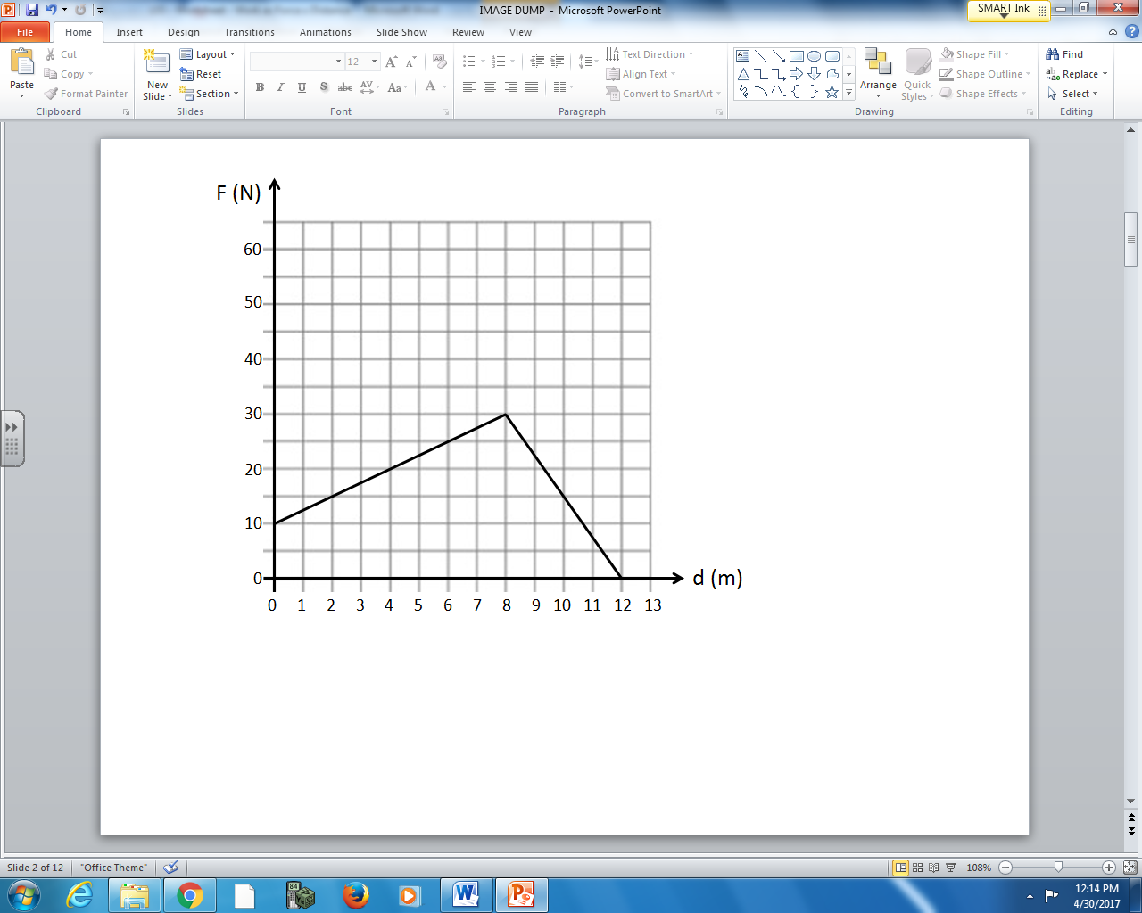

Q11: How much work was done to drag the box 12 meters across the carpet?

Part 4: Work, Dynamics and Kinematics
Use the following information to answer Q12-Q14:
Force Acting on an Initially Stationary Object
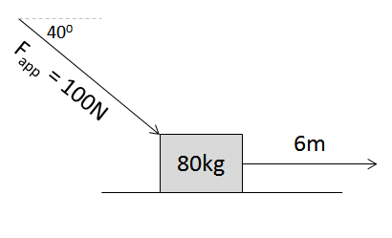

Q12: The work done over 6m is a.bc x 10^{d} joules, where a, b, c, and d are ___, ___, ___, and ___.
(Record your four-digit answer in the Numerical Response boxes below)

Q13: Assuming that the system is frictionless, the acceleration of the object is ____ m/s².
(Record your three-digit answer in the Numerical Response boxes below)

Q14: At the end of the 6m push, the object is moving at a speed of ____ m/s.
(Record your three-digit answer in the Numerical Response boxes below)

