First Name:_________________________________ Last Name:______________________________

L02 – FQ – Distance, Position, Displacement, and Velocity

Use the following information to answer Q1– Q3:
Jill drives straight from Vegreville to Edson. Vegreville is 102.5 km [East] of Edmonton, while Edson is 202.1 km [West] of Edmonton.

Q1: Which best describes Jill’s starting position, relative to Edmonton?
- 99.6 km [West]
- 102.5 km [East]
- 202.1 km [West]
- 304.6 km [West]
Q2: Which best describes Jill’s final position, relative to Edmonton?
- 99.6 km [West]
- 102.5 km [East]
- 202.1 km [West]
- 304.6 km [West]
Q3: Which best describes Jill’s displacement?
- 99.6 km [West]
- 102.5 km [East]
- 202.1 km [West]
- 304.6 km [West]

Use the following information to answer Q4 – Q5:
A hyper child is 8m [North] of a swing set. He runs 14m [South], 6m [North], 12m [South], and then 25m [North].

Q4: How much distance did the child run?
(Record your three digit answer in the Numerical Response boxes below)

Q5: What is the magnitude of the child’s displacement?
(Record your three digit answer in the Numerical Response boxes below)

Use the following information to answer Q6:
Venn Diagram for Scalars and Vectors
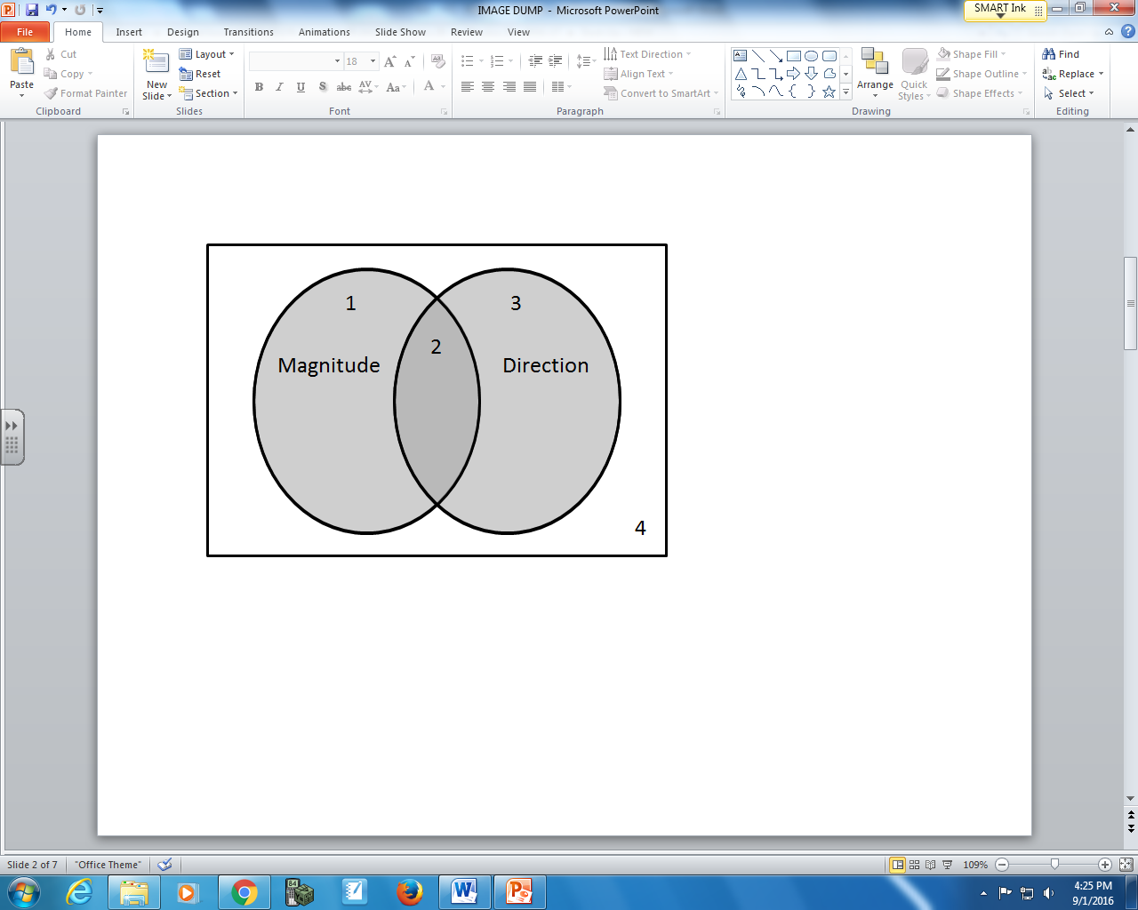

Q6: Match the numbers of the regions in the Venn diagram with the descriptions given below.
Region: __________ __________ __________ __________
Description: Time Position Distance Displacement
(Record your four digit answer in the Numerical Response boxes below)

Use the following information to answer Q7-Q10:
A hyper dog starts 5m [East] of a fire hydrant. He runs 10m [East], 3m [West], then 5m [East]. After running for 5 seconds, he is exhausted and lays down to rest.

Q7: The dog’s total distance travelled is _____m.
- 7m
- 17m
- 18m
- 23m

Q8: The dog’s total displacement is _____m [East].
(Record your 3-digit answer in the Numerical Response boxes below)

Q9: The dog’s final position is a.bc x 10^{d} m [East] of the fire hydrant.
(Record your 4-digit answer in the Numerical Response boxes below)

Q10: What is the dog’s velocity?
(Record your 3-digit answer in the Numerical Response boxes below)

MARKING:
Beginning 0.0 – 4.5
Progressing 5.0 – 6.5
Competent 7.0 – 8.5
Exemplary 9.0 – 10.0

