First Name:____________________________ Last Name:______________________________

L02 – FQ – Electrical Interactions and Electroscopes

Use the following information to answer Q1-Q2:
Charge by Induction
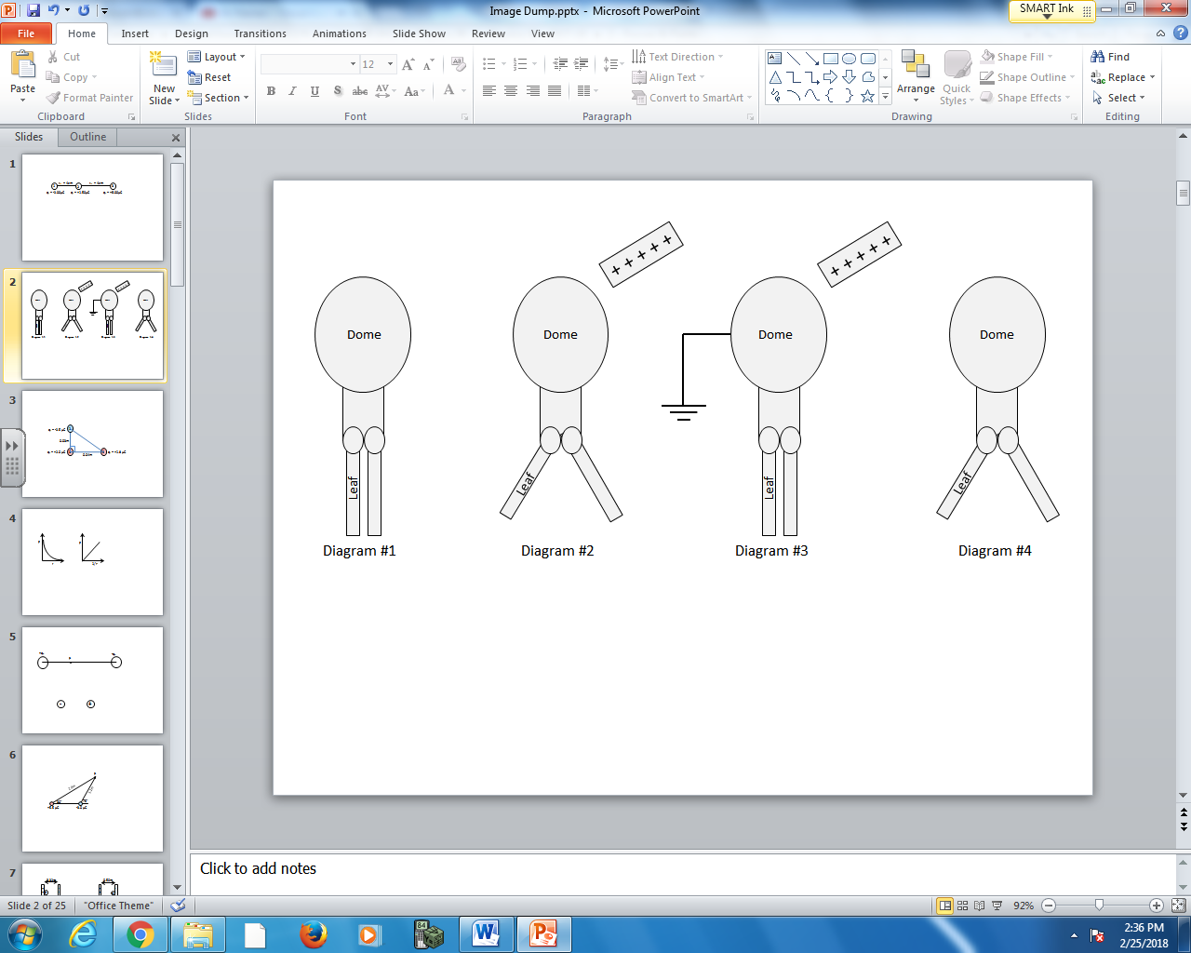

Q1: In Diagram #2, the dome has a net __i__ charge, and has __ii__ protons.
 | i | ii
A. | positive | lost
B. | positive | the same number of
C. | negative | lost
D. | negative | the same number of

Q2: In Diagram #4, the dome has a net __i__ charge, and the leaves have a net __ii__ charge.
 | i | ii
A. | positive | positive
B. | positive | negative
C. | negative | positive
D. | negative | negative

Use the following information to answer Q3:
Three identical objects are each independently charged.
- Object A receives an initial net charge of +5.0 Coulombs.
- Object B receives an initial net charge of -2.6 Coulombs.
- Object C receives an initial net charge of +1.0 Coulombs.

Q3: Object A is briefly touched to Object B, then separated. Object A is then touched to Object C, and separated. What is the magnitude of the final charge on Object C, measured in Coulombs?
(Record your three digit answer in the Numerical Response boxes below)

Use the following information to answer Q4:
A stationary 50.0g steel ball has a net charge of +5.00μC. The steel ball is temporarily exposed to an identical steel ball of net charge +3.00μC placed 1.00m away. As the electrostatic force repels the 50.0g ball, the force becomes weaker, as depicted below.
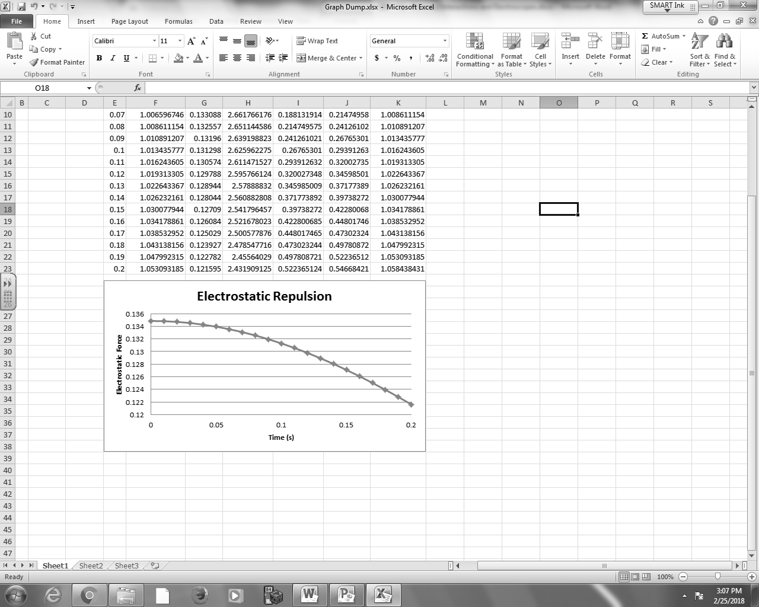

Q4: Approximate the final speed of the 50.0g steel ball after 0.200 seconds. (1 mark)

MARKING:
Beginning 0.0 – 1.5
Progressing 2.0 – 2.5
Competent 3.0 – 3.5
Exemplary 4.0

