First Name:_____________________________ Last Name:______________________________

L02 – FQ – Gravitational Force

Q1: Two objects each have a mass of 30,000kg. If the gravitational force of attraction between the two objects is 5x10⁻¹²N, then the distance between them is a.bc x 10^{d} m, where a, b, c, and d are ___, ___, ___, and ___. (1 mark)
(Record your four digit answer in the Numerical Response boxes below)

Q2: The gravitational force between two masses, m₁ and m₂, located a distance r from each other, is F. What is the gravitational force if each mass is doubled and the distance between the masses is halved? (1 mark)
a) ½F
b) F
c) 2F
d) 4F
e) 8F
f) 16F

Use the following information to answer Q3:
Arrangement of Masses
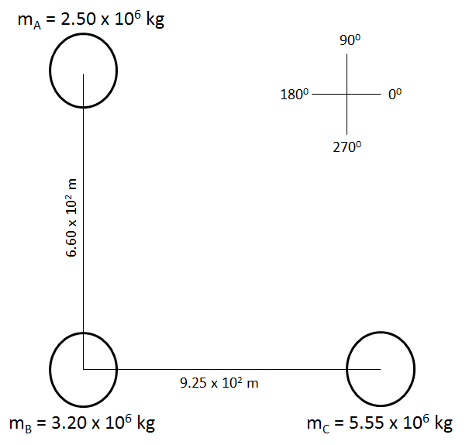

Q3: What is the acceleration of Mass B? (4 marks)
Marking Key:
- 1 mark – Finding F_{AB}
- 1 mark – Finding F_{BC}
- 1 mark – Finding F_{NET} (magnitude and direction)
- 1 mark – Finding acceleration (magnitude and direction)

MARKING:
Beginning 0.0 – 2.5
Progressing 3.0 – 4.0
Competent 4.5 – 5.5
Exemplary 6.0

