First Name:____________________________ Last Name:______________________________

L02 - FQ – The Electron
Use the following information to answer Q1-2:
Models of the Atom
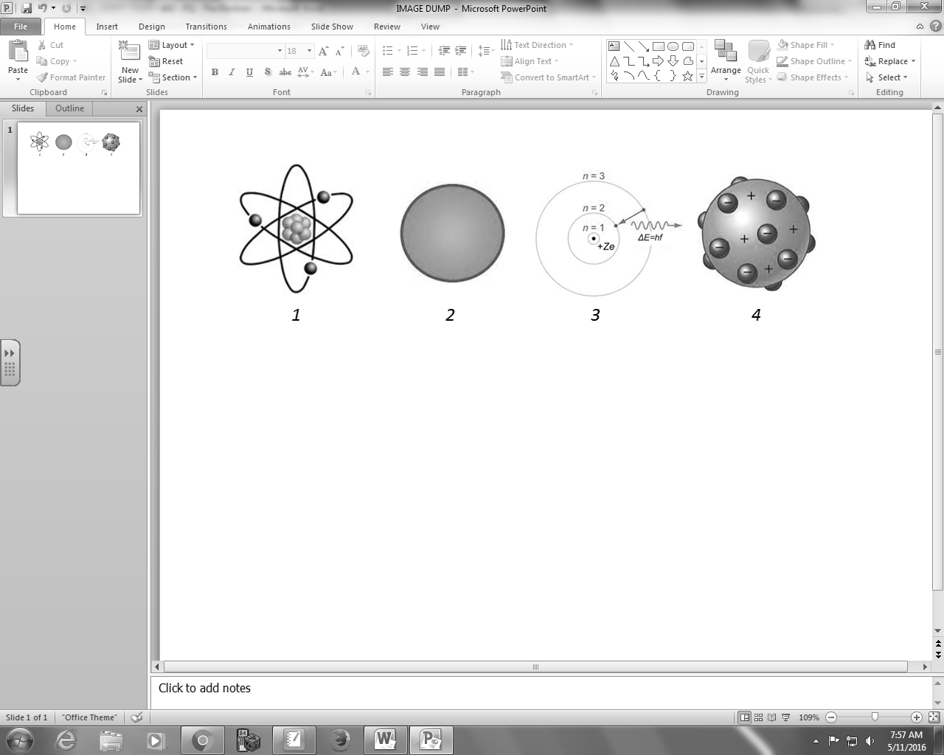

Q1: The different models of the atom, when ordered from oldest to newest, are ___, ___, ___, and ___.
(Record your four digit answer in the Numerical Response boxes below)

Q2: Which model best describes the model proposed by J.J. Thomson after his experiments involving Cathode Rays?
- Model 1
- Model 2
- Model 3
- Model 4
Q3: A Cathode Ray is best described as a beam of
- electrons
- protons
- EMR
- X-rays

Q4: In a detection chamber of a mass spectrometer, which path is an electron most likely to take?
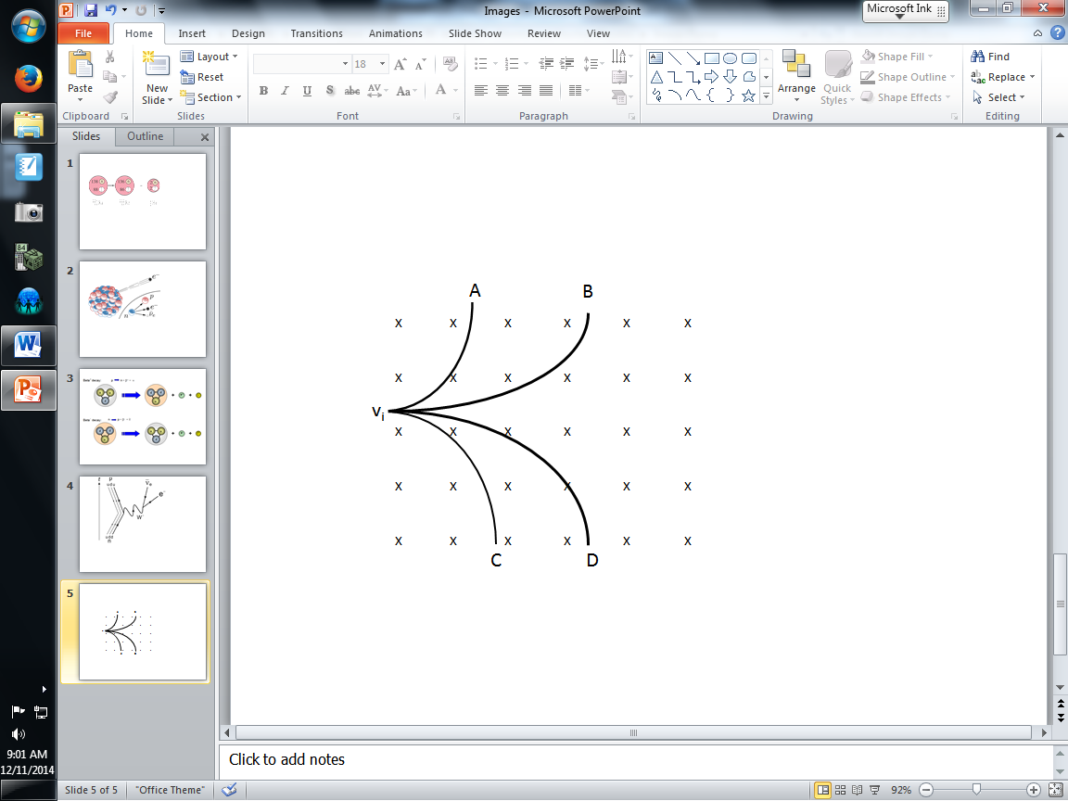
- Circular path A
- Parabolic path B
- Circular path C
- Parabolic path D
Q5: In the velocity selector of a mass spectrometer, a particle of unknown mass and charge is subject to a magnetic field of strength 0.55 T and an electric field of strength 40 kN/C. If the particle’s path is undeflected, then the particles speed is a.bc x 10^{d} m/s, where a, b, c, and d are ___, ___, ___, and ___.
(Record your four digit answer in the Numerical Response boxes below)

MARKING
Beginning 0.0 – 2.0
Progressing 2.5 – 3.5
Competent 4.0 – 4.5
Exemplary 5.0

