First Name:__________________________ Last Name:______________________________

L02 - Physics 20 – Formative Quiz – Waves and Wave Equation

Q1: using the diagram below, label using correct wave terminology. (2 marks)
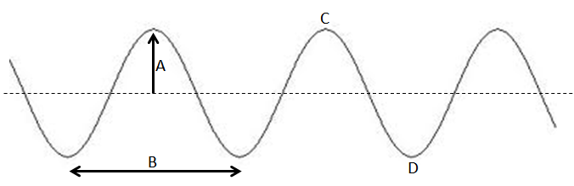

Q2: A light wave of frequency 5.61x10¹⁴ Hz travels at 3.0 x 10⁸ m/s through a vacuum. What color is this light wave? (3 marks)
Color | Wavelength (x10⁻⁹ m)
Violet | ~ 430 to 380
Blue | ~ 500 to 430
Cyan | ~ 520 to 500
Green | ~ 565 to 520
Yellow | ~ 590 to 565
Orange | ~ 625 to 590
Red | ~ 740 to 625

MARKING:
Beginning 0 - 2
Progressing 2.5 - 3.5
Competent 4 - 4.5
Exemplary 5

