First Name:_____________________________ Last Name:______________________________

L02 – FQ – Work and Energy

Q1: Nate is trying to drag his dog, Kepler, over to his food dish. Nate is applying 200N of force, and the food dish is 3.65 meters away. How much work does Nate need to do?
(Record your three-digit answer in the Numerical Response boxes below)

Q2: Nate decides the easiest way is to carry the dog. Kepler is approximately 13.6 kg, and Nate lifts him 75cm into the air, then walks 3.65 meters over to the food dish. How much work has Nate done?
(Record your three-digit answer in the Numerical Response boxes below)

Use the following information to answer Q3:
Force-Distance Graph
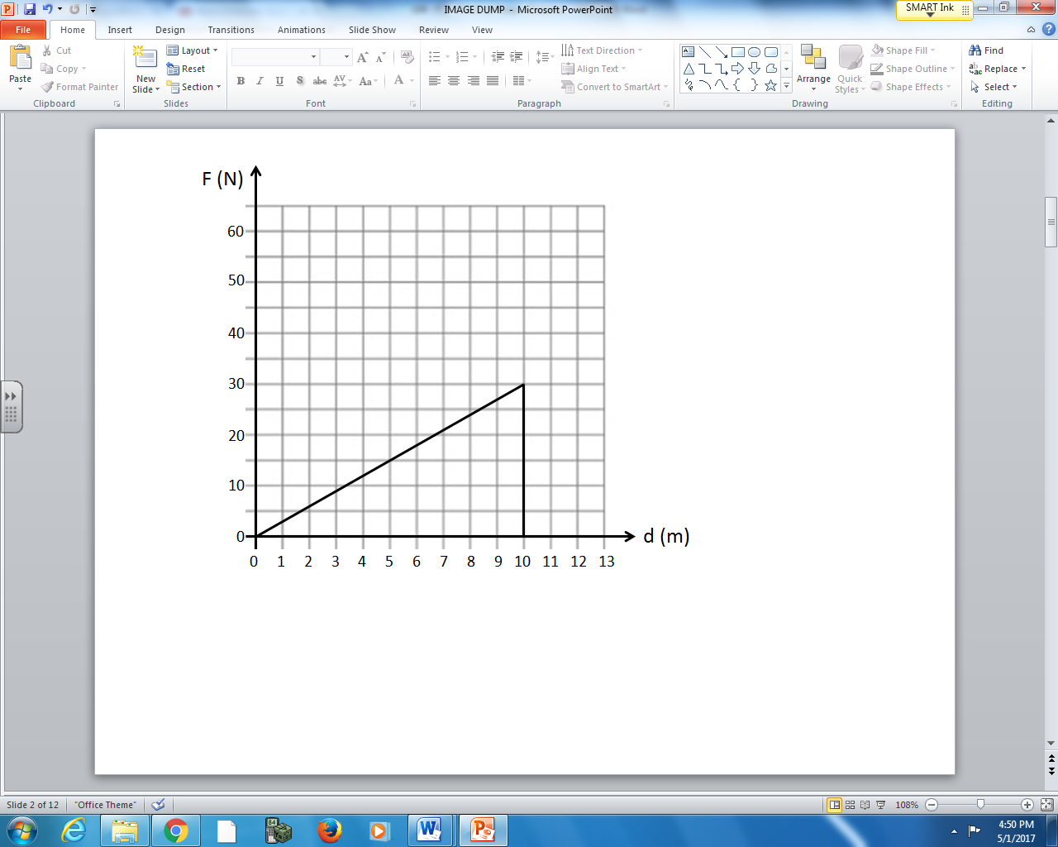

Q3: In the graph depicted above, how much work is done when pushing the object for 10 meters?
- 3 J
- 30 J
- 150 J
- 300 J

Q4: Bob pushes at a slight downward angle with a force of 100N to move a box 5m. If Bob only did 400 J worth of work, what angle below the horizontal did Bob push at?
(Record your three-digit answer in the Numerical Response boxes below)

MARKING:
Beginning 0 – 1.5
Progressing 2 – 2.5
Competent 3 – 3.5
Exemplary 4

