First Name:______________________________ Last Name:______________________________

L02 – Worksheet – Coulomb’s Law in 1-Dimension

Textbook Questions
Pg 530 #1: In a hydrogen atom, an electron is 5.29 x 10⁻¹¹ m from a proton. An electron has a charge of -1.60 x 10⁻¹⁹ C, and the proton’s charge is +1.60 x 10⁻¹⁹ C. Calculate the electrostatic force of attraction acting on the two charges.

Pg 531 #1: A metal sphere with a negative charge of 3.00 μC is placed 12.0 cm from another similar metal sphere with a positive charge of 2.00 μC. The two spheres momentarily touch, then return to their original positions. Calculate the electrostatic force acting on the two metal spheres.

Pg 533 #1: A metal sphere with a charge of -2.50 x 10⁻⁹ C is 1.50 cm to the left of a second metal sphere with a charge of +1.50 x 10⁻⁹ C. A third metal sphere of -1.00 x 10⁻⁹ C is situated 2.00 cm to the right of the second charged sphere. If all three charges form a line, determine the net electrostatic force on the second sphere.

Diploma Worksheet Questions – Coulomb’s Law (Basic Definitions)
Q86: The force of repulsion between two unequal like charges is
- Directly proportional to the sum of the charges
- Directly proportional to the square of each charge
- Inversely proportional to the distance separating the charges
- Inversely proportional to the square of the distance separating the charges
Q91: Newton’s Law of Universal Gravitation has a mathematical relationship similar to one developed by
- Coulomb
- Einstein
- Lenz
- Ohm
Diploma Worksheet Questions – Coulomb’s Law (in 1-Dimension)
Q93: Two very small conducting spheres with equal radii have charges of 3.0 x 10⁻⁶ C and -6.0 x 10⁻⁶ C respectively. The spheres are touched together and then are separated to a distance of 5.0 cm between their centers. What is the magnitude of the electric force on each sphere?
- 65 N
- 8.1 N
- 6.5 x 10⁻³ N
- 8.1 x 10⁻⁴ N

Q94: Two charges, each of 4.0 x 10⁻⁷ C, repel each other with a force of 1.6 x 10⁻⁴ N. The charges are separated by a distance of
- 1.0 m
- 3.0 m
- 4.0 m
- 9.0 m

Q98: When a helium nucleus with a charge of +2e and a neon nucleus with a charge of +10e are separated by 3.0 x 10⁻⁸ m, the force of repulsion is
- 5.1 x 10⁻¹² N
- 3.2 x 10⁷ N
- 6.0 x 10¹⁸ N
- 2.0 x 10²⁶ N

Use the following information to answer Q103:
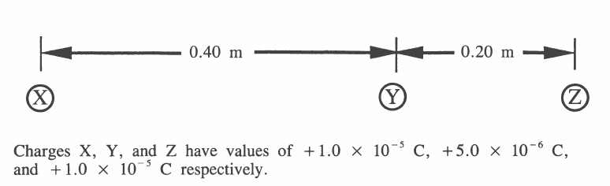

Q103: The net electrostatic force acting on Y because of X and Z is
- 14 N to the left
- 14 N to the right
- 8.4 N to the left
- 8.4 N to the right

Use the following information to answer Q110 – Q111:
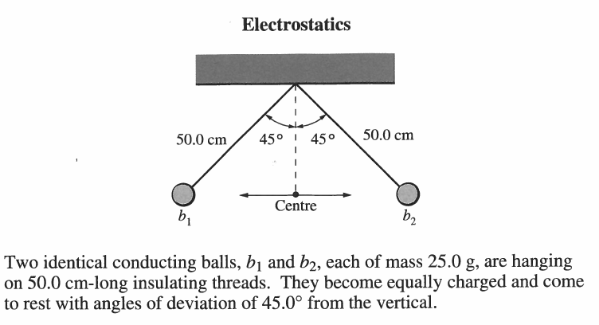

Q110: The electrostatic force between the charged balls can best be described as
- An attraction due to dissimilar charges
- A repulsion due to dissimilar charges
- An attraction due to similar charges
- A repulsion due to similar charges
Q111: What is the tension in the thread that is supporting one of the balls?
- 0.173 N
- 0.245 N
- 0.347 N
- 9.81 N

Use the following information to answer Q112:
Two conducting spheres have identical surface areas. Sphere A has a charge of 4.50 μC. Sphere B has a charge of -2.40 μC. Spheres A and B are brought into momentary contact and separated to a distance of 2.50 cm.

Q112: The magnitude of the electric force exerted by sphere A on sphere B after contact and separation is ______N.
(Record your three digit answer in the Numerical Response boxes below)

Diploma Worksheet Questions – Coulomb’s Law (Algebra)
Q128: The electrostatic force between two charged objects is 1.0 N. If the charge on each object is doubled and their separation is halved, the new force is
- 1.0 N
- 4.0 N
- 8.0 N
- 16 N

Q130: If the distance between two charged spheres remains constant, and the charge on each sphere is doubled, then it can be predicted that the force between them will be
- ¼ the original
- ½ the original
- 2 times the original
- 4 times the original

Q139: Coulomb started with two identically charged spheres separated by a distance r. The force between the spheres was F. If he changed the separation to $\frac{2}{3}r$, then the force between the spheres would have become
- $\frac{4}{9}F$
- $\frac{2}{3}F$
- $\frac{3}{2}F$
- $\frac{9}{4}F$

Q140: Coulomb again separated the identically charged spheres by distance r. The force between the spheres was F. Coulomb touched one of the spheres with a third, identical neutral sphere. The third sphere was them moved far away from the other spheres. If he then measured the force between the original spheres, the new force between the spheres would have been
- $\frac{1}{2}F$
- $\frac{1}{4}F$
- $F$
- $2F$

Challenge Questions
Use the following information to answer Q1:
A negative charge is suspended at Point P between two positive charges, such that the net electrostatic force acting on the negative charge is zero.
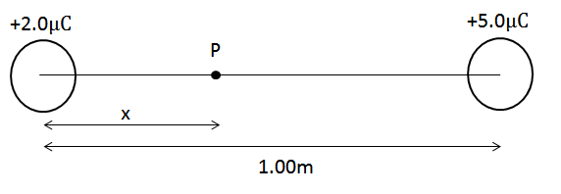

Q1: At what distance, x, from the 2.0μC charge is the negative charge placed?

Cumulative Review from Previous Units
Q1: An 200g object is moving at 3m/s [W] when it experiences a force of 20N [E] for 0.6 seconds. The final velocity of the object is ____ m/s [E].
(Record your three digit answer in the Numerical Response boxes below)

