First Name:______________________________ Last Name:______________________________

L02 – Worksheet – Impulse

Textbook Questions
Pg 467 #4: What is the effect on impulse if
- The time interval is doubles?

- The net force is reduced to $\frac{1}{3}$ of its original value?

Pg 467 #5: Even though your mass is much greater than that of a curling stone, it is dangerous for a moving stone to hit your feet. Explain why.

Pg 467 #8: What will be the magnitude of the impulse generated by a slapshot when an average net force of magnitude 520 N is applied to a puck for 0.012 s?

Pg 467 #9: During competitive world-class events, a four-person bobsled experiences an average net force of magnitude 1390 N during the first 5.0 s of a run.
- What will be the magnitude of the impulse provided to the bobsled?

- If the sled has the maximum mass of 630 kg, what will be the speed of the sled?

Pg 467 #10: An advertisement for a battery-powered 25-kg skateboard says that it can carry an 80-kg person at a speed of 8.5 m/s. If the skateboard motor can exert a net force of magnitude 75 N, how long will it take to attain that speed?

Pg 467 #11: Whiplash occurs when a car is rear-ended and either there is no headrest or the headrest is not properly adjusted. The torso of the motorist is accelerated by the seat, but the head is jerked forward only by the neck, causing injury to the joints and soft tissue. What is the average net force on the motorist’s neck if the torso is accelerated from 0 to 14.0 m/s [W] in 0.135 s? The mass of the motorist’s head is 5.40 kg. Assume that the force acting on the head is the same magnitude as the force on the torso.

Diploma Worksheet Questions
Q5: A proton is accelerated to a speed of 2.0 x 10⁶ m/s by a strong electric field. The proton is then stopped in 4.0 x 10⁻³ s. Assuming uniform deceleration, the stopping force exerted on the proton is
- 1.4 x 10⁻²³ N
- 3.4 x 10⁻²¹ N
- 8.4 x 10⁻¹⁹ N
- 3.4 x 10⁻¹⁵ N

Use the following information to answer Q6 – Q8:
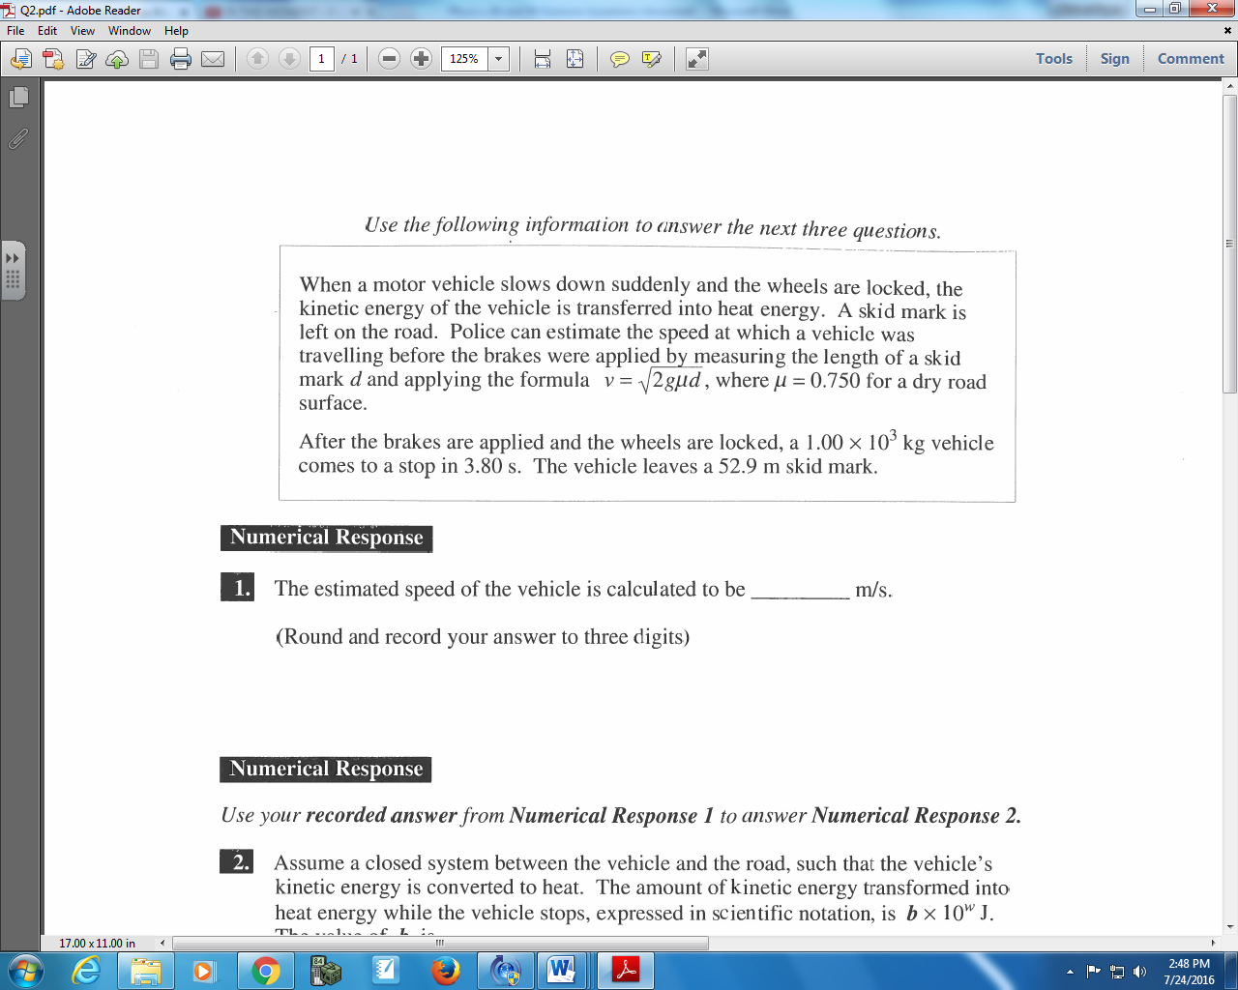

Q6: The magnitude of the impulse necessary to stop the vehicle, expressed in scientific notation, is
b x 10^{w} kg*m/s. The value of b is ____.
(Record your three digit answer in the Numerical Response boxes below)

Use the following additional information to answer Q7 – Q8:
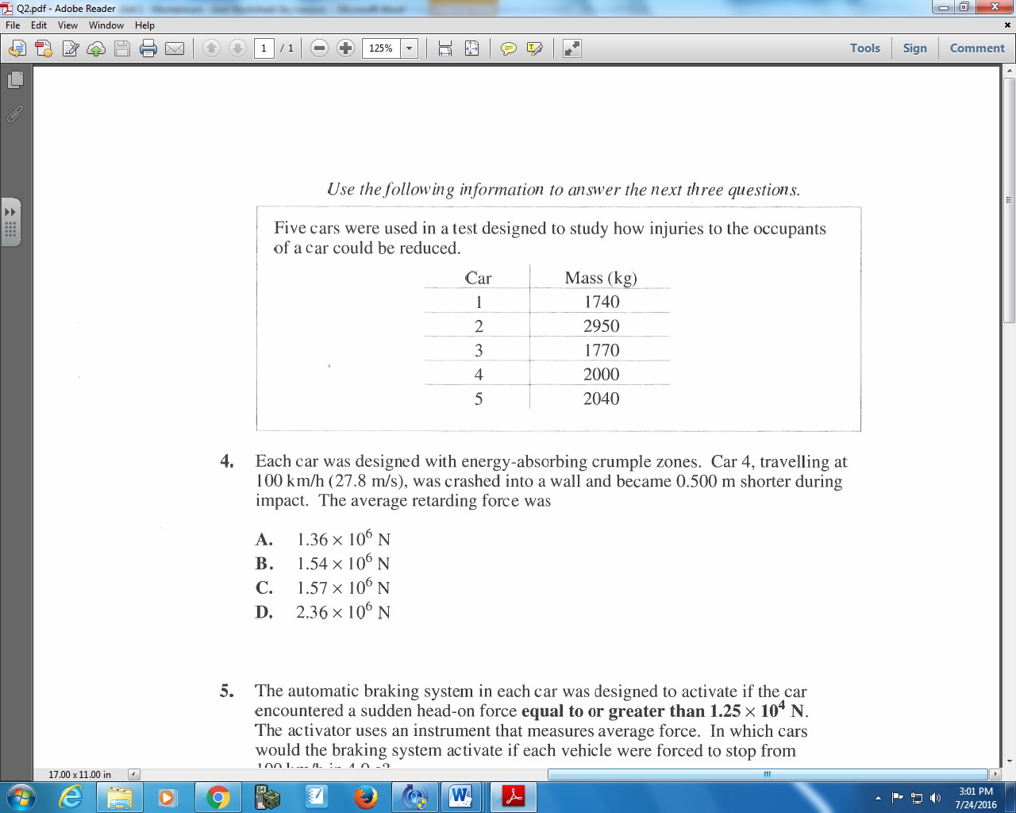

Q7: Each car was designed with energy-absorbing crumple zones. Car 4, travelling at 100 km/h (27.8 m/s), was crashed into a wall and became 0.500 m shorter during impact. The average retarding force was
- 1.36 x 10⁶ N
- 1.54 x 10⁶ N
- 1.57 x 10⁶ N
- 2.36 x 10⁶ N

Q8: The automatic braking system in each car was designed to activate if the car encountered a sudden head-on force equal to or greater than 1.25 x 10⁴ N. The activator uses an instrument that measures average force. In which cars would the braking system activate if each vehicle were forced to stop from 100 km/h in 4.0 s?
- 1, 2, and 4
- 1, 3, and 4
- 2, 3, and 5
- 2, 4, and 5

