First Name:____________________________ Last Name:______________________________

L02 – Worksheet – Mass Spectrometer and Millikan’s Experiment
NOTE: Complete the homework (Pg756 #1-3, Pg 758 #1-3, Pg 760 #4-6) first.

Use the following information to answer questions in this worksheet:
Mass Spectrometer
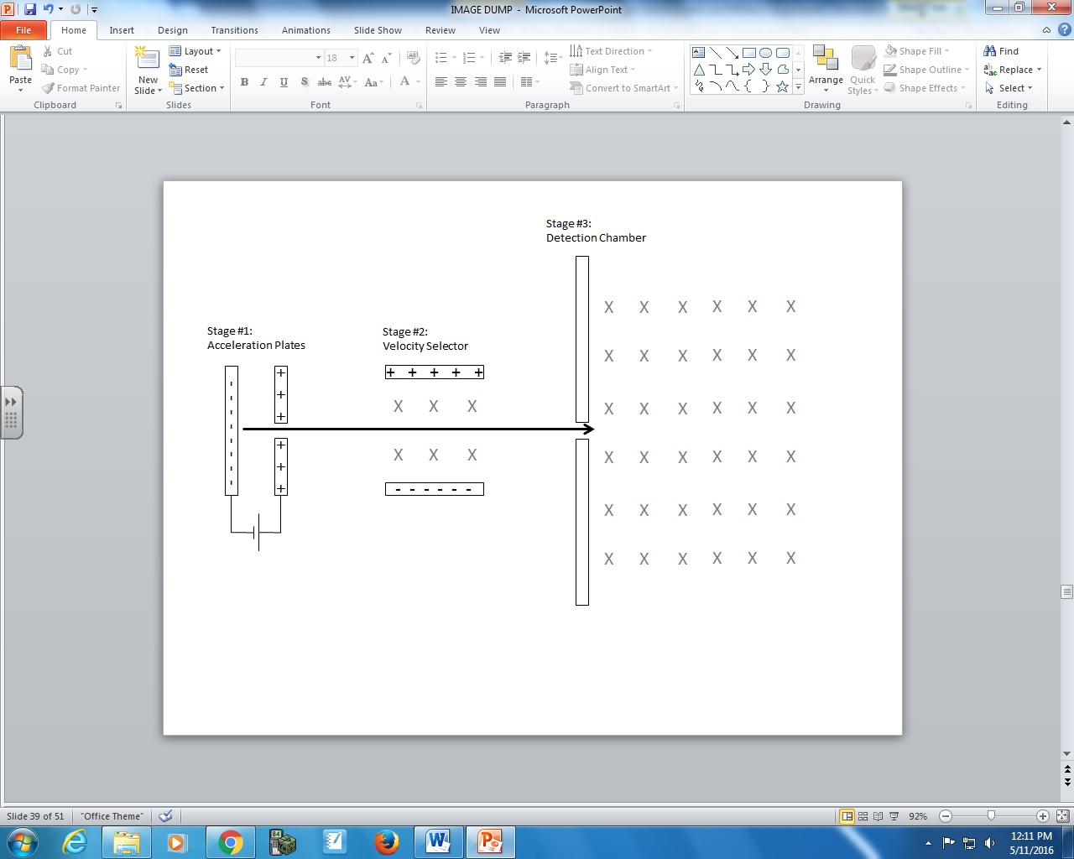
Millikan Experiment
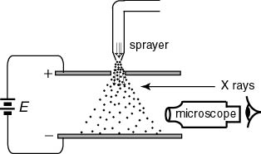

Use the following information to answer Q1 through Q2:
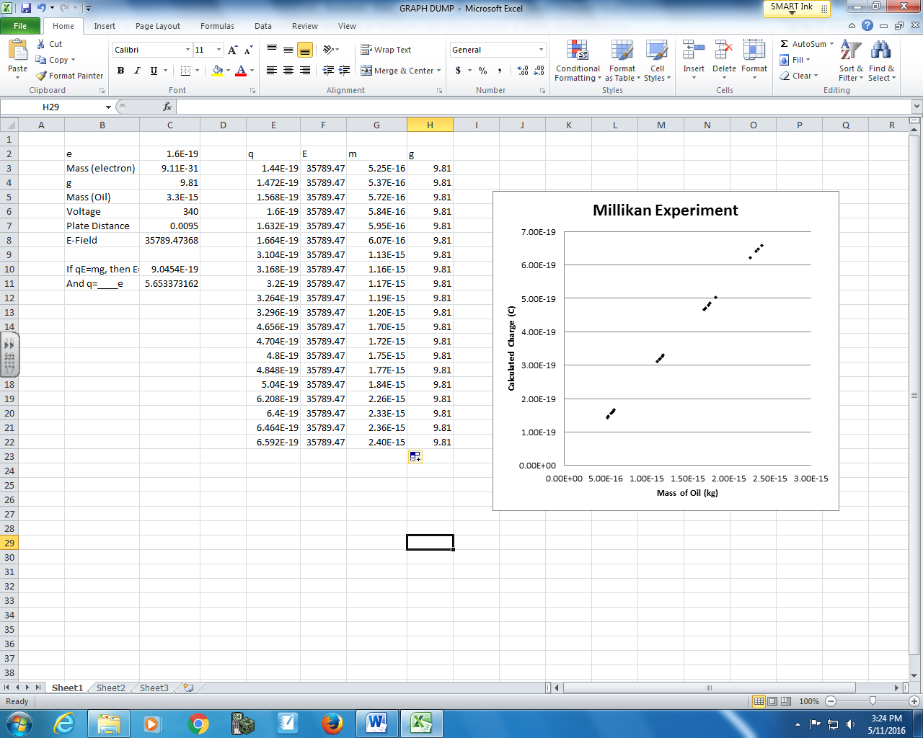

Q1: Which of the following best describes this data?
- Continuous and Linear
- Continuous and Non-Linear
- Discrete and Linear
- Discrete and Non-Linear
Explain why: __________________________________________________________________________
_______________________________________________________________________________________________________________________________________________________________________________________________________________________________________________________________
Q2: Which of the following quantities best describes the slope?
- $\frac{m}{\left|\vec{E}\right|}$ b. $\frac{\left|\vec{E}\right|}{g}$ c. $g\left|\vec{E}\right|$ d. $\frac{g∆d}{∆V}$

Q3: Which Physics Principle is essential for understanding Millikan’s Experiment?
(Record your one digit answer in the Numerical Response boxes below)

Use the following information to answer Q4 and Q5:
A potential difference of 340.0 V exists between two plates that are separated by a distance of 95.0 cm, and an oil drop of mass 1.70x10⁻¹⁵ kg is suspended between the plates.

Q4: The net charge on the oil drop is a.b x 10^{-cd} C. The values of a, b, c, and d are ___, ___, ___, and ___.
(Record your four digit answer in the Numerical Response boxes below).

Q5: The oil drops charge is caused by:
- An excess of a discrete number of electrons.
- An absence of a discrete number of electrons.
- Both a and b.
- Either a or b, but not both.
Explain why: __________________________________________________________________________
_______________________________________________________________________________________________________________________________________________________________________________________________________________________________________________________________
Use the following information to answer Q6 through Q10:
Charge-to-Mass Ratio of an Electron
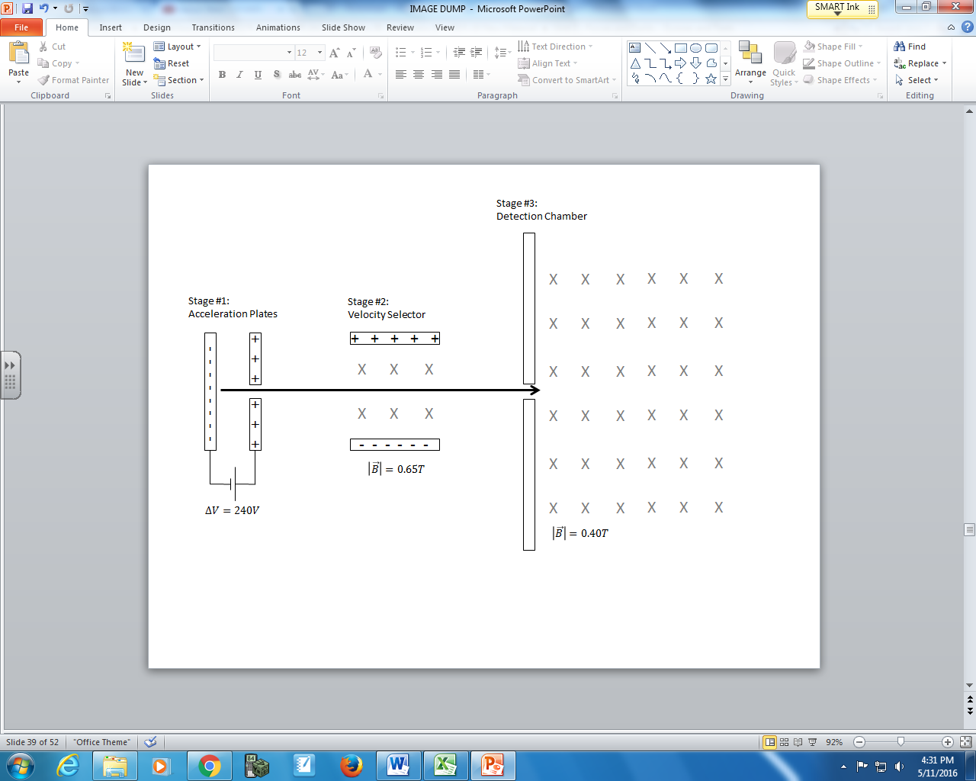

Q6: The first stage of a mass spectrometer involves accelerated a particle from rest at the __i__ towards the __ii__. Upon exiting, it travels forward to the velocity selector. Because of where these particles originated, they were originally referred to as __iii_. Today we call them __iv_.
Select the row the best completes the above sentence.
 | i | ii | iii | iv
A. | Anode | Electrode | Anode rays | Electrons
B. | Cathode | Electrode | Cathode rays | Positrons
C. | Anode | Cathode | Anode rays | Positrons
D. | Cathode | Anode | Cathode rays | Electrons

Q7: To determine the speed of the charged particles as they exit the acceleration plates, we could calculate this using either Physics Principle a or Physics Principle b, where the values of a and b are ___ and ___.
(Record your two digit answer in the Numerical Response boxes below).
Q8: Upon exiting the acceleration plates, the charged particle beam is travelling at a.bc x10^{d} m/s, where a, b, c, and d are ___, ___, ___, and ___.
(Record your four digit answer in the Numerical Response boxes below).

Q9: To pass through the velocity selector undeflected, the electric field strength is a.bc x10^{d} N/C, where a, b, c, and d are ___, ___, ___, and ___.
(Record your four digit answer in the Numerical Response boxes below).

Q10: Inside the detection chamber the charged particles have a radius of curvature of a.bc x10^{-d} m, where a, b, c, and d are ___, ___, ___, and ___.
(Record your four digit answer in the Numerical Response boxes below).

