First Name:______________________________ Last Name:______________________________

L02 – Worksheet – Speed of Light

Textbook Questions
Pg 652 #5: A communication satellite is in orbit around Earth at an altitude of 2.00 x 10⁴ km. If the satellite is directly above a ground-based station, how long does it take a signal to travel between the satellite and the station?

Pg 652 #6: Using a similar approach to Michelson, a student sets up a 64-sided set of rotating mirrors, 8.00 km away from a fixed mirror. What minimum frequency of rotation would be required to successfully measure the speed of light?

Pg 652 #7: A 16-sided set of rotating mirrors is used to measure the time it takes light to travel a certain distance. At what frequency does the mirror need to rotate such that it makes 1/16th of a rotation in the time it takes light to travel 3.5 km and back again?

Pg 652 #8: An 8-sided set of rotating mirrors rotates at 545 Hz in an experiment similar to that of Michelson. How far away should the fixed mirror be placed in order to correctly measure the speed of light?

Pg 652 #9: The speed of light was measured to be 2.97 x 10⁸ m/s using a 16-sided set of rotating mirrors and a fixed mirror separated by 5.00 x 10³ m. At what frequency was the mirror rotating?

Diploma Worksheet Questions – Speed of Light
Use the following information to answer Q497:
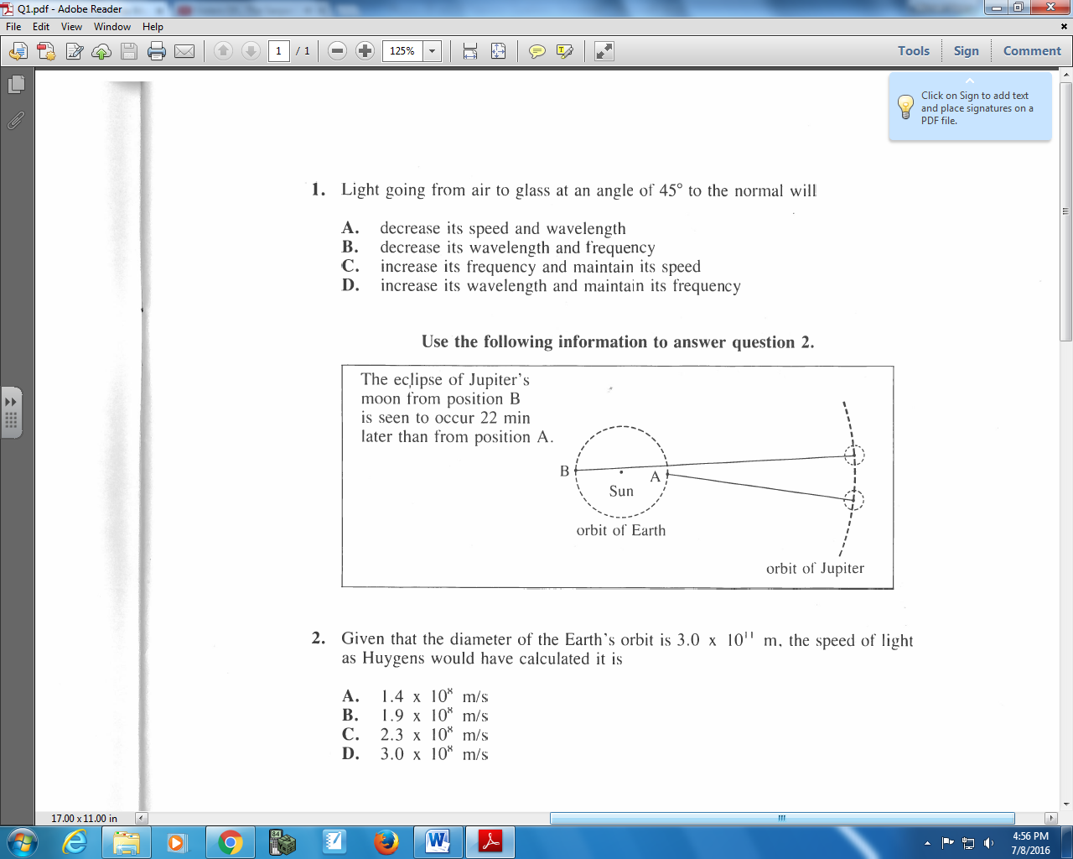

Q497: Given that the diameter of the Earth’s orbit is 3.0 x 10¹¹ m, the speed of light as Huygens would have calculated is
- 1.4 x 10⁸ m/s
- 1.9 x 10⁸ m/s
- 2.3 x 10⁸ m/s
- 3.0 x 10⁸ m/s

Use the following information to answer Q498:
Measuring the Speed of Light
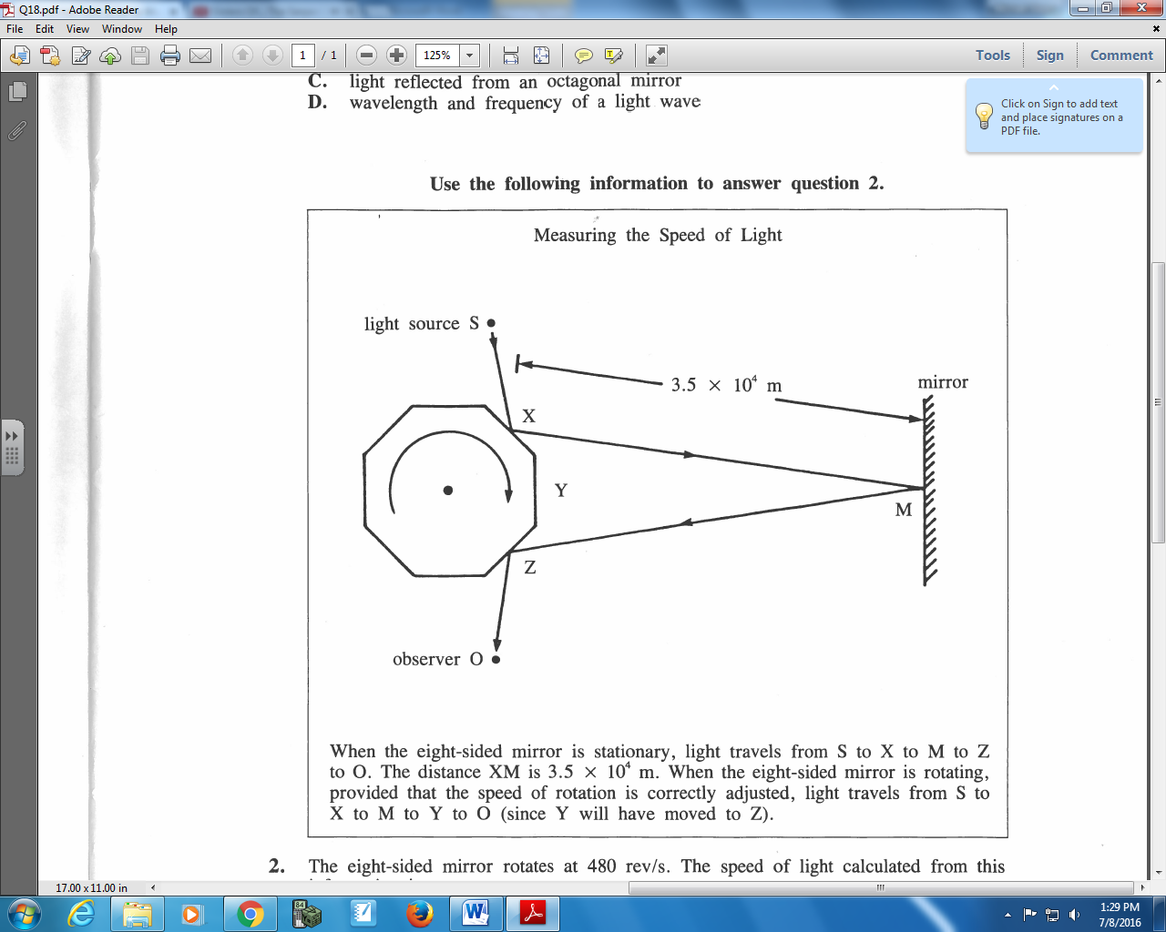
When the eight-sided mirror is stationary, light travels from S to X to M to Z to O. The distance XM is 3.5 x 10⁴ m. When the eight-sided mirror is rotating, provided that the speed of rotation is correctly adjusted, light travels from S to X to M to Y to O (since Y will have moved to Z).

Q498: The eight-sided mirror rotates at 480 rev/s. The speed of light calculated from this information is
- 3.0 x 10⁸ m/s
- 2.7 x 10⁸ m/s
- 1.7 x 10⁷ m/s
- 4.2 x 10⁶ m/s

