First Name:_____________________________ Last Name:______________________________

L02 – Worksheet – Uniform Motion in 1-Dimension

Use the following information to answer Q1-Q2:
Dozer is a scruffy cat that lives down from Mr. Bayer’s old house and will protect his yard at all costs.
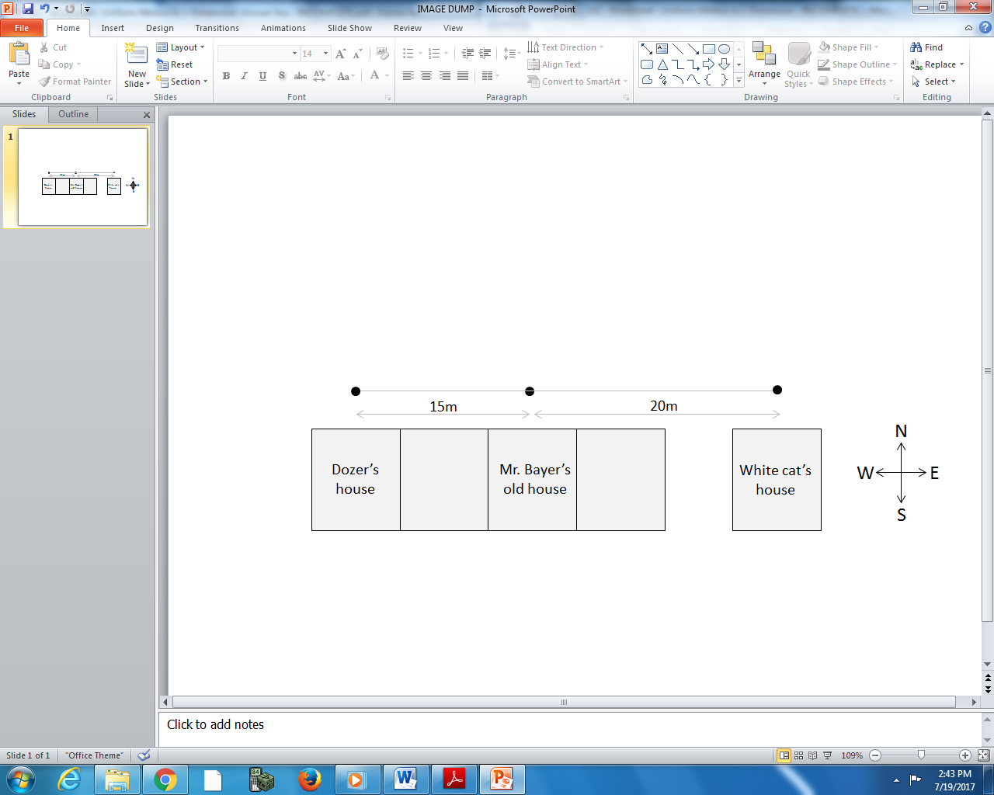

Q1: Dozer is originally in his own yard when he sees the white cat hanging out in from of Mr. Bayer’s house. Dozer charges 15m [East] in 12 seconds. What is Dozer’s velocity?
(Record your three digit answer in the Numerical Response boxes below)

Use the following additional information to answer Q2:
Dozer’s fight manages to wake up Mr. Bayer at 3am, causing Mr. Bayer to run out and break up the fight. Both cats scurry over to the white cat’s house. Mr. Bayer retrieves Dozer from the white cat’s house, which is 20m [East] of Mr. Bayer’s doorstep, and carries Dozer back to his own house, 15m [West] of Mr. Bayer’s doorstep. Being tired, Mr. Bayer is travelling at approximately 0.4 m/s [West].

Q2: Mr. Bayer was travelling for a.bc x 10^{d} seconds, where a, b,c, and d are ___, ___, ___ and ___.
Record your four digit answer in the Numerical Response boxes below)

Q3: A tyrannosaurus is hunting 300m [North] of a clearing when it hears a loud noise. It runs at 2.8 m/s [South] for 45 seconds towards the clearing before being knocked unconscious by a laser blast. How far was the tyrannosaurus from the clearing before it fell unconscious, in meters?
(Record your three digit answer in the Numerical Response boxes below)

Q4: After capturing the tyrannosaurus and equipping it with a “brain box” and laser blasts, Krulos, leader of the Rulons, marches the tyrannosaurus at a velocity of 3.4 m/s [West] for 300 seconds, leading it towards the heroic Valorians for battle. What is the magnitude of the displacement of the tyrannosaurus, in meters?
(Record your four digit answer in the Numerical Response boxes below)

Q5: The battle started at t₁ = 0.00 seconds. At t₂ = 15.00 seconds, Krulos orders a very unheroic retreat, causing his tyrannosaurus to run away at 4.5 m/s [West] for 60m before it stops at t₃. The tyrannosaurus stopped at t₃ = a.bc x 10^{d} seconds, where a, b, c, and d are ___, ___, ___, and ___.
(Record your four digit answer in the Numerical Response boxes below)

Use the following information to answer Q6-Q7:
Ash is a horrible person who engages in viscous animal fights for both profit and enjoyment. He sees two other individuals looking for trouble and decides to attack them with his electric yellow mouse. He throws a pokeball through the air, which lands a distance away from him. The electric yellow mouse ejects from the ball and runs 5m/s for 15 seconds before biting the foes 100m from Ash.

Q6: How far away from Ash did the pokeball land, in meters?
(Record your three digit answer in the Numerical Response boxes below)

Q7: Something resembling a blue ninja turtle squirts the electric yellow mouse with a blast of water, pushing it 150m [North] along the ground at a steady velocity of 18 m/s [North]. For how long was the electric yellow mouse subjected to the water blast, in seconds?
(Record your three digit answer in the Numerical Response boxes below)

Use the following information to answer Q8-Q10:
Two cats decide to pretend they are rams and smash their heads together.
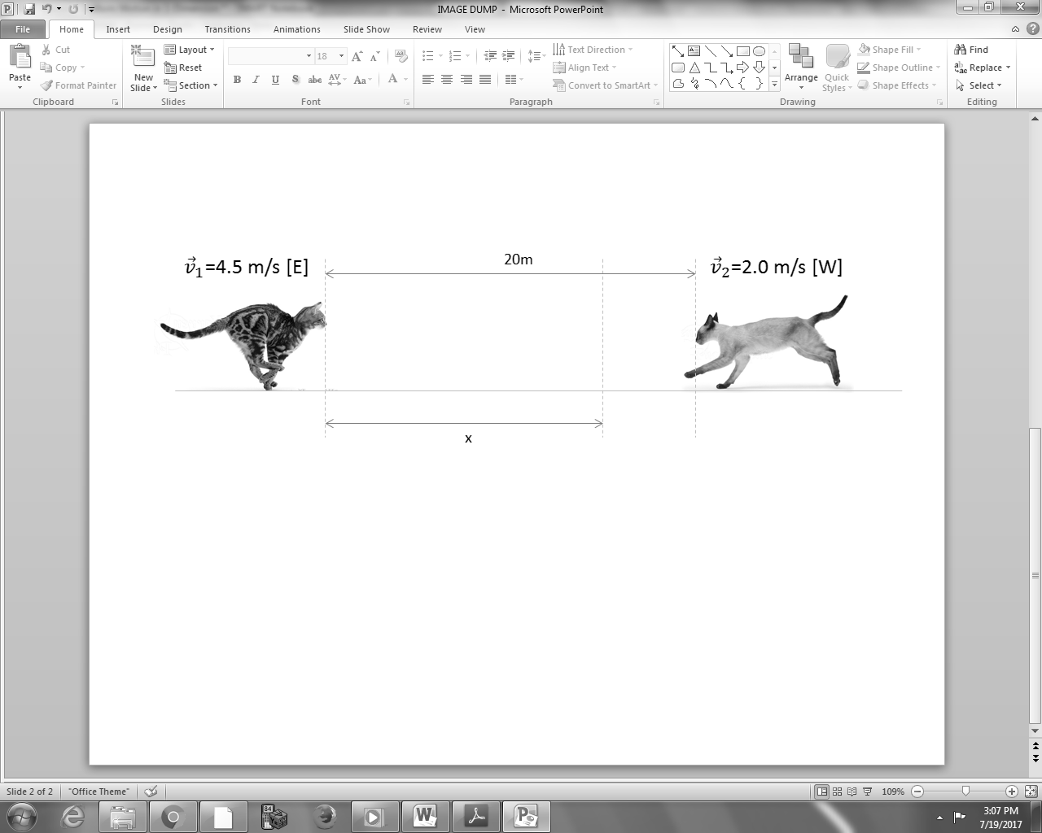

Q8: How far does the first cat (on the left) run before the collision?

Q9: How long after the snapshot above do the cats collide?

Q10: Verify your answer graphically.
