First Name:__________________________ Last Name:______________________________

L02 – Worksheet – Waves and Wave Equation (Light Waves)

Part 1 - Light Waves (Simple Calculations)
1984-1989
Q446: The period of vibration for a 4.0 x 10⁻⁷ m light source is
- 1.3 x 10⁻¹⁵ s
- 3.0 x 10⁻⁸ s
- 1.2 x 10² s
- 7.5 x 10¹⁴ s

Q449: A radar beam reflected off a distant object takes 2.0 x 10⁻³ s from transmission to reception. The distance between the transmitter and the object is
- 3.0 x 10⁵ m
- 6.0 x 10⁵ m
- 1.5 x 10¹¹ m
- 6.7 x 10¹¹ m

Q451: A laser beam is transmitted to a satellite and back. If the time of travel there and back is
1.23 x 10⁻² seconds, the distance between the satellite and the surface of the Earth is
- 7.39 x 10⁷ m
- 3.69 x 10⁶ m
- 1.85 x 10⁶ m
- 1.20 x 10⁶ m

Q452: A period of vibration for light of wavelength 5.0 x 10⁻⁷ m is
- 6.0 x 10¹⁴ s
- 2.0 x 10⁶ s
- 2.0 x 10⁻¹⁵ s
- 1.7 x 10⁻¹⁵ s

Use the following information to answer Q456:
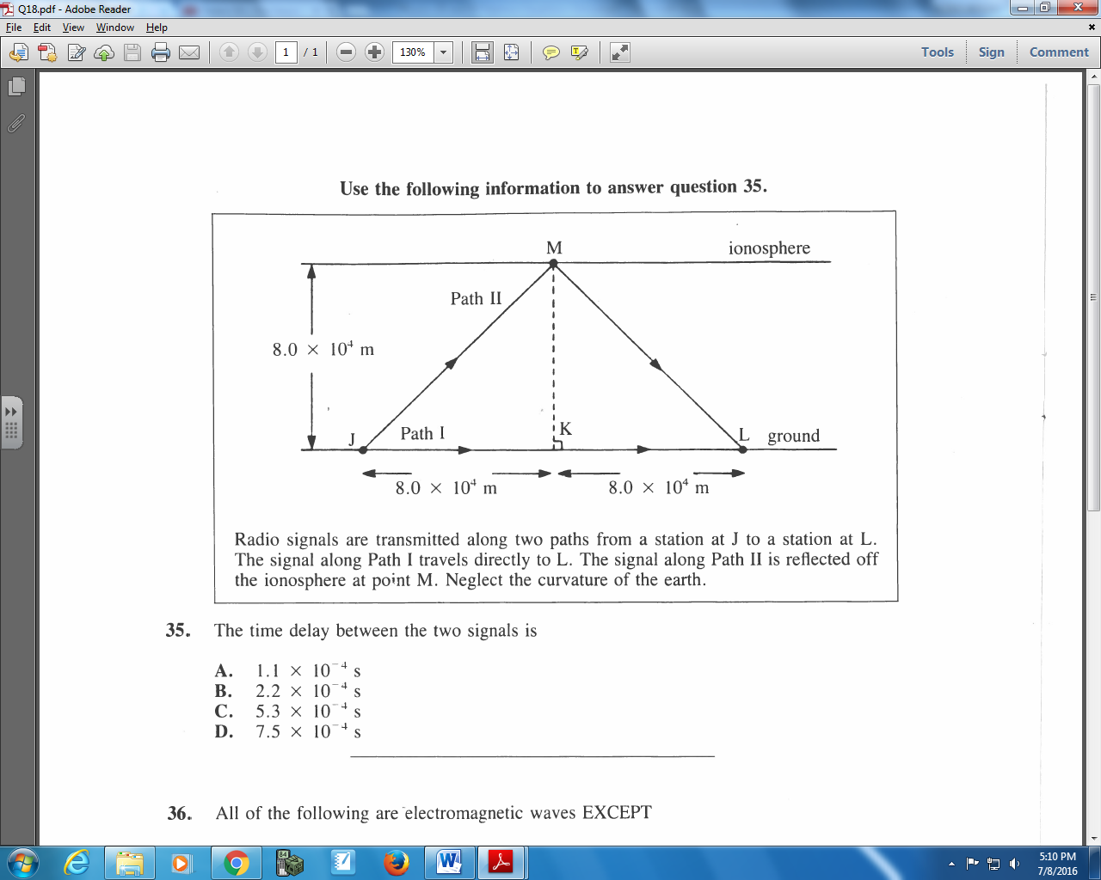
Radio signals are transmitted along two paths from a station at J to a station at L. The signal along Path I travels directly to L. The signal along Path II is reflected off the ionosphere at point M. Neglect the curvature of the earth.

Q456: The time delay between the two signals is
- 1.1 x 10⁻⁴ s
- 2.2 x 10⁻⁴ s
- 5.3 x 10⁻⁴ s
- 7.5 x 10⁻⁴ s

Use the following information to answer Q457:
Measuring Distance using Radar Waves
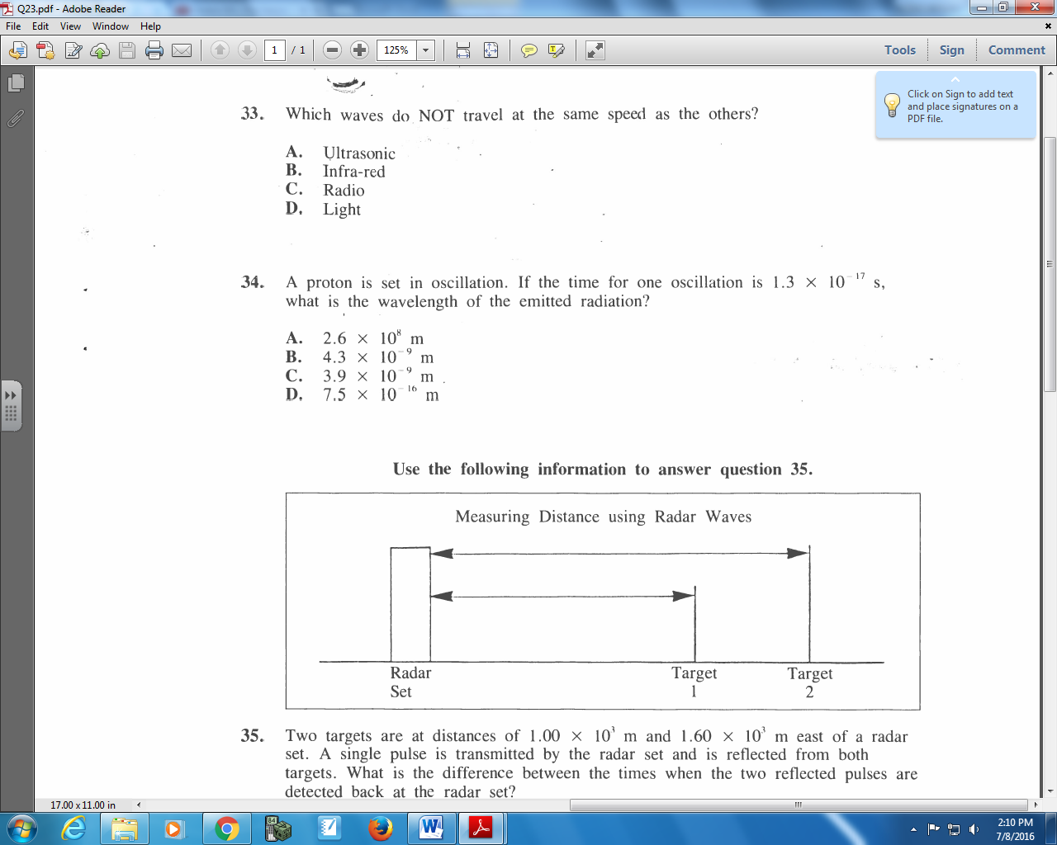

Q457: Two targets are at a distance of 1.00 x 10³ m and 1.60 x 10³ m east of a radar set. A single pulse is transmitted by the radar set and is reflected from both targets. What is the difference between the times when the two reflected pulses are detected back at the radar set?
- 2.0 x 10⁻⁶ s
- 4.0 x 10⁻⁶ s
- 6.7 x 10⁻⁶ s
- 1.1 x 10⁻⁵ s

Q458: Blue light, with a wavelength in vacuum of 4.8 x 10⁻⁷ m, has a period of vibration of
- 1.6 x 10⁻¹⁵ s
- 6.9 x 10⁻³ s
- 1.4 x 10² s
- 6.3 x 10¹⁴ s

Q462: If the distance from Earth to a planet is 2.0 x 10¹¹ m, a radar signal can travel to that planet and return to Earth in
- 6.7 min
- 11 min
- 13 min
- 22 min

Q463: The wavelength of a particular red light in a vacuum is 6.3 x 10⁻⁷ m. The period of the red light is
- 4.8 x 10¹⁴ s
- 1.6 x 10⁶ s
- 1.9 x 10² s
- 2.1 x 10⁻¹⁵ s

Q464: An electromagnetic radiation of wavelength 2.7 x 10⁻¹⁴ m has a period of
- 9.0 x 10⁻²³ s
- 4.5 x 10⁻¹³ s
- 3.7 x 10¹³ s
- 1.1 x 10²² s

Use the following information to answer Q472:
A Japanese car manufacturer is designing an automatic braking system that detects objects in a car’s path. The system involves a detector that receives reflected laser signals.

Q472: A signal sent by the laser is reflected and returned to the detector 0.15 μs after its transmission. The distance from the car to the detected object is
- 15 m
- 23 m
- 42 m
- 45 m

Q473: An electromagnetic wave has a frequency of 2.00 x 10²⁴ Hz. The speed of the wave in a vacuum, expressed in scientific notation, is b x 10^{w} m/s. The value of b is _____.
(Record your three digit answer in the Numerical Response boxes below)

Part 2 – Light Waves (Calculations with Trigonometry)
1984-1989
Use the following information to answer Q485:
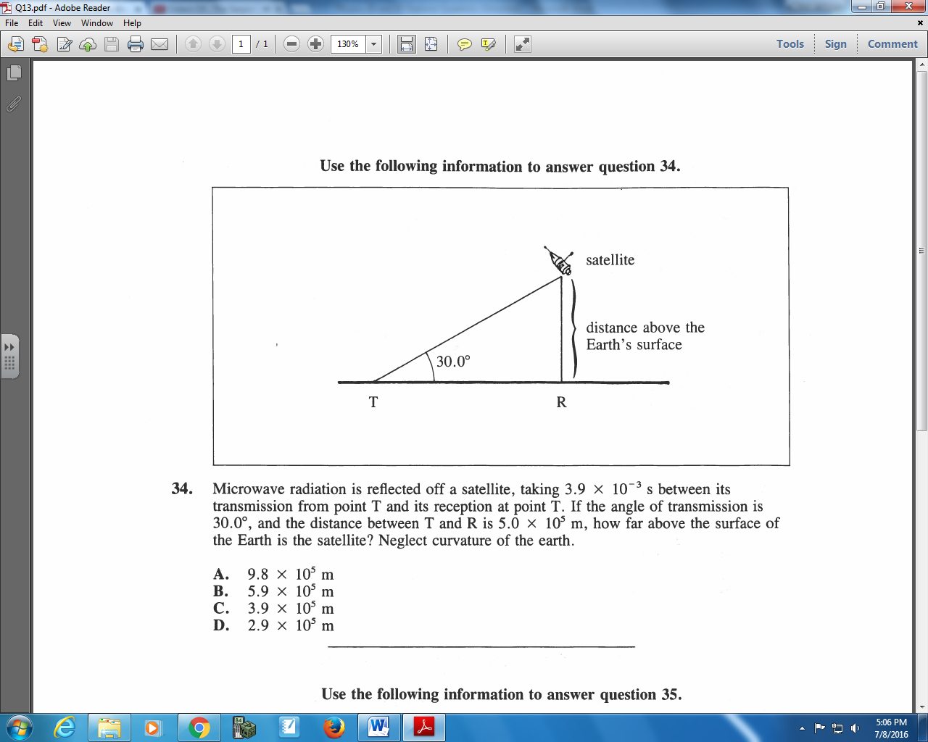

Q485: Microwave radiation is reflected off a satellite, taking 3.9 x 10⁻³ s between its transmission from point T and its reception at point T. If the angle of transmission is 30.0⁰, and the distance between T and R is 5.0 x 10⁵ m, how far above the surface of the Earth is the satellite? Neglect curvature of the earth.
- 9.8 x 10⁵ m
- 5.9 x 10⁵ m
- 3.9 x 10⁵ m
- 2.9 x 10⁵ m

Use the following information to answer Q487:
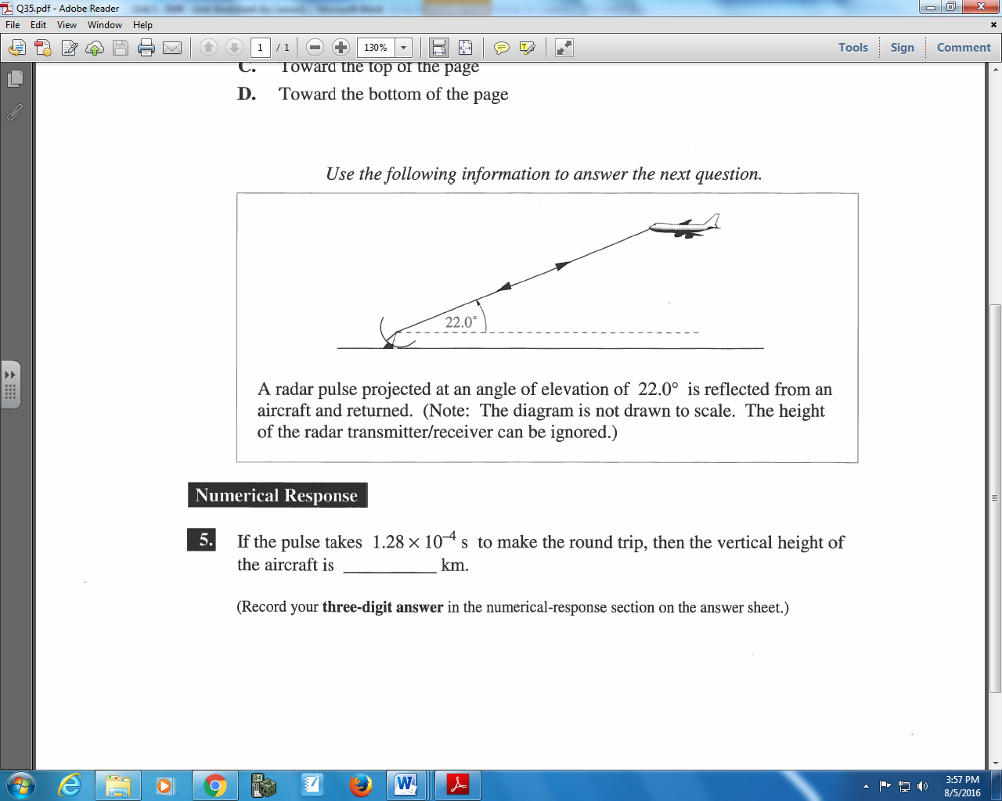

Q487: If the pulse takes 1.28 x 10⁻⁴ s to make the round trip, then the vertical height of the aircraft is _____ km.
(Record your three digit answer in the Numerical Response boxes below)

Part 3 – Light Waves (Graphs)
Q489: Of the following graphs showing the relationship of frequency to wavelength, the one that is true for ALL forms of light is
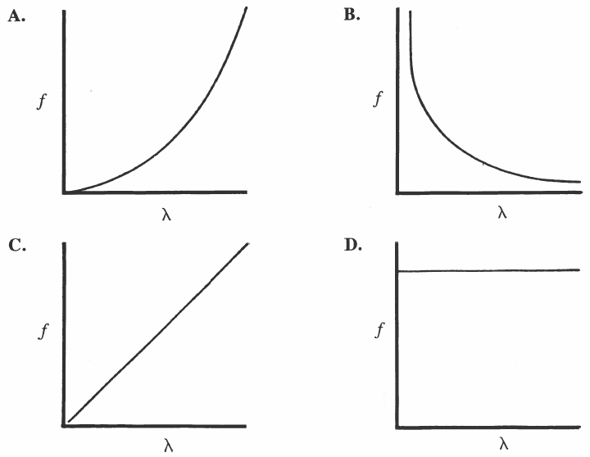

Q491: If the frequency-time graph for a particular electromagnetic wave generator is
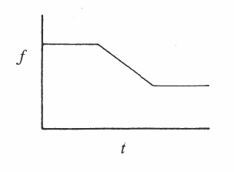
Then the corresponding wavelength-time graph is
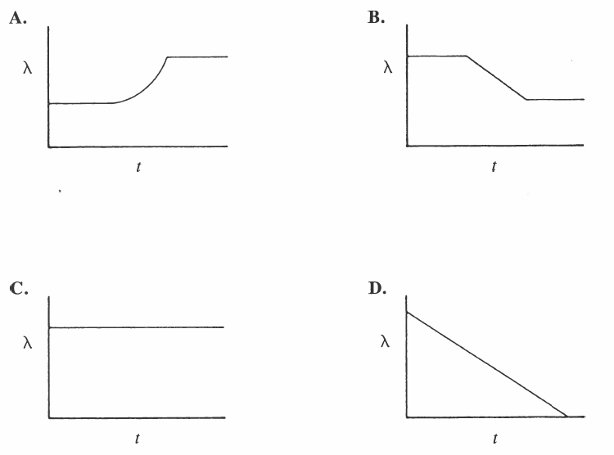

Q492: The graph that relates velocity in a vacuum to frequency for electromagnetic radiation is
