First Name:__________________________________ Last Name:______________________________

L03 – FQ – Calculating Net Forces

Use the following information to answer Q1-Q3:
Two young children are in a wagon being pulled to the left by a young boy with a force of 300N at an angle of inclination of 20° above the horizontal and pushed by a girl with a horizontal force of 320N to the left. The wagon and contents experience a combined gravitational force of 900N.
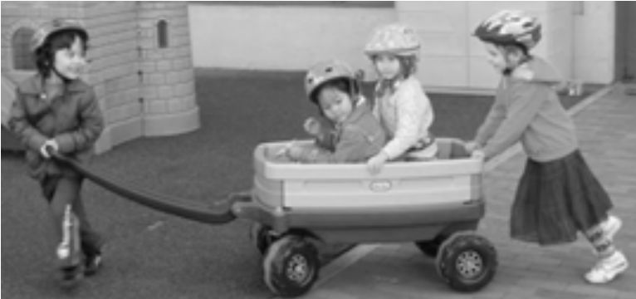

Q1: Which image best represents the free-body diagram of the wagon?
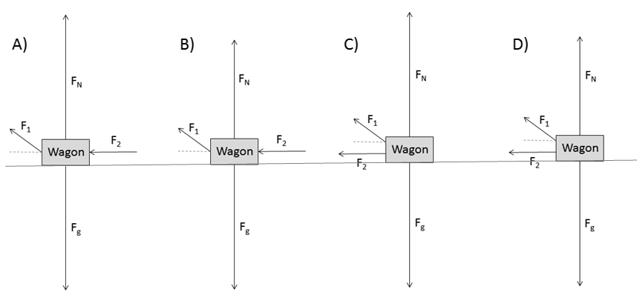

Q2: The net force in the x-component is a.bc x 10^{d} N, where a, b, c, and d are ___, ___, ___, and ___.
(Record your four-digit answer in the Numerical Response boxes below)

Q3: The net force in the y-component is
- 0.0 N
- 102.6 N
- 281.9 N
- 797.4 N

Q4: The Normal Force exerted on the wagon by the ground is a.bc x 10^{d} N, where a, b, c, and d are ___, ___, ___, and ___.
(Record your four-digit answer in the Numerical Response boxes below)

MARKING:
Beginning 0 – 1
Progressing 2
Competent 3
Exemplary 4

