First Name:__________________________________ Last Name:______________________________

L03 – FQ - Coulomb’s Law in 1-Dimension

Q1: If the second charge, q₂, has a mass of 0.02kg, what is its instantaneous acceleration? (4 marks)
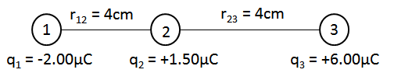

Q2 (1 mark): A uniform metal sphere with a charge of +8.0 μC is momentarily brought into contact with an identical sphere of charge -6.0 μC. After they are separated, the charge on each sphere is:
- +0μC and -0μC
- +1μC and +1μC
- +2μC and +2μC
- +8.0 μC and -6.0μC

MARKING:
Beginning 0.0 – 2.0
Progressing 2.5 – 3.0
Competent 3.5 – 4.5
Exemplary 5

