First Name:____________________________ Last Name:______________________________

L03 – FQ – Mass Spectrometers and Millikan’s Experiment

Use the following information to answer Q1:
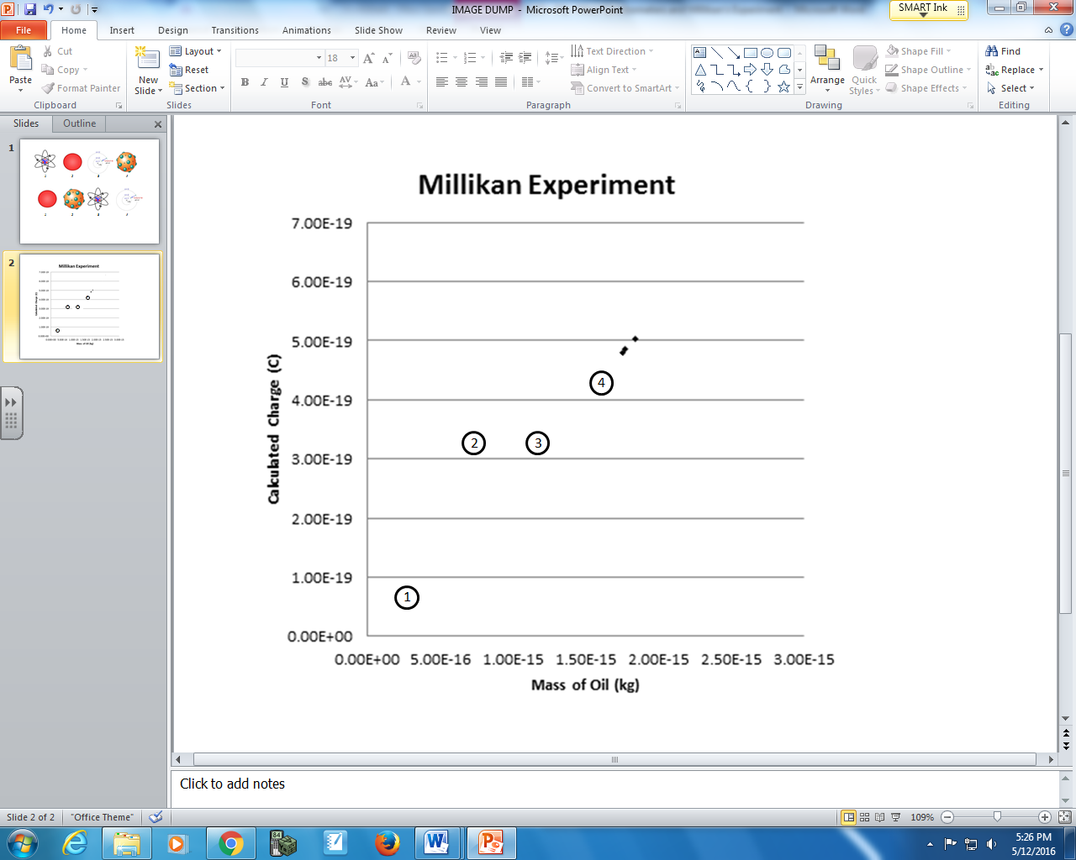

Q1: What is the most probable location for data collected in a Millikan-style experiment?
- Location 1
- Location 2
- Location 3
- Location 4

Use the following information to answer Q2:
Mass Spectrometer
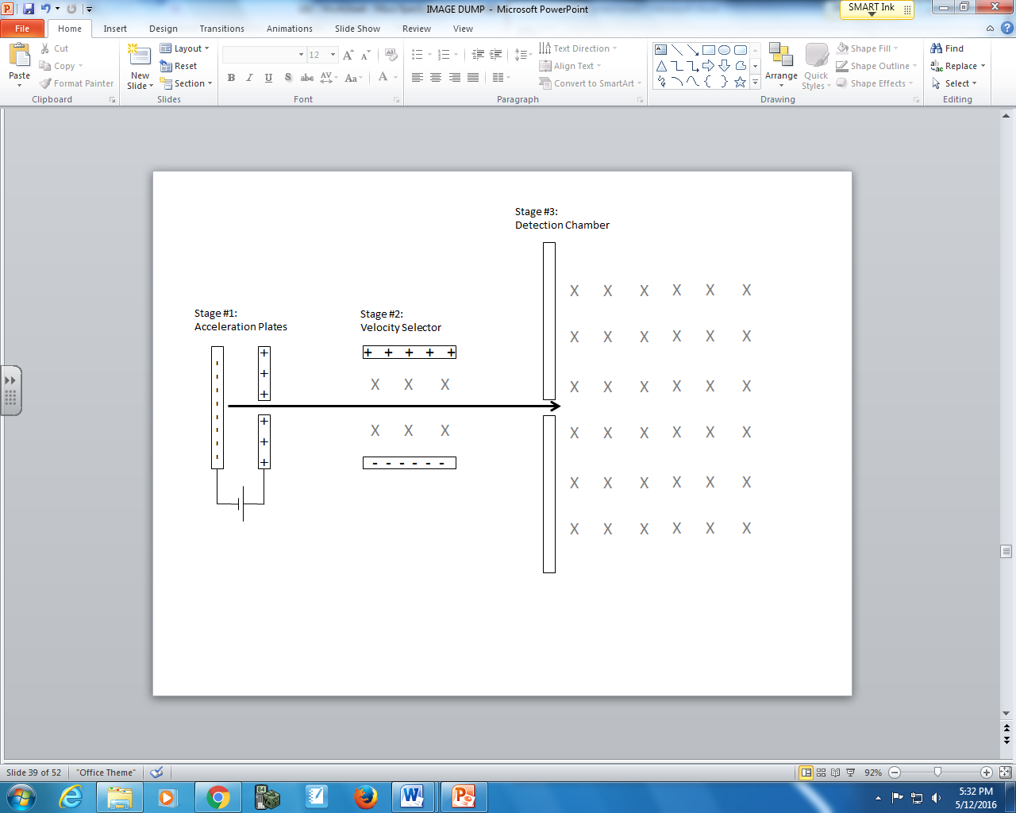
Equation Configurations
1 - $q∆V=\frac{1}{2}mv^{2}$ 2 - $q\left|\vec{E}\right|=\frac{1}{2}mv^{2}$
3 - $q∆V=qv\left|\vec{B}\right|$ 4 - $q\left|\vec{E}\right|=qv\left|\vec{B}\right|$
5 - $qv\left|\vec{B}\right|=\frac{mv^{2}}{r}$ 6 - $q\left|\vec{E}\right|=\frac{mv^{2}}{r}$

Q2: Which equation configurations would be used for each of the various stages?
________ ________ ________
Acceleration Velocity Detection
Plates Selector Chamber
(Record your three digit answer in the Numerical Response boxes below)

Use the following information to answer Q3:
Models of the Atom
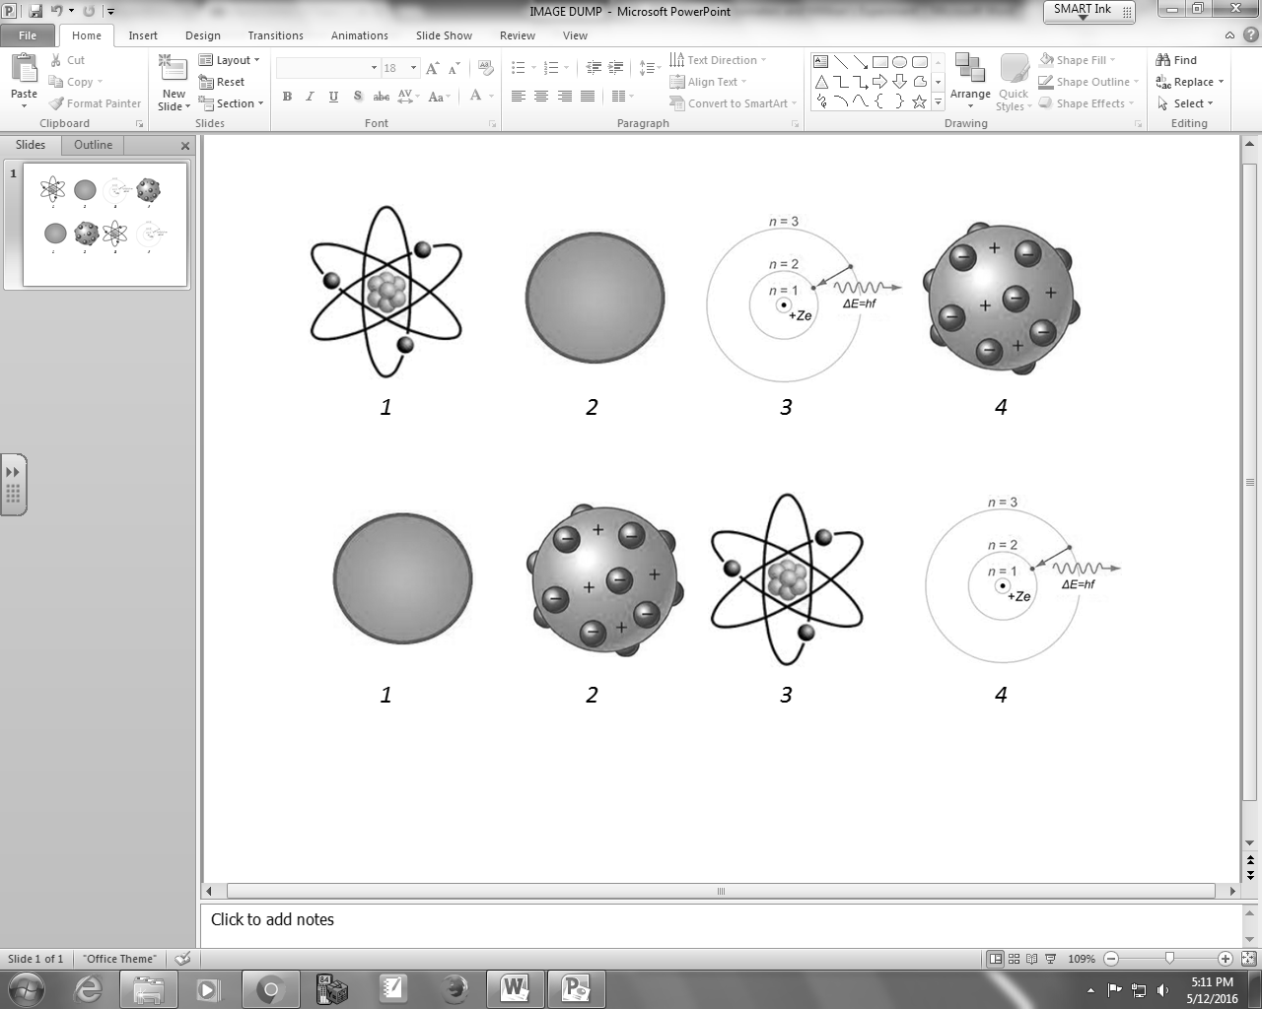

Q3: Using the information above, assign the model to the person that proposed the model:
________ ________ ________ ________
Bohr Dalton Rutherford J.J. Thomson
(Record your four digit answer in the Numerical Response boxes below)

MARKING:
Beginning 0
Progressing 1
Competent 2
Exemplary 3

