First Name:___________________________ Last Name:______________________________

L03 - Formative Quiz – Speed of Light

Use the following information to answer Q1 to Q4.
A Michelson-type experiment is set up using a rotating 8-sided mirror. A lamp is uncovered, and the observer increases the frequency of rotation until they reach the minimum frequency required to observe the light source.
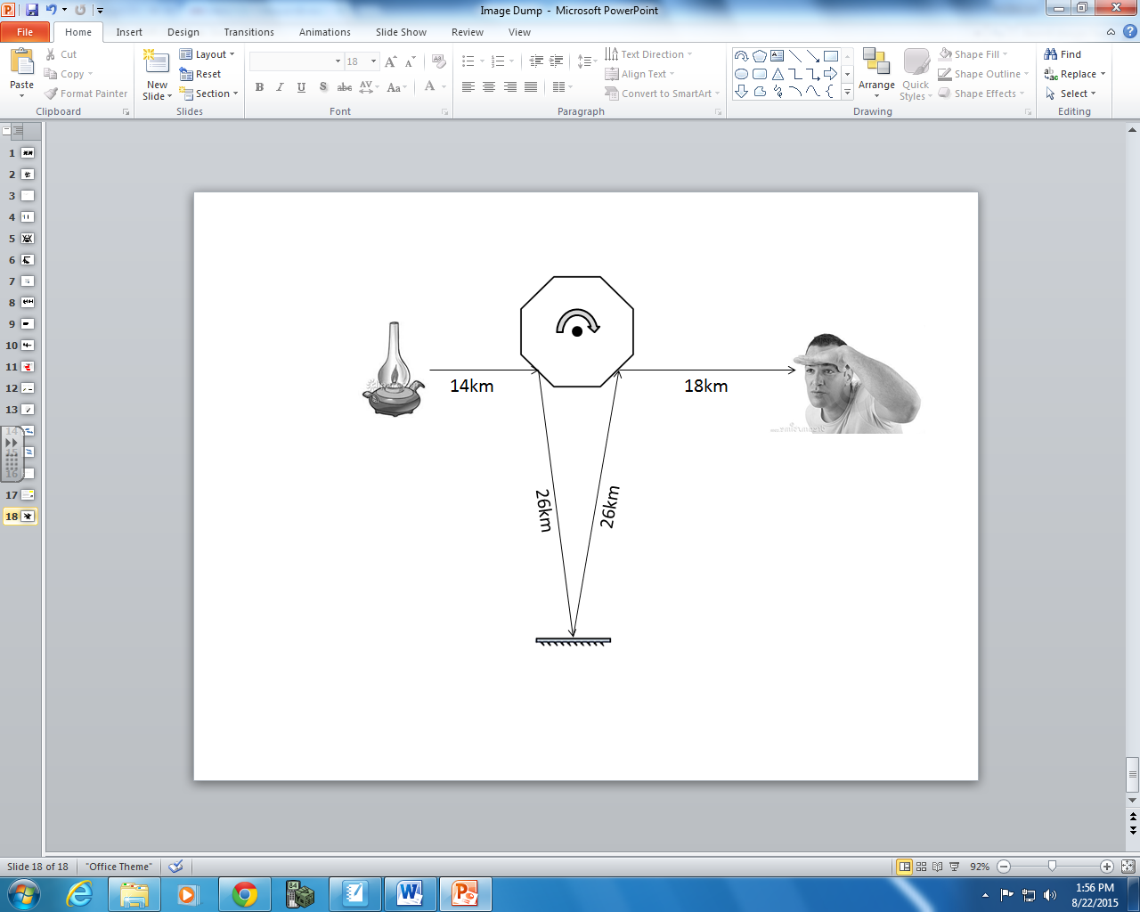

Q1: How much distance must the light travel in 1/8th of a rotation?
- 26km
- 32km
- 52km
- 84km

FLIP THE PAGE TO CONTINUE
Q2: When the rotating mirror is rotating at the minimum frequency required for the observer to see the light, the time it takes the mirror to rotate 1/8th of a rotation is a.bc x 10^{-d} seconds, where a, b, c, and d are ____, ____, ____, and ____. (1 mark)
(Record your four-digit answer in the numerical response boxes below.)

Q3: When the rotating mirror is rotating at the minimum frequency required for the observer to see the light, the period of the mirror’s rotation is a.bc x 10^{-d} seconds, where a, b, c, and d are ____, ____, ____, and ____. (1 mark)
(Record your four-digit answer in the numerical response boxes below.)

Q4: When the rotating mirror is rotating at the minimum frequency required for the observer to see the light, the frequency of the mirror’s rotation is a.bc x 10^{d} Hertz, where a, b, c, and d are ____, ____, ____, and ____. (1 mark)
(Record your four-digit answer in the numerical response boxes below.)

MARKING:
Beginning 0-1
Progressing 2
Competent 3
Exemplary 4

