First Name:_________________________________ Last Name:______________________________

L03 – FQ – Uniform Motion in 1-Dimension

Use the following information to answer Q1-Q2:
A squirrel is 15m [West] of a tree when it sees a friendly park attendant with bread crumbs. The park attendant is 40m [East] of the tree. The squirrel runs at 3.6 m/s [East] towards the park attendance.

Q1: Which best describes the squirrel’s final position, relative to the tree?
- 15m [East]
- 25m [East]
- 40m [East]
- 55m [East]

Q2: Which best describes he squirrel’s displacement?
- 15m [East]
- 25m [East]
- 40m [East]
- 55m [East]

Q3: How long, in seconds, was the squirrel running for?
(Record your three digit answer in the Numerical Response boxes below)

Use the following information to answer Q4:
A young baby is playing in a playground 10m from his father, when he decides to start running for the road. The father immediately chases after and catches him 3.5 seconds later.
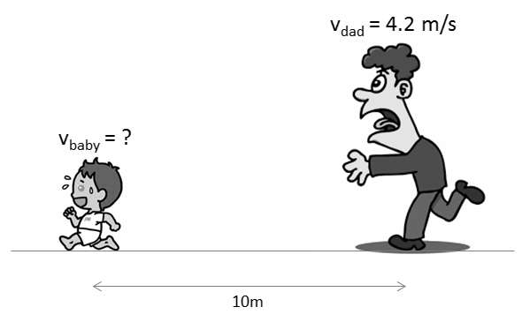

Q4: How fast, in meters per second, was the baby running?
(Record your three digit answer in the Numerical Response boxes below)

MARKING:
Beginning 0.0 – 1.5
Progressing 2.0 – 2.5
Competent 3.0 – 3.5
Exemplary 4.0

