First Name:___________________________ Last Name:___________________________

L03 – Lab – Linearizing Gravitational Forces /24 marks

Students will:
- Use the data table provided to graph the relationship between radius (r) and force (Fg) by hand.
- Manipulate the x-variable to linearize the graph. Graph inverse radius squared (1/r²) versus force of gravity (Fg) by hand.
- Use the linearized graph to calculate the Gravitational Constant, G.
Step #1: Complete the following table.
Radius, r  (meters) | Force of Gravity, F_{g}  (Newtons) | Inverse radius squared, 1/r²  (1/m²)
0.1 | 20 x 10⁻⁷
0.2 | 5.0 x 10⁻⁷
0.3 | 2.2 x 10⁻⁷
0.4 | 1.3 x 10⁻⁷
0.5 | 0.8 x 10⁻⁷

 | Marks | Weighting Multiplier | 3 | 2 | 1 | 0
Organize and integrate data, using a format that is appropriate to the task or experiment. |  | x1 | Student has properly taken the inverse square of the radius for all values | Student has correctly taken the inverse square of the radius for 3-4 values. | Student has correctly taken the inverse square of the radius for 1-2 values. | Student has not correctly taken the inverse square of any value.
Step #2: Graph radius (r) versus Force of Gravity (F_{g}) below.

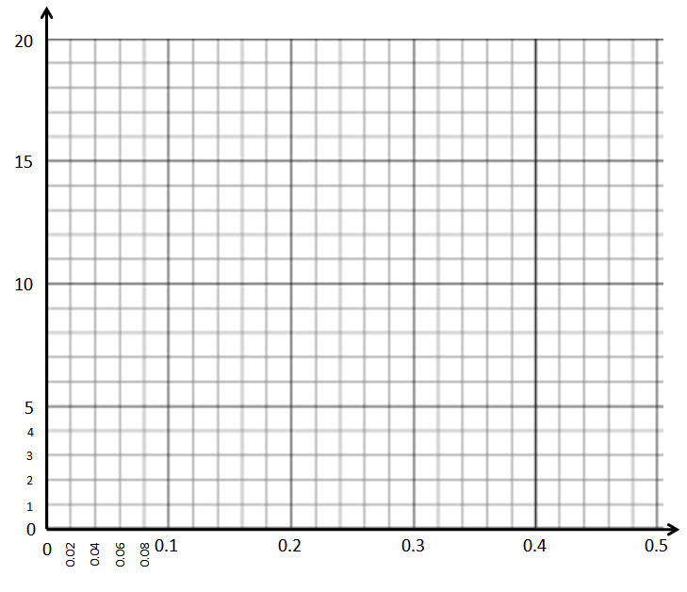

 | Marks | Weighting Multiplier | 3 | 2 | 1 | 0
Organize and integrate data, using a format that is appropriate to the task or experiment. |  | x2 | Student has completed the graph, selecting their independent and dependent variables and labelling their graphs correctly. | Student has completed the graph, but either axis switched or labels are missing. | Student's graphs are incorrect. | Not included in write-up.
Step #3: Graph inverse radius squared (1/r²) versus Force of Gravity (F_{g}) below.

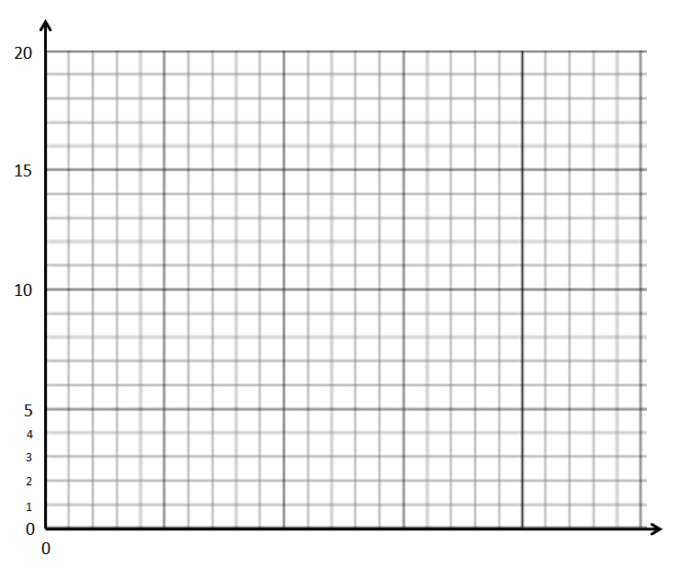

 | Marks | Weighting Multiplier | 3 | 2 | 1 | 0
Organize and integrate data, using a format that is appropriate to the task or experiment. |  | x2 | Student has completed the graph, selecting their independent and dependent variables and labelling their graphs correctly. | Student has completed the graph, but either axis switched or labels are missing. | Student's graphs are incorrect. | Not included in write-up.
Step #4: Interpolation
Determine the radius that would yield a gravitational force of 3.5 x 10⁻⁷ N.
Graph used: | How did you use this data? | Radius that yielded this value:

Step #5: Extrapolation
Determine the radius that would yield a gravitational force of 50 x 10⁻⁷ N.
Graph used: | How did you use this data? | Radius that yielded this value:

 | Marks | Weighting Multiplier | 3 | 2 | 1 | 0
Predict the value of a variable, by interpolating or extrapolating from graphical data or from a line of best fit. |  | x1 | Student is able to interpolate or extrapolate, and justify the reliability of their prediction. | Student is able to interpolate and extrapolate linear data, without justification. | Student's interpolation or extrapolation is incorrect. | Not included in write-up.

Step #6: Calculations using the Linearized Graph
Calculate slope of linearized graph: | Determine the units of the slope:
Rearrange the formula, $F_{g}=\frac{Gm_{1}m_{2}}{r^{2}}$, to give the same units as the slope. | If m₁ = 10kg and m₂ = 30kg, calculate the Gravitational Constant, G.

 | Marks | Weighting Multiplier | 3 | 2 | 1 | 0
Interpret patterns and trends in data, and infer and calculate linear and nonlinear relationships among the variables. |  | x2 | Student is able to:  (a) Determine units of slope  (b) Rearrange formula  (c) Calculate slope  (d) Calculate G | Student is able to complete 3 of the 4 tasks to the left. | Student is able to complete only 1 or 2 tasks to the left. | Not included in write-up.

