First Name:__________________________ Last Name:______________________________

L03 – Worksheet – Conservation of Mechanical Energy /34 marks

Part 1: Gravitational and Kinetic Energy (Very Easy)
Q1: A 39.0N force is applied to a 3.98kg to lift it 1.3 meters high. How much work was done?
(Record your three-digit answer in the Numerical Response boxes below)

Q2: Another 3.98kg desk is lifted using 39.0N of force. If 16.0J of work was done, then the desk was lifted a height of a.bc x 10^{-d} meters, where a, b, c, and d are ___, ___, ___, and ___.
(Record your four-digit answer in the Numerical Response boxes below)

Q3: A plane that is 1238 meters above the ground has a gravitational potential energy of 5.0 x 10⁸ J. The mass of the plane is a.bc x 10^{d} kg, where a, b, c, and d are ___, ___, ___, and ___.
(Record your four-digit answer in the Numerical Response boxes below)

Q4: What is the kinetic energy of a 675g baseball that is moving at 376 cm/s?
(Record your three-digit answer in the Numerical Response boxes below)

Q5: If a bullet fired from a rifle has a velocity of 87 m/s and a kinetic energy of 83.26J, then the mass of the bullet is a.bc x 10^{-d} kg, where a, b, c, and d are ___, ___, ___, and ___.
(Record your four-digit answer in the Numerical Response boxes below)

Q6: A bird is flying at 121 cm/s while 23.4 meters above ground. If the bird has a mass of 1780 grams, then its total mechanical energy is _____ Joules.
(Record your three-digit answer in the Numerical Response boxes below)

Q7: What is the mechanical energy of a 394g arrow flying at 4.8 m/s, 0.79 meters above the ground?
(Record your three-digit answer in the Numerical Response boxes below)

Q8: A butterfly has a gravitational potential energy of 0.051 J when it is 5.2 meters above the ground, and is flying at a speed of 0.026 m/s. The total mechanical energy of the butterfly is a.bc x 10^{-d} J, where a, b, c, and d are ___, ___, ___, and ___.
(Record your four-digit answer in the Numerical Response boxes below)

Part 2: Conservation of Energy (Easy)
Q9: A ball has a mass of 0.500 kg and is kicked vertically, reaching maximum height of 17.0 meters. The maximum speed of the ball was a.bc x 10^{d} m/s, where a, b, c, and d are ___, ___, ___, and ___.
(Record your four-digit answer in the Numerical Response boxes below)

Q10: A 5kg mass is dropped from a height of 6m. What is the speed of the object immediately before impacting the ground, in m/s?
(Record your three-digit answer in the Numerical Response boxes below)

Q11: A disgruntled student throws their 1.3kg textbook straight up into the air at a speed of 6m/s. What is the maximum height that the textbook reaches?
(Record your three-digit answer in the Numerical Response boxes below)

Q12: An object of unknown mass is dropped from a height of 100m. Ignoring air resistance, what is the speed of the object directly before it hits the ground?
(Record your three-digit answer in the Numerical Response boxes below)

Part 3: Conservation of Energy (Medium)
Use the following information to answer Q13-Q16:
Incline Planes as Simple Machines
An inclined plane, also known as a ramp, is a flat supporting surface tilted at an angle, with one end higher than the other, used as an aid for raising or lowering a load. The inclined plane is one of the six classical simple machines defined by Renaissance scientists. Moving an object up an inclined plane requires less force than lifting it straight up, at a cost of an increase in the distance moved.
In the example below, a force of 70N is required to push a 10kg box up a wooden incline plane.
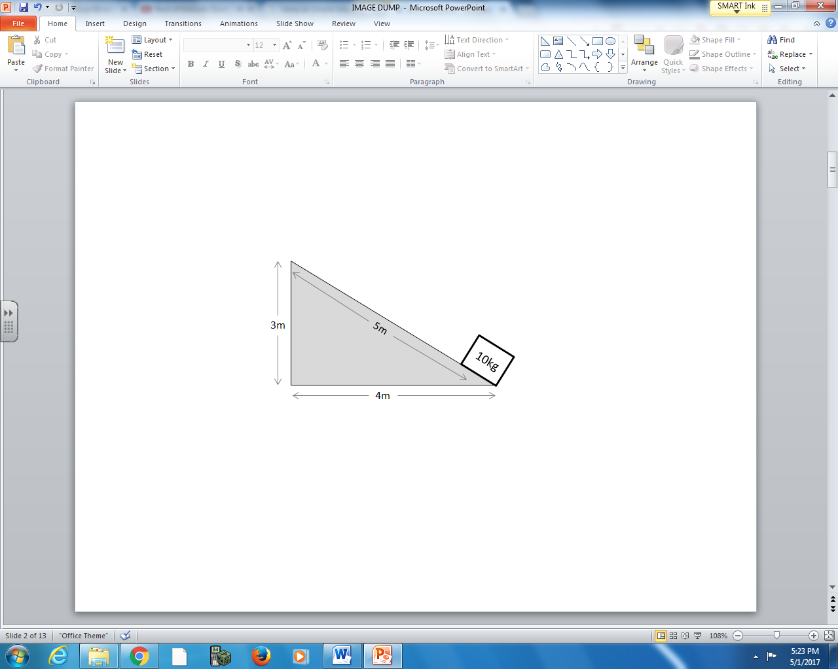

Text

Q13: How much work is done, in Joules, to push the 10kg box diagonally up the incline plane?
- 50 J
- 70 J
- 350 J
- 700 J

Q14: How much force would have been required to lift the box straight up in the air without the aid of an incline plane?
- 30.0 N
- 50.0 N
- 98.1 N
- 294.3 N

Use the following additional information to answer Q15-Q16:
When pushing the box up the incline plane, friction is created from the rubbing of the box on the wooden ramp. As a result, there is some thermal energy loss, and the incline plane is not 100% efficient.

Q15: How much potential energy does the 10kg block have when at the top of the incline plane?
- 98.1 J
- 294.3 J
- 392.4 J
- 490.5 J

Q16: How much energy is lost due to thermal energy loss?
(Record your three-digit answer in the Numerical Response boxes below)

Use the following information to answer Q17-Q18:
A 10kg object accelerates from 5m/s to 7m/s over 15m due to a constant force. Assume that the system is frictionless.

Q17: How much work was done to accelerate the object?
(Record your three-digit answer in the Numerical Response boxes below)

Q18: How much force was applied to the object to accelerate it?
(Record your three-digit answer in the Numerical Response boxes below)

Use the following information to answer Q19:
Rollercoaster Track
An empty 500kg rollercoaster cart has a velocity of 5m/s at Location A, and a velocity of 12m/s at Location B.
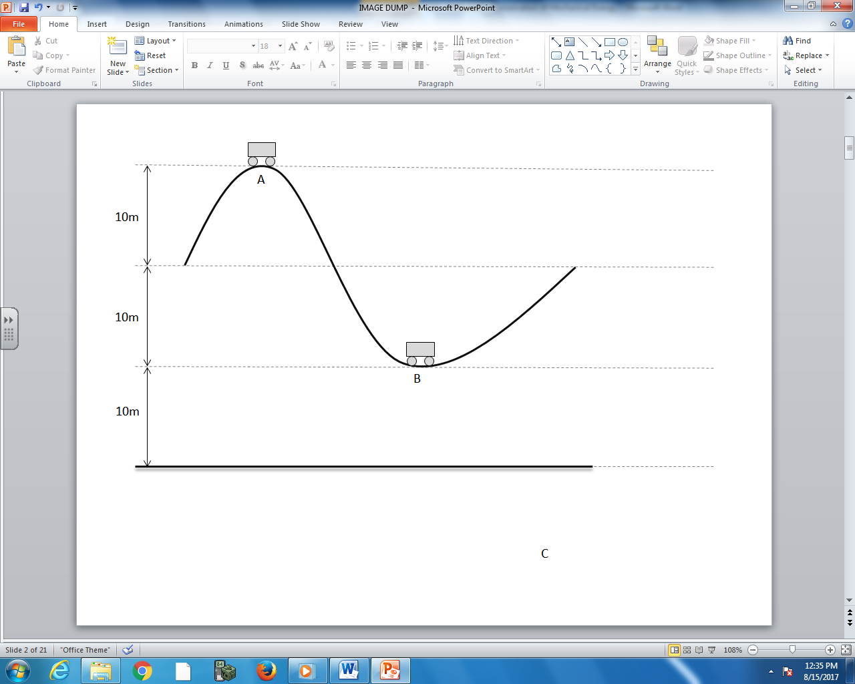

Q19: How much energy was lost due to friction? (2 marks)

Use the following information to answer Q20-Q22:
Frictionless Rollercoaster Track
An empty 500kg rollercoaster cart is used for a safety inspection of a recently constructed track. The cart is initially stationary at Location A, and the track is considered frictionless.
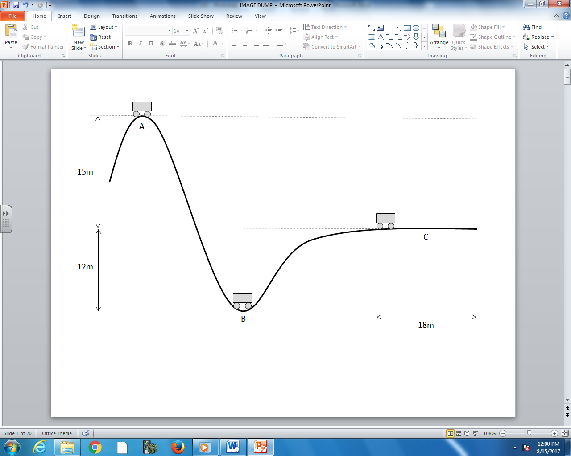

Q20: What is the total mechanical energy of the cart at Location A? (1 mark)

Q21: What is the speed of the cart at Location B?(1 mark)

Q22: How long does it take the cart to clear the 18m distance at Location C? (3 marks)

Part 4: Combination Questions (Hard)
Use the following information to answer Q23:
An initially stationary block is pushed with a force of $\vec{F_{app}}=100N [{330}^{0}]$, moving a displacement of $\vec{∆d}=5m \left[0^{0}\right].$ The coefficient of friction between the block and the surface is 0.05.

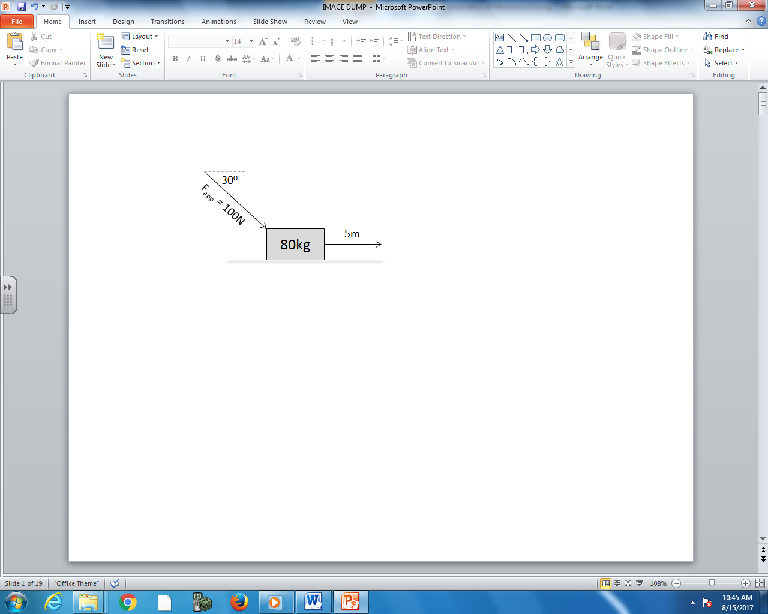

Q23: The thermal energy loss due to friction is a.bc x 10^{d} Joules, where a, b, c, and d are ___, ___, ___, and ___.
(Record your four-digit answer in the Numerical Response boxes below)

Use the following information to answer Q24:
A pendulum arm is raised upward, as depicted below. When the arm reaches the lowest point, the string snaps and the mass is launched horizontally.
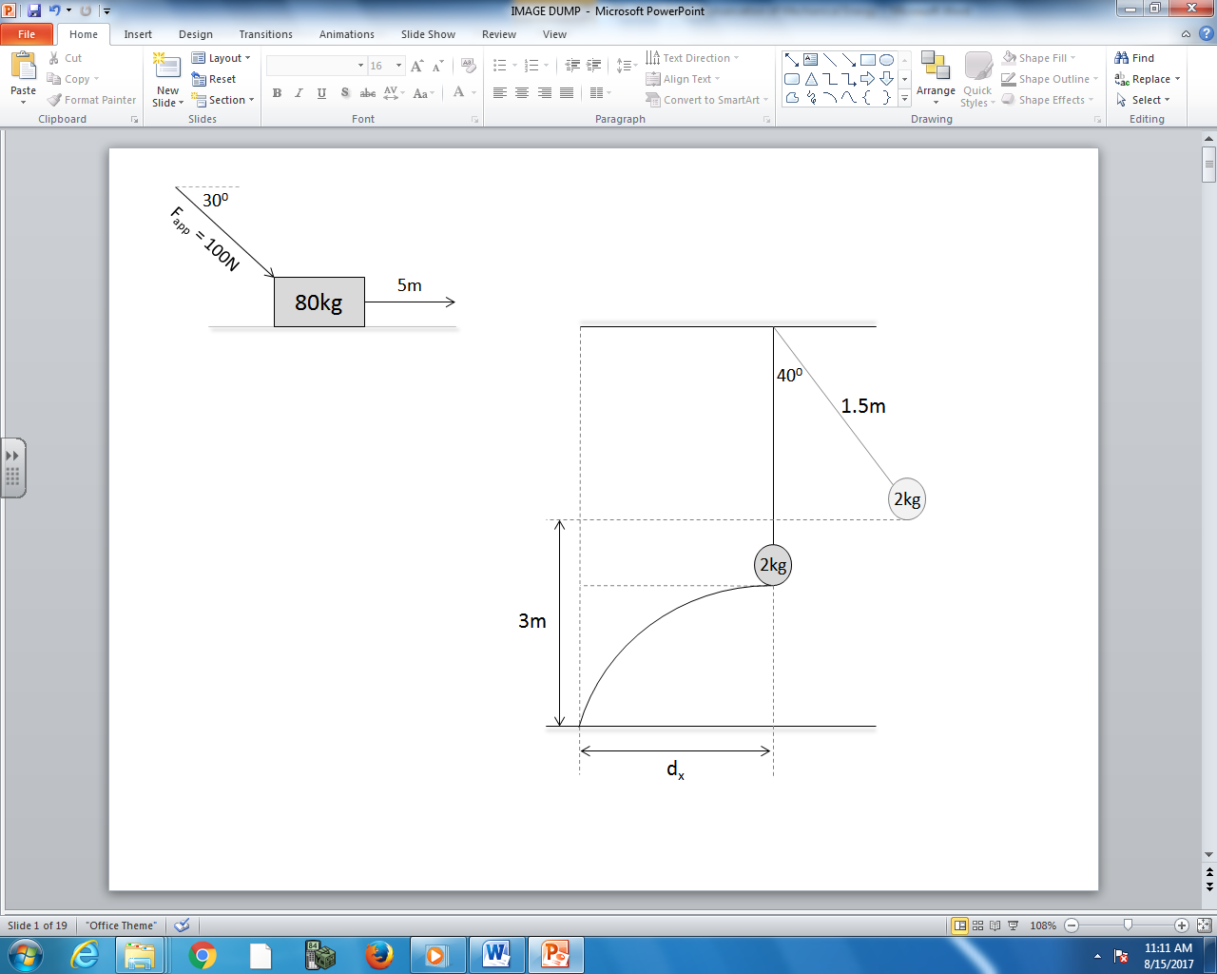

Q24: What is the horizontal range of the launched mass? (3 marks)

Use the following information to answer Q25-27:
A string is connected to a 200g mass to create a pendulum. The mass is originally at Position A when it is released. It swings down to Position C, at which point the string catches on a post located 25cm above the mass. The mass then swings around the post, up to Position E, as depicted below.
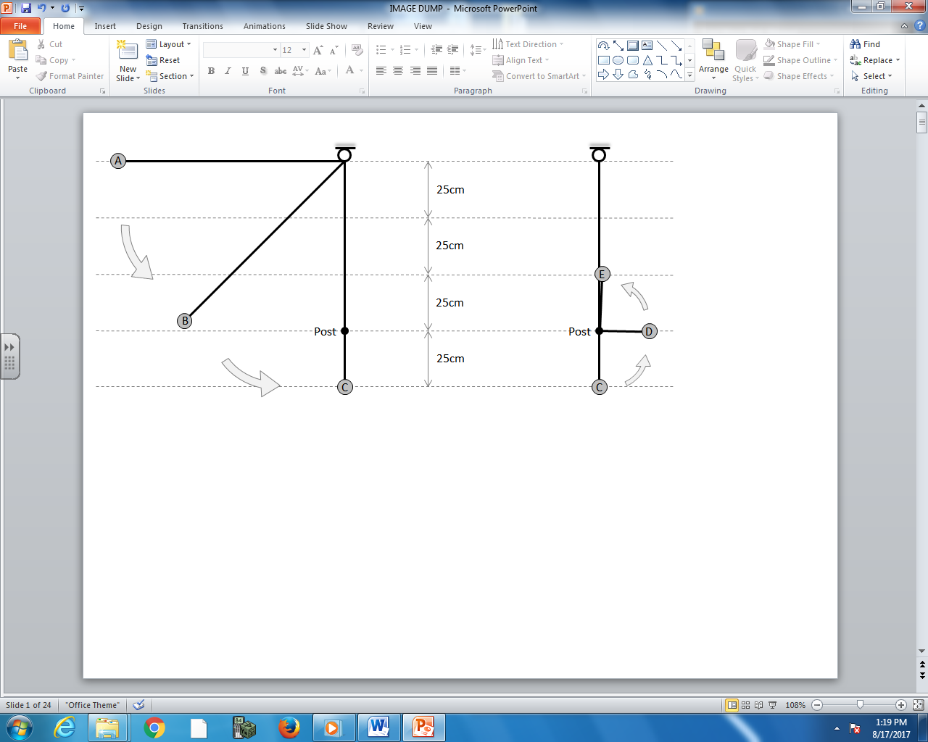

Q25: How much potential energy does the mass have while at Position A?
(Record your three-digit answer in the Numerical Response boxes below)

Q26: What is the speed of the pendulum mass while at Position C?
(Record your three-digit answer in the Numerical Response boxes below)

Q27: What is the tension of the mass while at Position E? (3 marks)

