First Name:______________________________ Last Name:______________________________

L03 – Worksheet – Coulomb’s Law in 2-Dimensions

Textbook Questions
Pg 534 #1: A small metal sphere X with a negative charge of -2.50 C is 1.20 cm directly to the left of another similar sphere Y with a charge of +3.00 C. A third sphere Z with a charge of +4.00 C is 1.20 cm directly below sphere Y. The three spheres are at the vertices of a right triangle, with sphere Y at the right angle. Calculate the net electrostatic force on sphere Y, sketching diagrams as necessary.

Pg 534 #2: Calculate the net electrostatic force on charge B in the figure below.
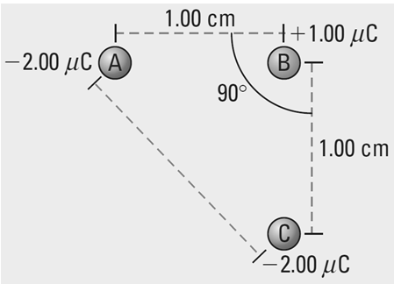

Diploma Worksheet Questions – Coulomb’s Law (in 2-Dimensions)
Use the following information to answer Q118:
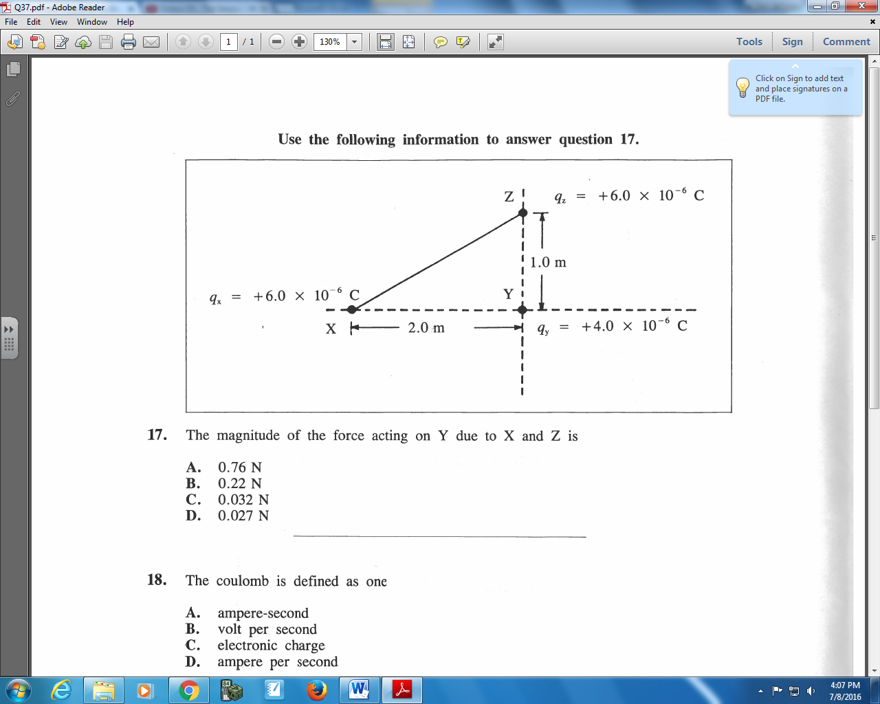

Q118: The magnitude of the force acting on Y due to X and Z is
- 0.76 N
- 0.22 N
- 0.032 N
- 0.027 N

Use the following information to answer Q119 and Q120:
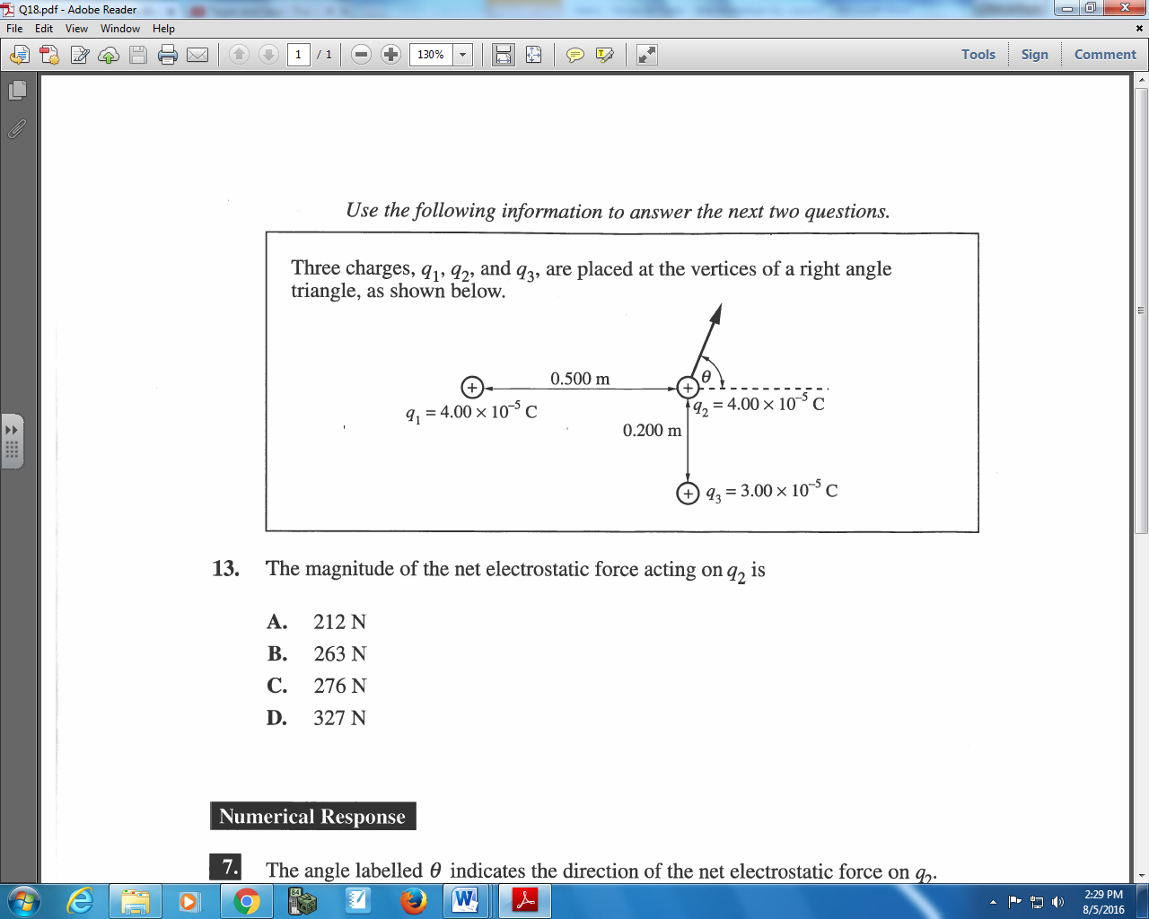

Q119: The magnitude of the net electrostatic force acting on q₂ is
- 212 N
- 263 N
- 276 N
- 327 N

Q120: The angle labelled θ indicates the direction of the net electrostatic force on q₂. The value of θ is ______⁰.
(Record your three digit answer in the Numerical Response boxes below)

Challenge Questions
Pg 535 #2: Four charged spheres, with equal charges of +2.20 C, are situated in positions forming a rectangle, as shown in the figure below. Determine the net electrostatic force on the charge in the top right corner of the rectangle.
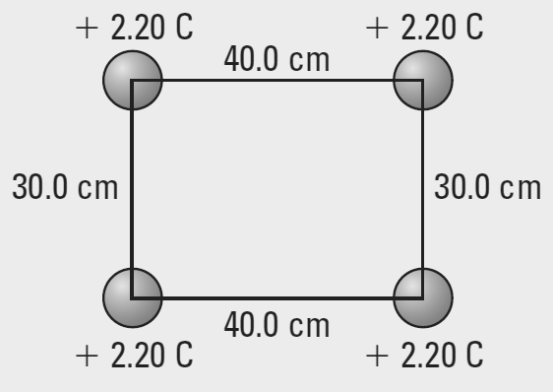

Cumulative Review from Previous Units
Use the following information to answer Q1:
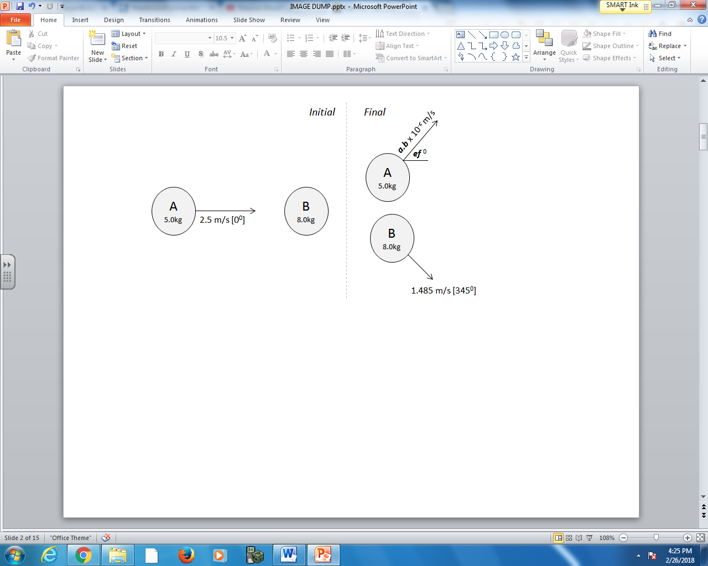

Q1: In an isolated system, Object A hits Object B inelastically. Object A then rebounds upward with a velocity of a.b x 10^{-c} m/s [ef ⁰], where a, b, e, and f are ___, ___, ___, and ___.
(Record your four digit answer in the Numerical Response boxes below)

