First Name:___________________________ Last Name:______________________________

Physics 30 – Unit A: Momentum – L03 – Impulse Graphs

The graph below depicts the forces acting on an initially stationary 3kg mass. Use this information to answer the questions below.
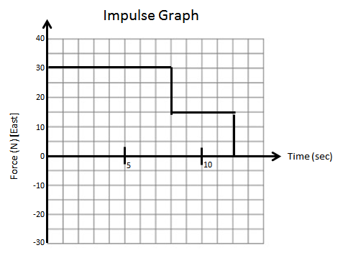
Q1: What is the impulse acting on the 3kg mass over the first 8 seconds?

Q2: What is the velocity of the 3kg mass at 8 seconds?

Q3: What is the impulse acting on the 3kg mass over the total 12 seconds?

Q4: What is the velocity of the 3kg mass at 12 seconds?
The graph below depicts the forces acting on a 12kg mass. Use this information to answer the questions below.
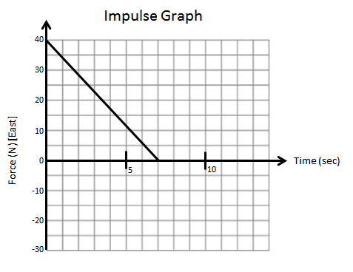
Q5: The 12kg mass experiences an impulse of a.bc x10^{d}, where a, b, c, and d are ___, ___, ___, and ___.

Q6: If the 12kg mass was initially moving at 15 m/s [West], then its final velocity is a.bc x10^{d}, where a, b, c, and d are ___, ___, ___, and ___.

The graph below depicts the forces acting on an initially stationary 5kg mass. Use this information to answer the questions below.
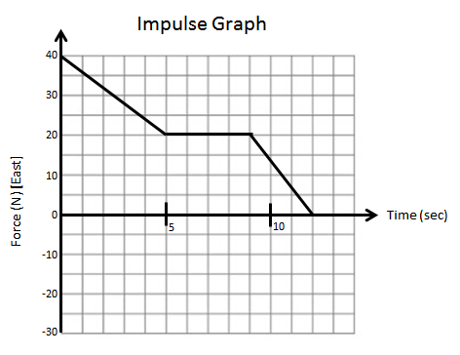
Q7: The instantaneous velocity of the 5kg mass at 5 seconds is a.bc x10^{d}, where a, b, c, and d are ___, ___, ___, and ___.

Q8: The instantaneous velocity of the 5kg mass at 9 seconds is a.bc x10^{d}, where a, b, c, and d are ___, ___, ___, and ___.

The graph below depicts the forces acting on an initially stationary 5kg mass. Use this information to answer the questions below.
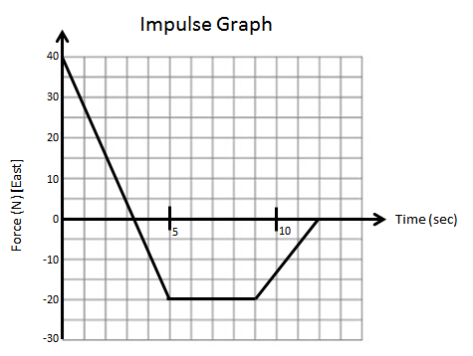
Q9: The total impulse acting on the 5kg mass over the 12 seconds is ____ x10^{w} Ns.
(Record your two-digit answer in the numerical-response section on the answer sheet.)

Q10: The speed of the 5kg mass at 12 seconds is ____ x10^{w} m/s.
(Record your two-digit answer in the numerical-response section on the answer sheet.)

